Mobility of A-Level geography students

This analysis considers how far A-Level geography students tend to move to pursue a degree, and whether that varies by whether they chose geography or another subject at degree level, by demographics, or by where they took their A-Levels.
For this report, we only considered those students who took geography A-Level in the 2014/15 academic year and who went on to begin a degree, in any subject, in or before the 2017/18 academic year. This gives us a snapshot of the situation for the most recent cohort for which we have complete data; more recent A-Level students may not yet have progressed to a degree.
An Excel document, showing all of the results of this analysis, is also provided. It also includes editable versions of the charts shown in this document.

Moves between regions
Those A-Level geography students who went on to study geography at university were less likely to stay in the same region where they did their A-Levels than those who took another subject; 74% of those who took geography degrees studied in a different region from where they took A-Levels, compared to 70% studying another subject.
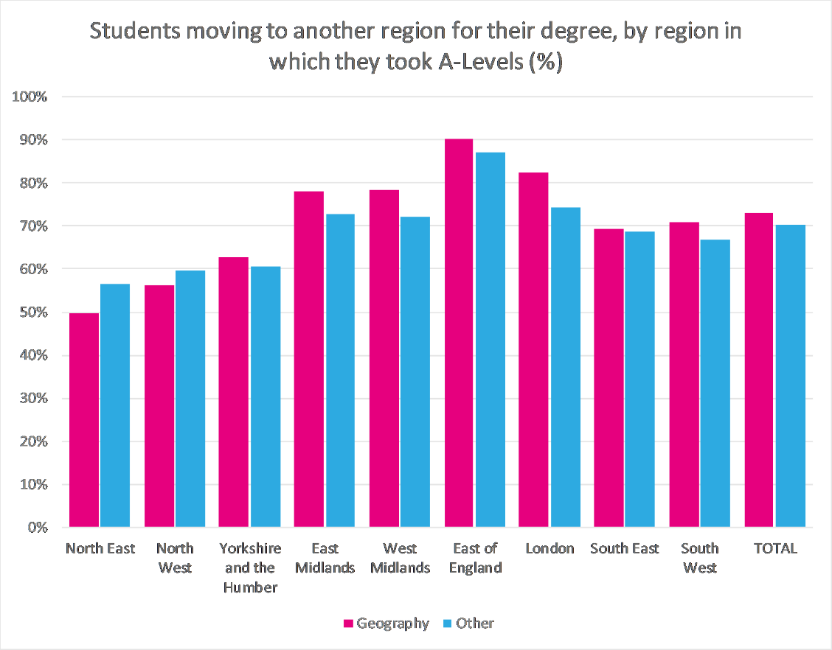
This was the case for every region except the North West and the North East. Differences were particularly large for the East Midlands, in which 82% of those who went on to a geography degree did so in a different region, compared to 73% of those studying another subject, London (82% compared to 74%) and the West Midlands (78% compared to 72%).
This does suggest quite high levels of mobility for A-Level geography students in general when compared to results from work such as Donnelly and Gamsu’s research for the Sutton Trust. This perhaps isn’t surprising as the same work suggests that some groups of students tend to be less mobile than others, including disadvantaged students and some ethnic minorities, and as our original report showed, A-Level geography students tend to be less disadvantaged and less ethnically diverse than average.

Distance in kilometres
An alternative to looking at region moves is to consider the distance between the school in which a student took A-Levels and the HEI where they started a degree. Those A-Level geography students who went on to take a geography degree travelled further, on average, than those who studied another subject. However, the difference was small; the median distance travelled to study geography was 126 km, compared to 112 km for another subject.

Gender and ethnicity
There were only small differences in the distance travelled by male and female students; for both genders, students travelled further to study geography, on average, than other subjects. Male geography students travelled a median distance of 122 km, and female students 128 km. For all other subjects, male students travelled 113 km and female 111 km.
There were some differences for students from different ethnic backgrounds. For any subject, including geography, students from Asian or Other ethnic backgrounds tended to travel much shorter distances than those from other backgrounds.
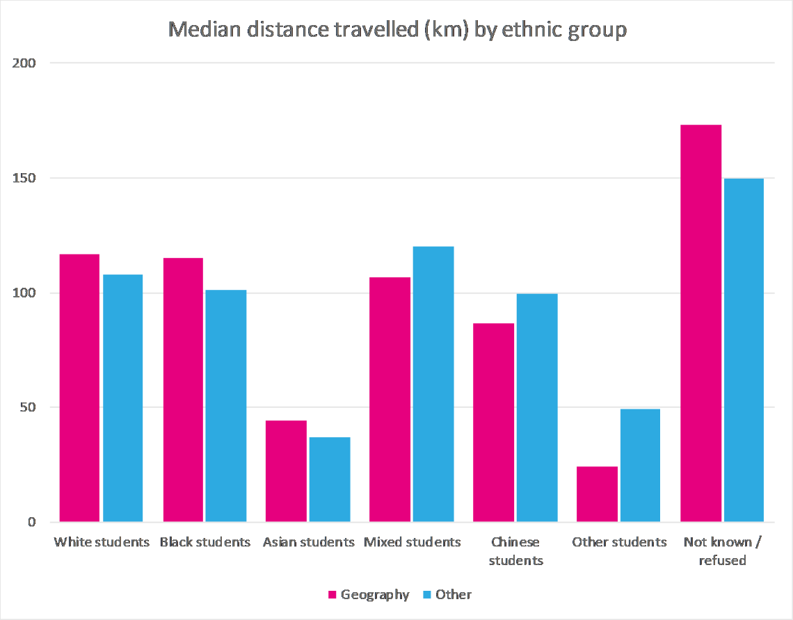
Asian students who went on to take a geography degree travelled a median distance of 44 km, compared to an overall median of 126 km, and students from a background classed as Other travelled 24 km. Students from Black, White and Mixed backgrounds tended to travel similar distances, with medians of 115 km, 117 km and 107 km respectively. Within the Asian group, students from Bangladeshi and Pakistani backgrounds tended to travel particularly short distances, with medians of 16 km and 24 km.
This overall pattern for students travelling to study geography is very similar to the pattern for students going on to study other subjects. However, while students from some ethnic backgrounds tended to travel further to study geography than other subjects, the opposite was true for other backgrounds. Asian, Black and White students all tended to travel further, as did students for whom we have no data on ethnicity. Students from Mixed, Chinese or Other backgrounds all tended to travel less distance. For all groups, these differences were small; all were below 25 km except the Other group. The larger difference for this group (49 km for other subjects compared to 24 km for geography) may be partly due to the small number of students involved; only 31 students from this group went on to study a geography degree.

Distance to an HEI offering geography
We also looked at students’ distance from a higher education institution (HEI) that offered geography. This only included 65 HEIs that ran a degree-level geography course for at least 20 students per year, on average.
All students had one of these 65 HEIs within 100 km of the school where they took A-Levels. The highest distance between a school and nearest such HEI was 86 km, and the median distance was just 14 km. Just over a thousand A-Level geography students had no HEI offering geography within 50 km of their school. These students mostly took their A-Levels in the East of England (438 students), the South West (261 students) and the East Midlands (217 students).
They were slightly less likely to take a geography degree; 21% went on to study geography, compared to 23% of those with a nearby HEI.
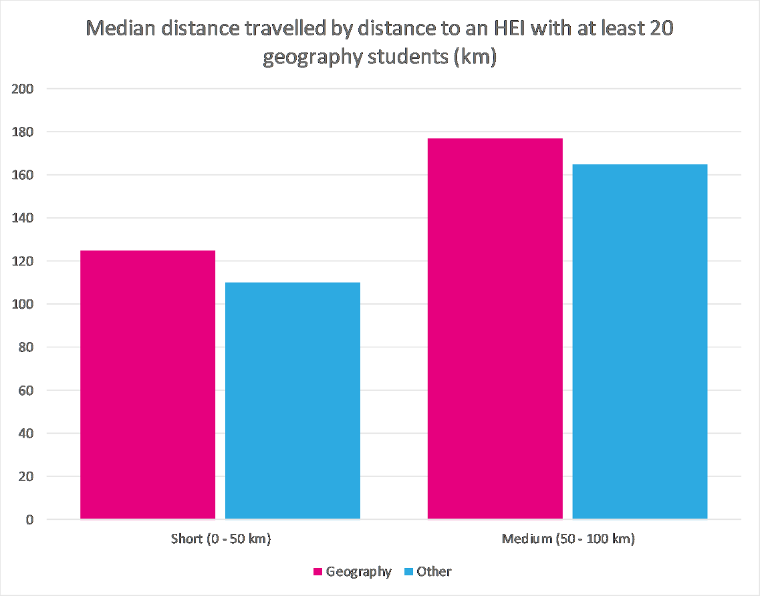
Students with no nearby geography HEI tended to move relatively high distances to take a degree, regardless of subject. Of those who took a subject other than geography, the median distance travelled was 165 km, and the majority (70%) studied in a different region. This suggests that lack of access to a nearby HEI offering geography was not a necessarily a barrier for most of these students, as they were willing to travel some distance for degree level study anyway.

Distance to an HEI offering a large geography course
Finally, we considered students’ distance from an HEI with a large cohort of geography students, defined here as more than 180 students per year, on average. There were ten HEIs that ran these courses. For many A-Level geography students, the nearest such HEI was some distance away, with a maximum distance of 206 km and a median of 70 km.
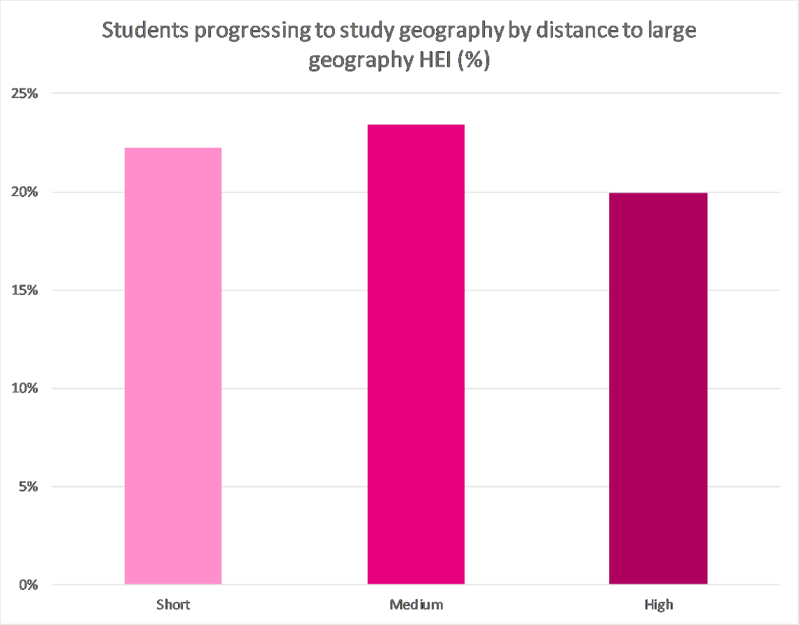
Nearly 40% of A-Level geography students had a large geography HEI nearby, within 50 km. This does not include any students in either London or the East of England, but does include almost all students from the North East (99%) and the vast majority from the West Midlands (85%), Yorkshire and the Humber (83%) and the North West (80%). Those A-Level geography students with a large geography course nearby do not appear to be more inclined to study geography; 22% of these students progressed to geography compared to 23% of all A-Level geography students.
There were just over 1,500 students with no large geography HEI within 150 km. These students were slightly less likely to study geography, with only 20% progressing. They took A-Levels in either the East of England (1,244 students) or the South East (332 students). The 80% who studied another subject tended to travel a long distance to do so, with a median distance of 170 km, and 76% moving to a different region.

Donnelly and Gamsu, Home and Away: Social, ethnic and spatial inequalities in student mobility, https://www.suttontrust.com/research-paper/home-and-away-student-mobility/

