Hargeisa, Somaliland
- Factsheet

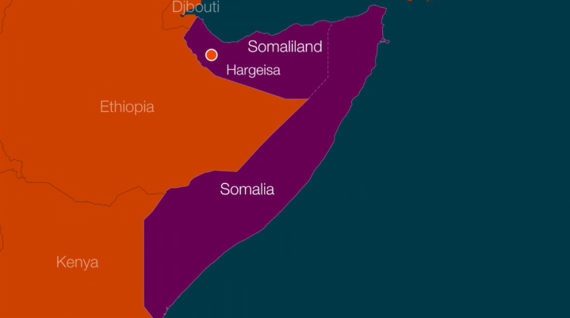
Population
Hargeisa is the capital of Somaliland. Somalia was a former British colony which had a brief period of independence; before being united with the formerly Italian colony of Italian Somaliland to form the Somali Republic in 1960. In 1991 Somaliland declared itself to be independent from Somalia. The exact population of Hargeisa is unknown. Estimates suggest around 750,000 but over half the population is nomadic, so the actual figure is likely to be much higher.

Climate
Located in the Horn of Africa, the climate is tropical. Average annual temperature is around 22ºC and average annual precipitation is only around 400mm. Droughts are common.

Economy
Nomadic agriculture dominates in and around Hargeisa, with dry farming and animal grazing being the main types.

Infrastructure
Much of the city was destroyed during the civil war and security of tenure (who owns the land) remains a big issue in the city. The Migrants on the Margins team is working in three communities in Hargeisa: The State House in the city centre, Camp A and Digaale Camp located on the outskirts of the city. The settlements have houses and huts made from corrugated iron, recycled plastic, cloth and any other materials people can patch together to make a shelter.

Politics
Hargeisa is the capital of Somaliland, a former British colony which unilaterally declared independence from the rest of Somalia in 1991. A brutal civil war between 1988-91 resulted in most of the city being destroyed. After 25 years of rebuilding amidst a climate of relative peace, the city now has an estimated one million people living there and is continuing to grow.

