Colouring London – A level
The need for regeneration
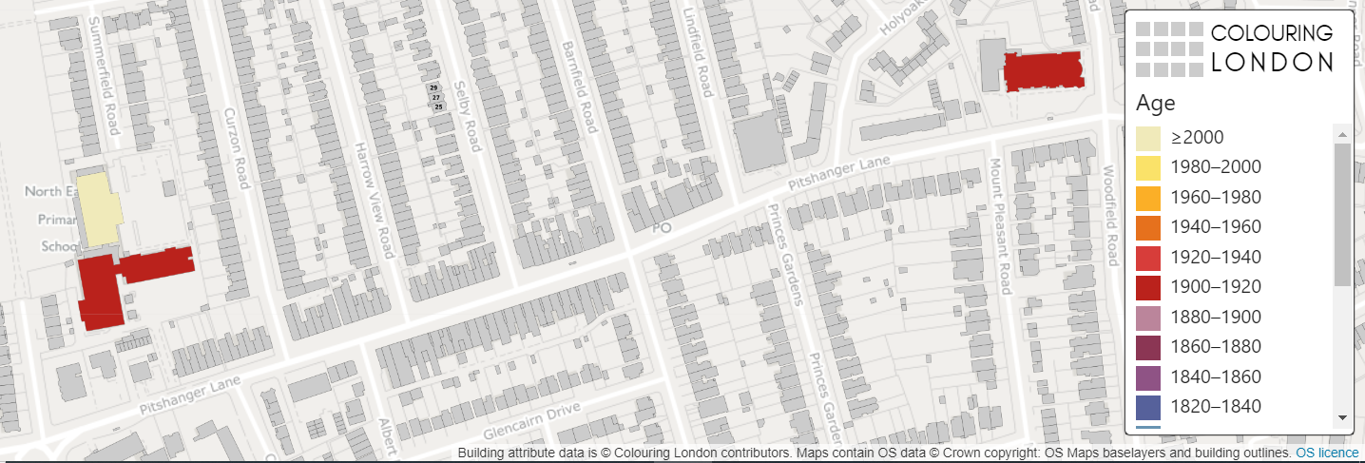

[Start text here]

Colouring London aims to collect information on every building in London, to help make the city more sustainable. It provides information about your local area.
https://colouringlondon.org/

Colouring London would like to collect
- Location
- Land use
- Type
- Age
- Size & Shape
- Construction
- Streetscape
- Team

Detailed information is available on https://www.pages.colouring.london/buildingcategories

Evaluating the need for regeneration

How can GIS be used?

Geo-located data can be used to examine a range of social, economic and environmental reasons behind the need for urban regeneration
For example mapping building type, derelict buildings and lack of green spaces using the Colouring London categories

Determining the need for regeneration

- Collecting and evaluating data in your local area can help to determine the need for regeneration
- Discuss the different data sets that could be used to help determine the need for regeneration

Census data – using DataShine
Multiple Deprivation Index – using CDRC Maps
Decline in businesses
Derelict buildings

Identifying the need for regeneration

The Index of Multiple Deprivation measures relative deprivation in an area using income deprivation, employment deprivation, health deprivation and disability, education skills and training deprivation, barriers to housing and services, living environment deprivation, and crime.
CDRC maps are available to help access secondary data
For your local area or area of study you can use DataShine to research the need for regeneration by mapping the indicators into Colouring London.

Local area study

How do vacant/derelict buildings demonstrate the need for regeneration?
- Decline in businesses
- Lack of investment
- Indication property values do not reflect the needs of the local area
A simple count of the vacant/derelict buildings/empty retail units along a transect is one method
Derelict buildings can then be mapped using Colouring London under the ‘Land Use’

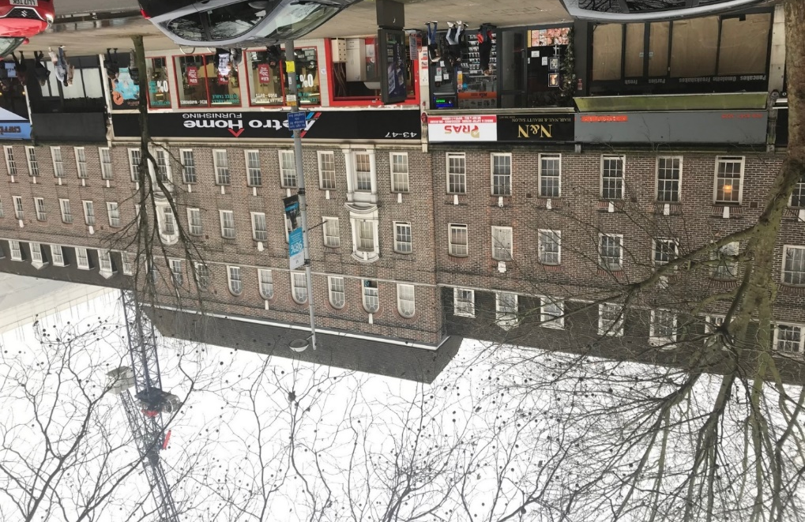
Ealing, London

Vacant retail units

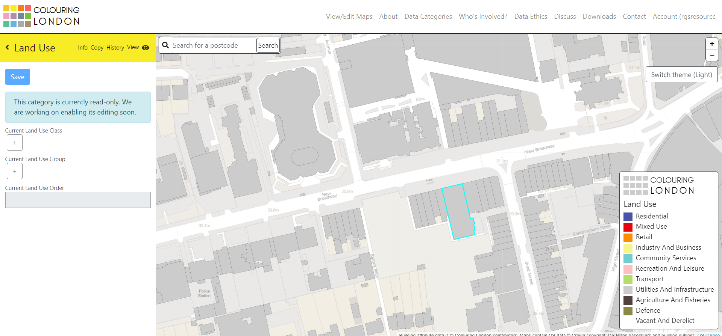

Summary

Visualising the distribution of derelict or vacant buildings can help key stakeholders determine the need for regeneration.

