Physical environment and flooding in Venice: lagoon environment factsheet
Images, charts, and the sources follow the tabulated information
QUESTIONS THAT PARAGRAPHS ANSWER | KEY POINTS | PARAGRAPHS
How do tides affect the environment of the lagoon?  What is the sediment budget of the lagoon and how is it changing? | >tides cause waters to exchange between the Adriatic and the lagoon  >The lagoon sediment budget changes over time with changes in fluvial and marine processes  >Presently, erosive forces are causing a net loss of sediment from the lagoon  >water currents in the lagoon change, the velocity of currents is affected by changes in the shape of the bed of the lagoon | Compiled by Carlotta Dagnino, Eleonora Baldan, Francesco Barbato, Asia Colmagro, and Arianna Semenzato  The Lagoon of Venice (LoVe) is influenced by  tides of the upper Adriatic Sea, and it is Italy’s largest lagoon (about 550 km²). Like all lagoons, the LoVe is a constantly changing environment with sediment inputs and outputs. Sediments arrive into the lagoon from erosion of the land and transport by rivers. Sediments also transfer to and from the Adriatic Sea with water currents moving in and out of the lagoon’s three inlets (at Lido, Malamocco, and Chioggia)  If the erosive forces of tides and waves prevail, the LoVe will lose sediment and become “swallowed up” by the sea. If instead, the sediments carried by rivers into the lagoon prevail (deposition exceeding erosion) it will develop into a strip of coastal land.  Marine currents bring sediments, which can accumulate on the littoral of the lagoon blocking the flow of water through the inlets.  A GIS showing marine currents and tidal levels in the LoVe can be seen here: http://cigno.ve.ismar.cnr.it/maps/30/view  In order to assess the long-term sediment balance between the total river transport and the sediment fluxes (controlled by tidal currents and waves) in the  LoVe and along the Adriatic coast, it is of primary importance to evaluate the quantity of sediment transported by rivers flowing directly in the lagoon and eventually conveyed through its inlets to the Adriatic sea.  The creation of jetties at the inlets, and the creation of deep channels through the lagoon for shipping have speeded up the tidal currents moving in and out of the lagoon increasing erosion and causing a net loss of sediments. The shape of the lagoon bed has also become smoother, and therefore less resistant to tidal flows.
How has the sediment budget been managed over the centuries? | >Human intervention has been a major factor in the lagoon’s sediment budget for centuries  >Most intervention was to reduce sediment accumulation  >Today the opposite problem is occurring with the lagoon deepening and trending towards a bay of the sea | The rivers that now flow, used to flow, and/or would flow into the lagoon (in the absence of human management) include the Piave, Sile, Zero, Dese, Marzenego, Muson, Brenta, Bacchilione, Adige and the mighty Po itself. The Dese qualifies as a minor stream, even as now combined with the Zero before entering the lagoon; however, the Piave, Brenta, Bacchilione and Adige have large annual flows and sometimes monumental seasonal flood flows that have historically had a dramatic effect on the lagoon and Venice itself.  The Po, a river of glacial origin, the course of this river has been deviated many times so as to avoid its sediment silting up the lagoon of Venice. One of the most significant of these projects was carried out at the beginning of the 1600s when a 7km-canal was built from the northernmost branch to deviate the flow southwards. This was successful in keeping the Venetian Lagoon open for navigation but led to destructive flooding in the Po Delta.  Nowadays, all of the Po delta is below sea level, except for its river banks and fossil dunes. It is a protected area, popular with birdwatchers  Even though river input is presently very small in terms of the sediment net balance, it used to be a dominant factor before the large rivers Brenta and Piave were diverted out of the lagoon by Venetian engineers in past centuries.  While historically, Venetians had to manage the lagoon to prevent it from silting up (to maintain access to the sea for trade), the problem has now become one of limiting erosion to prevent the LoVe from turning into a bay of the sea.
What factors cause the exceptional high tides in the lagoon of Venice? | >Exceptional high tides cause coastal flooding  >In Venice this type of flooding is called acqua alta | Exceptional tides statistically occur once every 3 years. They are caused by a combination of various factors, such as the astronomical tide, low atmospheric pressure, and a strong south-east wind (the Sirocco) that drives surface water up the Adriatic Sea towards Venice.  Another wind, the Bora from the north-east, also drives surface water into the Lagoon of Venice.  Coastal flooding of Venice caused by high tides is called acqua alta (high water). Acqua alta can be long-lasting due to moving water creating ‘seiches’ in the northern Adriatic Sea.
What are the long-term factors that have changed, and are continuing to change, the lagoon?  What is the effect of climate change? | >Background natural phenomena drive long-term change  >Global warming is contributing to rising sea level, thereby contributing to the increased frequency of flooding in Venice | Compiled by Flavia Pozza and researched by Francesco Barbato, Pascal Tchen, Max Vaughan, Francesca Drago, Catalina Josanu, Eva Mariotto, Francesco Bellati  The Lagoon of Venice formed as sea level rose due to melting of ice sheets during the ending of the last glacial (Ice Age) phase. This phenomenon is called eustatic sea level rise. The lagoon reached something close to its present form between 6,000 and 4,000 years ago.  Over recent centuries, natural phenomena of rising sea level and land subsidence continue to change the lagoon alongside human interventions.  Plate tectonic processes in the Mediterranean area are uplifting the Apennines, but driving the north-eastern part of Italy downwards relative to the Alps. Natural subsidence in parts of the lagoon can be up to 2mm a year.  Presently global warming is causing further sea level rise (due to thermal expansion of sea water and melting glaciers), with the IPCC predicting that sea level could increase by between half a metre to nearly a metre by the year 2100. Global sea level has already risen by about 20cm since 1870.  Combining higher tides with subsidence of the plate and the city itself into the lagoon bed may cause a cumulative decrease in the height of the city relative to sea level each year of up to 5mm in the coming century.
How have human interventions been affecting the lagoon recently?  What are the problems that these changes bring? | >Human interventions have altered natural trends  >Such interventions include river diversion and land reclamation  >water currents in the lagoon change, the velocity of currents is affected by the amount of salt marsh and changes in the shape of the bed of the lagoon | Includes research by Tom Austen, Laith Belkacem, Marta D’Este, Johnny Wallace, Gaia Schiavon, and Francesca Colpo  Recent human interventions include building the Marghera port and industrial area in the early 20th century, and installation of seawalls, dams, and the present construction of the MOSE tidal barrier scheme. There has also been land reclamation.  Pumping groundwater from deep acquifers for industry at Marghera caused about 12cm of Venice subsidence before the process was stopped in the 1970s.  The historic diversion of rivers (Sile, Brenta, Adige, etc.) away from the lagoon and straight to the Adriatic Sea has also contributed to an increase in depth of the lagoon.  Land reclamation, particularly since the 19th century, has involved people infilling areas of the lagoon for agricultural use, and this has reduced the area of natural salt marshes which act to store water and slow flow rates through the lagoon.  In addition to more wave action and stronger currents in the lagoon, the bed of the lagoon has been changed due to dredging of channels for large ships (container and cruise ships). Stronger under water currents caused by dredging (and the passage through the water of the ships themselves) cause scouring of the bed. This increasing erosion and sediment transfer out of the lagoon, and also contributing to its deepening.  The widening of the inlets and installation of jetties has also increased water flow rates.  The lagoon has showed a clear-cut change in the most frequent depths (modal depth) measured from a value of -0.62m in 1927 to -0.88m in 2002. The deepening of the lagoon has been most significant in the lagoon sub-basins south of the city of Venice. Comparing the three inlet areas, modal depth increased -0.65 to -1.12m in Lido, from -0.64 to -1.75m in Malamocco, and from -0.39m to -0.88m in Chioggia.  In combination, the above factors strengthen tidal currents, thereby increasing erosion of the islands of the lagoon and increasing the speed of water flow through the lagoon and the potential height above sea level of high tides.  The ground level of Venice is now around 30cm lower relative to the normal water level of the lagoon compared with 1897 when the first reference point was established.
SOURCES:
The Science of Saving Venice (Fletcher and Da Mosto)
http://cigno.ve.ismar.cnr.it/maps/30/view
http://www.venicethefuture.com/schede/uk/358?aliusid=358
http://93.62.201.235/maree/DOCUMENTI/D_Alpaos_ICPSM_L_evoluzione_morfologica_della_laguna_di_Venezia_2010.pdf
http://www.silvenezia.it/?q=node/56
GRAPHICS
- Chart showing mean global sea level rise since 1870:
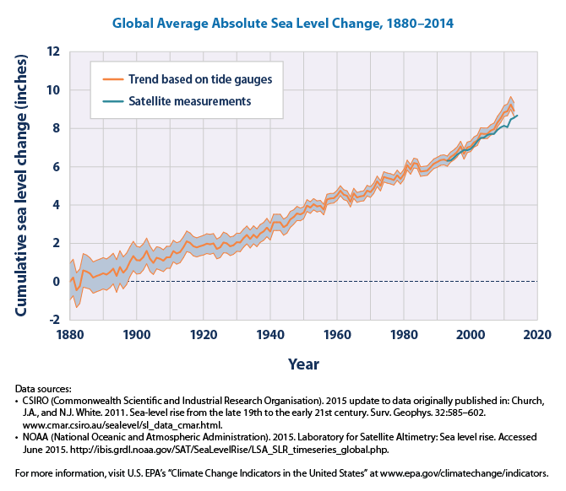
Global sea level change © US EPA, Wikimedia Commons

More graphics on the next page

- Chart showing the instrumental record of global sea level change and the sea level rise projected to 2100:
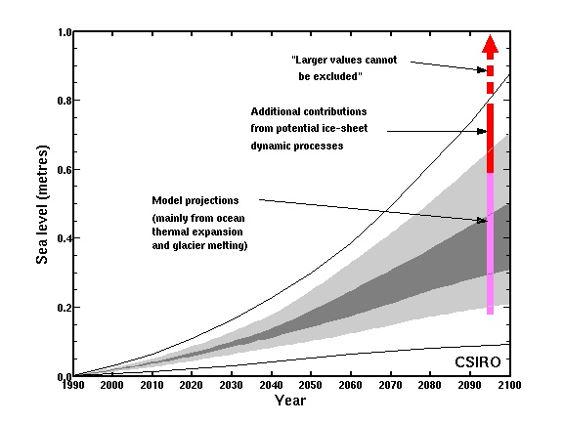
Projected sea level rise © CSIRO, Wikimedia Commons

- Sea level rise at Venice and Trieste (on the Adriatic, north-east Italy) compared since 1890. The line showing the difference between Venice and Trieste begins about 1930 when groundwater pumping from acquifers beneath the lagoon increased the Venice rate of subsidence. The pumping has since been stopped, and now Venice and Trieste are again subsiding at about the same natural rate.

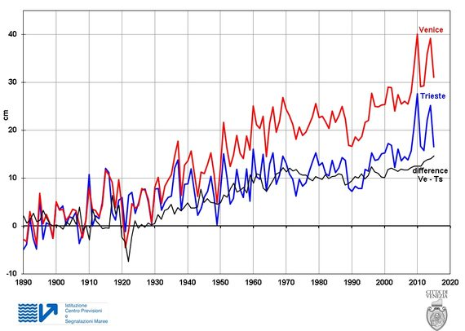
Sea level rise at Venice and Trieste © Venezia (?)
Trieste data: ISMAR-CNR Institute of Marine Science of Trieste. Venice data: from 1890 to 1922 come from various sources, from 1923 to 1982 ISPRA archive and from 1983 to 2015 ICPSM archive
http://archive.comune.venezia.it/flex/cm/pages/ServeBLOB.php/L/EN/IDPagina/1844/UT/systemPrint
More graphics on the next page
- Historic river diversions around the Lagoon of Venice:

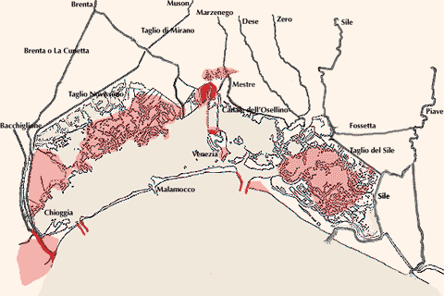
https://renaissancerules.wordpress.com/2011/01/11/venice-rivers-into-the-lagoon-2/

