Why do people move?
- Zine-making workshop

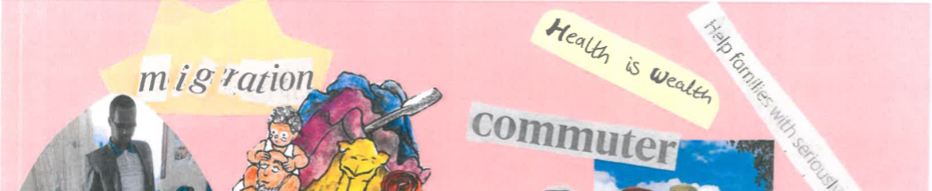

What is a zine?
A zine is a small DIY publication that can be made cheaply and with little design skills needed. Traditionally, they have been made as an ‘alternative’ to mainstream media and publications – sometimes to advocate for social and political reasons. Social theorist Sara Ahmed (2014) has said that “zines bring attention to how we live and interact with one another, and illustrate tangible possibilities for how to live together in more caring ways”.

You can read more about zine culture and how to make a zine in this article by Dr Jen Bagelman (2017) https://www.acme-journal.org/index.php/acme/article/view/1257

Having explored the Migrants on the Margins research project, and PositiveNegatives comics, the zine is an opportunity for pupils to bring together what they have learned so they can produce a publication. The purpose of the zine is to allow pupils to share what they have learnt about migration and urbanisation, and helps to dispel myths and stereotypes around these processes.

How do you make a zine?

You can find out more about zines and how to make them below:

  - What is a zine? https://www.youtube.com/watch?v=cCjtHVZ--JQ
  - How do you make a zine? https://youtu.be/m3n7nEPTwoY?list=PLfuvUgXMvnkdQCZE3J2UCliVdThTjfskr
  - How to distribute zines? https://www.youtube.com/watch?v=WrJN0SGp_iw&list=PLfuvUgXMvnkdQCZE3J2UCliVdThTjfskr&index=3

Learning objectives
- Discover the format of a zine and why it is different to other publications
- Produce a collaborative zine called: ‘Why do people move?’
- Dispel negative myths and stereotypes around global migration, and understanding of migration stories in Africa and Asia

Key questions
- Why do people move?
- Why is this impacting urban growth?
- How do comics and zines can link local stories to global issues?

Resources
Images of the four cities, maps, old newspapers, coloured paper, pencils, pens, scissors, glue, any other materials.

Starter
In class discussion, think about how the following themes, or drivers for migration.
- Food and water security
- Housing and planning
- Employment
- Environment and climate
- Family and networks
- Education and health

The zines should explore these issues, and showcase what pupils have learnt by engaging with the Migrants on the Margins research and telling their own stories. One of the main learning outcomes is that migration is multi-causal, so all of these drivers work together to influence why people move.

Introduce the idea of what a zine is, and how pupils are going to produce their own based on ONE country featured in the Migrants on the Margins research project:
- Dhaka, Bangladesh
- Colombo, Sri Lanka
- Harare, Zimbabwe
- Hargeisa, Somaliland.

In groups, pupils should pick or be allocated, one city from the Migrants on the Margins resources to produce a zine on. The zine should explain and discuss the drivers for migration in each city and the challenges migrants face, then, as a collective your class can share the zines as case studies.

Main activity

In groups, pupils should consult the themes, and choose their city and decide how they will best showcase what they know in the zine. This includes 1) deciding who will do what b) what their output will be c) what the overall editorial narrative will be of the zine.

Remember, zines are a creative output, there is no right or wrong answer to aim is to inspire readers to change negative assumptions about migration and advocate for migrants in these four cities. You may wish to include the following: short stories, newspaper cuttings, drawings, annotated images, maps, diagrams, poems or art.

It is encouraged that you provide pupils with old newspapers that they may cut out and use to create the zines. This is part of the learning objective to ‘dispel negative myths and stereotypes’ in media and news – by physically re-cutting and re-telling news.

Plenary

Recap with pupils to ensure they know their roles and what will be achieved in the zine. Remind pupils about the physical production of the zine, and that you should be able to make multiple copies of the zine itself.

The zine should then be finished for homework and brought in for next lesson to discuss and distribute – it can be used as a revision tool, as well as for display and distribution around school.

