The Russian Arctic: infrastructure and permafrost activity sheet 3

To start
There are a number of place names in this resource, which might become confusing. To start this activity sheet, print off the map in Appendix A. Using an atlas or online map:
- Label the ports of Murmansk, Provideniya, and Sabetta (all Arctic), and Arkhangelsk
- Label the city of Norilsk
- Study Figure 3 in Appendix B. Label the Nenets and Yamalo-Nenets Okrugs (areas)
A Level Specification
AQA
3.2.5.4 Energy security. Environmental impacts of a major energy resource development such as an oil, coal or gas field and associated distribution networks.

Edexcel
Topic 7: Superpowers. 7.6a Superpower resource demands (food, fossil fuels, and minerals) can cause environmental degradation and their carbon emissions contribute disproportionately to global
warming.

OCR
1.2 Earth’s Life Support Systems. 2.b. It is possible to identify the physical and human factors that
affect the water and carbon cycles in an Arctic tundra area: the impact of the developing oil and gas industry on the water and carbon cycles.

WJEC
4.4.5 Energy Challenges and Dilemmas. Problems associated with extraction, transport, and use of energy. Environmental (and technical) problems associated with fossil fuels and other forms of energy.

What infrastructure is there in the Russian Arctic?
Infrastructure investment is increasing in the Russian Arctic as the Russian Federation seeks to expand strategic control into and beyond the Arctic and extract mineral resources in the Russian Arctic.

Global warming is opening up new commercial opportunities in the Arctic, most notably in fishing and shipping.

Fishing has been identified as a future growth industry in Russia as a changing climate pushes fish stocks northward. Currently, about one-third of all fish caught in Russian waters are from the Arctic. Between now and 2030 the Russian government hopes to continue to enlarge this Arctic industry.

Shipping is also expected to dramatically increase in importance as sea ice continues to melt along what is now called the Northern Sea Route (NSR). In the future, this maritime sea lane will cut the time it takes for cargo to get from East Asia to Western Europe by 10 to 15 days. Cargo which has historically sailed through the Indian Ocean and Suez Canal over a 21,000 km journey will now only travel 12,800 km through the Arctic Ocean, significantly lowering costs and increasing interconnectivity.

Two land areas of the Russian Arctic are experiencing extreme climate change: the Nenets Autonomous Okrug (in North-western Russia), and the Yamalo-Nenets Autonomous Okrug (in Ural), both in Western Siberia. In these and many other Arctic areas thawing permafrost is making the climate less hostile but the ground more unstable. As a result, infrastructure such as port quays, railroads, oil pipelines, and urban buildings are all sinking into the ground.

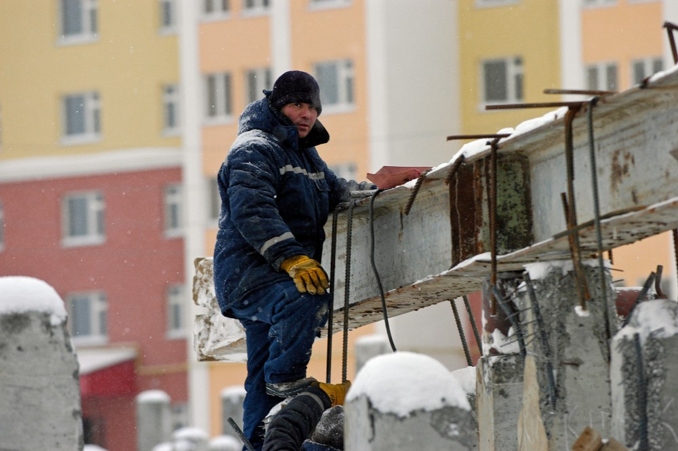
Figure 1 metal rods are now used to strengthen buildings against ground deformation © Thomas Nilsen

Railroads
Severe Russian winters often interrupt motorway traffic, due to heavy snowfalls. Railroads are, therefore, a much more reliable form of transport in the Russia Arctic, both for diesel-powered freight and electrified passenger services.

Mapping Russian railroad development gives a visual, nationwide picture of infrastructure investment. It also reveals highly populated regions (with high connectivity), and heavy industry areas (with freight lines).

A key part of the Russian Trans-Polar Railway investment is the Northern Latitudinal Railway (NLR), which will link the Northern Line from Arkhangelsk to the line between Nadym and Tyumen. An extension to the port of Sabetta is included in the project.

Ports
There are 13 ports in the Russia Arctic, including river ports accessible by seagoing ships. However, along the NSR there are only two deep-water ports: Murmansk, in the Arctic, and Provideniya which, at 64°N is nicknamed ‘the doorway to the Russian Arctic’ on the eastern end of the route.

Many ports along the NSR have seen a significant increase in the volume of goods, a proportion of which is linked to the exploitation of new oil and gas fields. For example, the port at Sabetta on the Yamal Peninsula has seen a significant increase in Liquified Natural Gas (LNG) shipments from Novatek’s Yamal LNG plant.

LNG transport has also spurred growth in Murmansk, which has grown into a major commercial seaport.

Mineral extraction
Nearly 50% of oil and gas fields in the Russian Arctic are located in areas where permafrost thaw could seriously damage infrastructure by 2050.

Norilsk is one of the few large cities within the Arctic Circle that is built entirely on continuous permafrost, located within the Arctic Circle on the Taimyr Peninsula.

The Peninsula is the most northerly piece of land in the world that is still attached to a continent. It is linked to other regions by the Yenisey River, the NSR and Norilsk airport. The area is suffering environmental damage from industrial disasters due to thawing permafrost.

Norilsk Nickel, one of the world’s largest nickel and palladium producers, has had two major spills over the last decade, in 2016 and 2020. In 2016 the company admitted ‘red river’ responsibility as the nearby Daldykan river turned blood red from a chemical pollutants leak, whilst in 2020 an aging reservoir collapsed and leaked over 21,000 tonnes of diesel into the surrounding area. This caused serious degradation of the Ambarnaya river and Lake Pyasino ecosystem. In total, a 350 km² area was contaminated.

Liquid Natural Gas (LNG) is also a growing Russian Arctic industry. Yamalo-Nenets is of particular LNG importance with more than 90% of the country’s total natural gas resources. Novatek, the Russian natural gas producer, opened the Yamal LNG plant in 2017 and plans a follow-up LNG-2 on the Gydan peninsula of the Okrug. Production for LNG-2 is due to start in 2023.

Infrastructure has grown significantly around the industry – at the start of the LNG project there was no access to the plant by land or by sea. Construction first began on a transportation hub which is now the port of Sabetta and the international airport.

Activity
Go to the website RussiaMap360° and access the Russia rail map.

The map shows planned Russian railroad development up to 2030 with existing railroads shown by single black lines and planned high-speed rail corridors represented by bold lines.

- Add the Arctic Circle onto Figure 2 in Appendix A.

- Add the Northern Sea Route.

- Visit the TotalEnergies webpage on their LNG investments in the Russian Arctic.

Scroll down to The Northern Sea Route textbox and add notes about the versatile LNG ice-breaker tankers and how much time it takes them to reach the Bering Strait.

- Figure 2 in Appendix A is missing some Russian Arctic railroads in Ural (which is outlined in Figure 4). Add the missing railroads to your map.

- Use the Barents Observer article New Barents Sea port and 500 km railway to add detail about the significance of the Belkomur railway to the North-western region.

- Will the oil and gas infrastructure be vulnerable to thawing permafrost? Use the RGS-IBG map titled Circumpolar permafrost map for infrastructure risk RCP 4.5 scenario in your answer or, alternatively, read the Reuters and Moscow Times articles listed below.

Further reading
- ScienceDirect Effect of the Northern Sea Route

- BBC News Russia's Arctic: Taimyr Peninsula

- The Barents Observer New Barents Sea port and 500 km railway link could help connect Asia with the Arctic

- Carnegie Endowment for International Peace, Economics and Energy, Russia in the Arctic—A Critical Examination

- The Barents Observer Big growth in Russian Arctic ports

- WWF Norilsk nickel must be held to account for devastating fuel spill

- BBC News Norilsk Nickel: Mining firm pays record $2bn fine over Arctic oil spill

- The Barents Observer In push for global lead in LNG, Moscow takes aim on Arctic tundra

- Arctic Today Moscow revives plans for a railway to Arctic coast at Sabetta

- The Barents Observer Bridge over river Ob marks start of new grand railway project

- Reuters Climate-fuelled permafrost thaw threatens up to half of Arctic infrastructure report

- The Moscow Times Russia Losing 1-3 Meters of Arctic Shoreline to Climate Change Annually

Appendix A

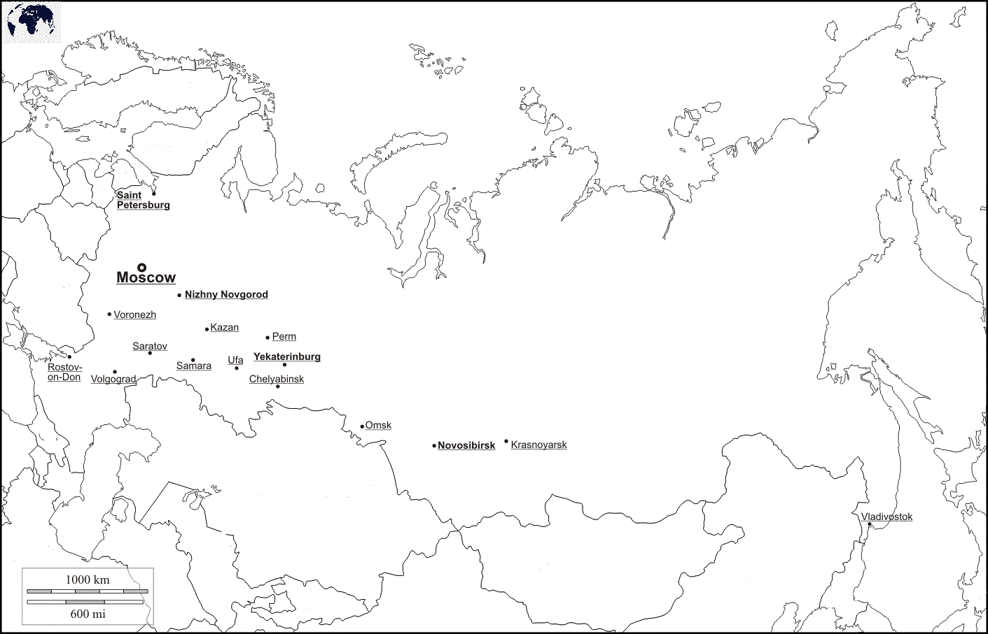
R U S S I A

Further work
- RussiaMap360° railroad map up to 2030

- Russia Beyond Norilsk railway: a lifeline amid bleak tundra

- The history of the Trans-Polar Mainline, BBC News Joseph Stalin's deadly railway to nowhere

- Russia Briefing Russia Explores Re-Development Of Its Trans-Polar Railway

- The Barents Observer, renewed interest in the Transpolar Mainline, Defence Chief says time might have come for revival of Stalin’s Arctic Death Road

- RZD-Partner magazine The development of the eastern shoulder of the Northern Latitudinal Railway is a hot topic (Pусский and English)

- The Siberian Times Getting connected: new $200 million bridge 'brings Arctic closer’ (Yamalo-Nenets Autonomous Okrug)

Figure 2 planned Russian railroad development to 2030, map © RussiaMap360°

Appendix B
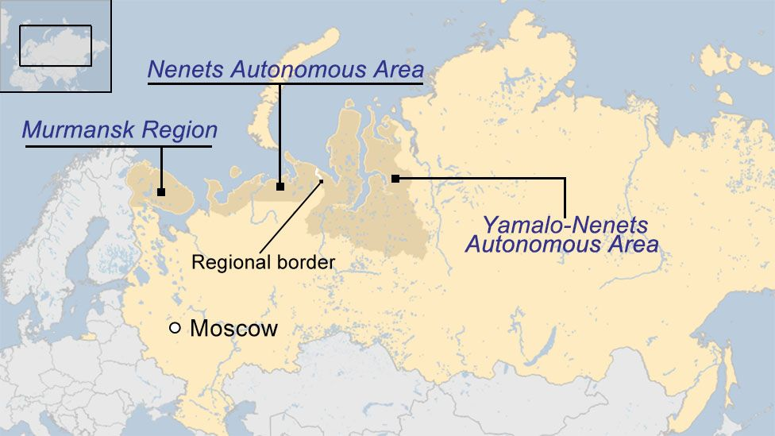
Figure 3 © BBC News

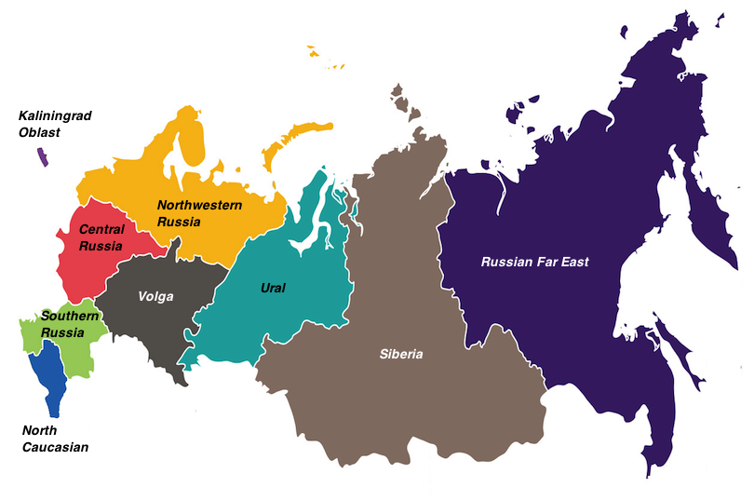
Figure 4 a regional map of Russia by Touropia

Answers
- For 1, 2 and 4 see the complete map below. Murmansk and Provideniya have been added.

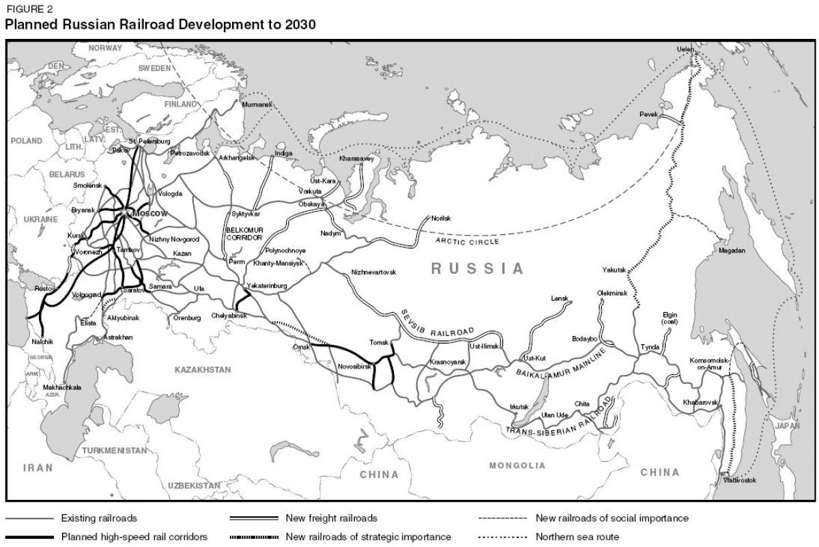
Provideniya
Figure 5 © RussiaMap360°

- In 2013, at the start of the LNG project in the Yamalo-Nenets Okrug, there was no access to the site at all. This was further hampered by the fact that the estuary of the Ob River was frozen for seven to nine months of every year. The project required a new breed of vessel: the LNG ice-breaker tanker which unlocked the Russia’s Far North, reducing the transit time from Sabetta port to Asia from 30 to 15 days, via the Bering Strait.

- The Belkomur railway is a significant infrastructural advance into the Arctic because it will allow more global cargo flow to go north to the year-round ports of Indiga and Arkhangelsk. This will link the mining and industrial areas in the South Urals to the NSR. Distance for freight from the Urals and Siberia to Arkhangelsk in North-western Russia will be cut by 800 kilometres. The restructuring of Arkhangelsk into a deep-water port now allows goods to arrive from Kyrgyzstan and China for export.

- Infrastructure will be affected by changing permafrost in the Russian Arctic. For example, thermal abrasion is eroding some parts of the coastline as much as 5 to 7 meters per year, which will impact coastal towns and ports such as Murmansk, Provideniya, and Sabetta.

Thank you to Dr Alexey Kokorin, Head of the Climate and Environment programme at WWF-Russia, for helping with the production of this resource

