Author:
Kit Rackley is an ex-high school Geography teacher with experience working in the climate science sector. They maintain a blog for educators at Geogramblings.com and is a consultant to the Geographical Association.
TITLE: Students as partners, not just stakeholders
The idea in providing students with leadership opportunities in school is not novel. But while student leadership is more or less ubiquitous, to what extent in any given establishment does it truly hand over the reins to students themselves? Student leadership and youth empowerment has always been a core component of my approach to teaching, and I learned to recognise and move from ‘tokenism’ leadership towards ‘partnership’. Here’s my experience, which may give you some encouragement and ideas to hand over the reins yourself.
Why engage in student partnership?
The reasons why a school, department or individual teacher may wish to engage in deeper student leadership can vary. I wanted students to not just experience leadership in learning, but also to become full partners in running the Geography Department. Some of my reasons why I did may be common: to increase student engagement in lessons; to move students from passive to active stakeholders; and as a head of Geography, not wanting the department to stagnate but to continuously ‘level up’ with fresh ideas from students themselves. Other reasons were a little more personal: department meetings were between me, myself and I (at the time, my geography colleague was a member of SLT so sometimes not able to attend meetings); and I as a millennial with my students increasingly from Gen-Z, I was getting more and more out of touch and could no longer claim to think like them!
Hart’s “Ladder of Participation”
Hart’s “Ladder of Participation” may have been published in 1992, but it is still a model which is useful today, especially if you take your own interpretation of it based on the culture of your school and your own teaching and management styles. This is what I did when I came across it long after I had started trying to increase student ownership, and I found it an exceptionally useful framework to evaluate what I was already doing. Here is an overview of Hart’s ‘Ladder’ through my interpretation.
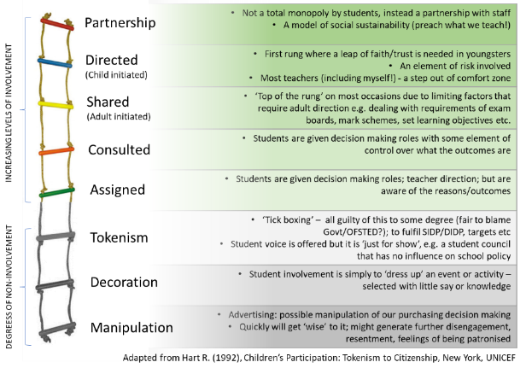
Hart’s ladder is in two sections according to the level of engagement and outcomes (especially student ownership of those outcomes). I’ll focus on giving examples for the upper section, where student involvement is increasingly active, so is an element of trust and risk-taking. “Assigned” is where students are given decision making roles with teacher direction, but are they are aware of the reason for the role and guided towards outcomes. Whereas “Consulted” is where students are given decision making roles with some element of control over what the outcomes are. Here in an example combining the two, using a classic resource some of us more ‘seasoned’ Geography Teachers may be familiar with!
Assigned/consulted and informed example – Year 7 Montserrat DME (Juicy Geography)
The Juicy Geography ‘Montserrat eruption role play’ activity lends itself perfectly to ‘assigned’ and ‘consulted’ levels of student leadership. Students make up crisis management teams from the Montserrat Volcano Observatory. There are three roles: an information coordinator who collects reports coming about the unfolding nature and impacts from the erupting Soufriere Hills volcano, a geologist who maps the reports and a crisis manager who uses the mapped reports to make decisions about what actions to take. They then get their decisions assessed by the Governor (more on that later). Here is the ‘assigned’ level of leadership, particularly attributed to the crisis manager. The crisis manager can be selected by the teacher or decided by each group. It is a prescribed role with set criteria where the decisions are given as a set of options. Other group members aid decision making, and the whole team are aware that the aim is to protect lives on Montserrat.
Usually the fourth role of the Governor who scores each team’s decisions and provides feedback, is done by the teacher. But to implement the ‘consulted’ level of leadership, my approach was to use 2 or 3 students who take GCSE Geography. The hardest part was finding a willing teacher to release them from whatever lesson they would have been in! In-lieu of their usual GCSE homework, they would be set a task to prepare for the Montserrat lesson by writing out a short explanation for each correct decision. This reinforces their own knowledge and understanding for their GCSE, but also allows them to provide feedback-for-learning to the Year 7s when they go get their decisions scored. They also advise the geologists on effective mapping of information.
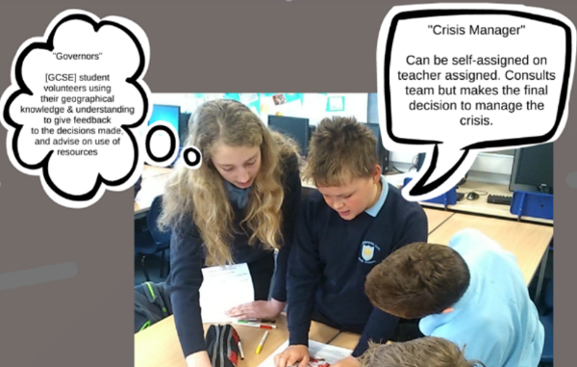
There are bonus perks to taking these approaches. The Year 7s enjoy the presence of older students, and even though it is prescribed they have an element of control over the activity. GCSE students strengthen their geographical knowledge and understanding, while imparting some of it onto their younger peers.
Shared decisions, adult initiated
Now to the top steps of the ladder, where students can really start taking the reins. The step third from top requires adult direction, much like an instructor would do with a learner driver. Outcomes can be very variable as students have at least equal weighting in decision making. Here are some examples of approaches I have taken.
Fieldwork & Controlled Assessments
During that memorable period of Geography GCSE controlled assessments, I introduced student leadership into the logistics in order to maximise student ownership and motivation into what many felt was a drag. Of course, due to the strict exam board requirements of narrow choice of focus and assessment criteria, the process had to be adult initiated and directed. But here’s how we approached it.
Pre-9-to-1 we did the OCR-B GCSE syllabus and so were sent a choice of four controlled assessment fieldwork questions, one per topic. As soon as we received those, I called a meeting with a handful of Year 10 student volunteers, representative of the demographics of the cohort, to discuss which we should choose. In preparation for the meeting, the student leaders collated opinions of their peers (via survey & informal discussions) and conducted own research on choices of topics and viable locations. This was in-lieu of their usual GCSE homework, although they had the option to complete that too – most did!
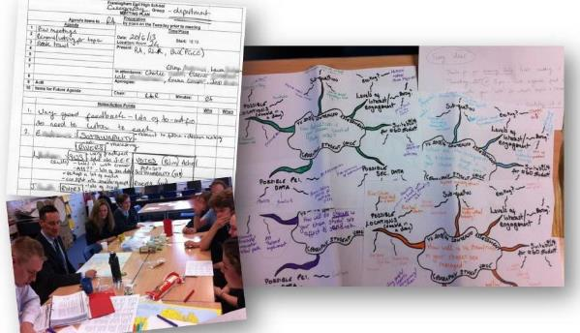
At the meeting, we broke up into four discussion groups, one for each fieldwork topic and thoughts were put down on a scaffolded mind-map. This is an example of the ‘adult directed’ part, ensuring that discussions about the necessary requirements and logistics for the fieldwork took place. After reconvening to share thoughts, there was a round of elimination voting with each person having one vote each, until a topic was chosen. Discussions then turned to possible locations. Since there were more students than staff, the weight of student voice was actually greater. In fact, in two of the four years I did this, the topic I voted for was not chosen! Student ownership continued during the controlled assessment, for example designed some of their own methods of data collection in order to access Level 3.
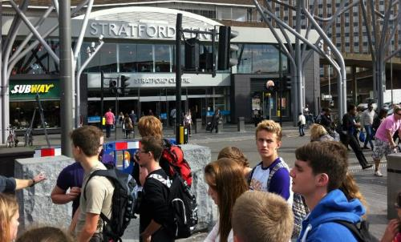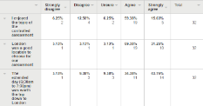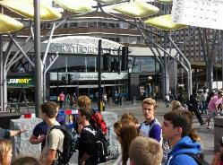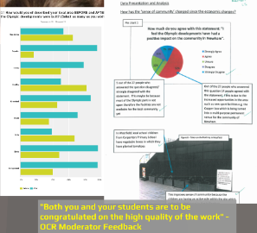
Outcomes of the student-led GCSE controlled assessment field trip to London in 2013.
Giving student ownership of the process helped to mitigate the issues brought on by the stress of a long, drawn-out examined piece of work. There was a greater sense of achievement (as well as the relief) at the end, and there was a tangible output of higher quality from students across the cohort. We also got a ‘pat on the back’ from OCR’s moderator on more than one occasion.
I adjusted this approach for the new 9-1 GCSE fieldwork, but essentially it was the same process. Arguably we had more freedom of choice, but students were encouraged to consider what topics they had studied up to the point of each fieldwork trip (human and physical), again an indication of the ‘adult-directed’ aspect of student leadership.
Year 7 Glaciers Debate
A fun jigsaw-style debate that the Geography extra-curricular group and I created for Year 7. Students are put into groups, each learning about a specific impact of melting ice and glaciers. However, one group are the judges, and they spend the prep time discussing what makes a good argument and how to judge them. These are the leaders. Criteria is given to them (adult directed), but the leaders free to make own informed judgements on whose arguments are strongest. The groups then mix up, one judge overseeing a group of students each arguing why their impact is the most important.
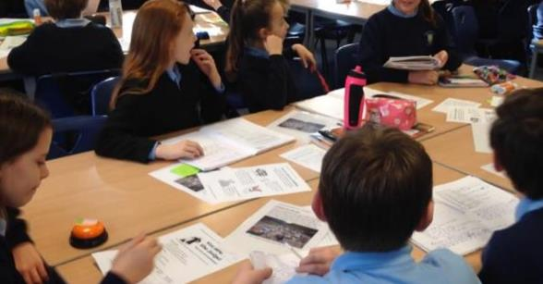
Year 7 debate about the impacts of melting glaciers. The ‘judge’ and chair is at left, with a handy buzzer to call “Order!”
You can download materials for this lesson via this link (Lesson 6). I loved doing this with the Year 7s, they were very good at it – often better than the older students at times! I always believe in building independence culture and critical thinking skills from the offset, so it hopefully becomes second nature by GCSE.
Decision Making Exercise Preparation: “Dragon’s Den”
Again, we started this in the days of lettered grades, when the OCR decision making exercise (DME) was its own exam. It was one idea of a few to attempt to raise achievement. It worked really well so it became a regularly used tool to build decision-making and analysis skills. Students were placed in teams to work on a decision-making activity, where their decisions must involve aspects that examiners will look for in an exam. One team of students are given prep-time to become Dragons (i.e. examiners), they use assessment for learning and decision-making activities in past lessons to guide them. The Dragons could be random, or selected based on their aptitude for decision-making or exam technique, and so being a Dragon is a method for them to model best practise for their peers. The teams each present their decision to the Dragons, who then give feedback based on what an examiner would look for (throwing in the “I’m in/out” for show!).
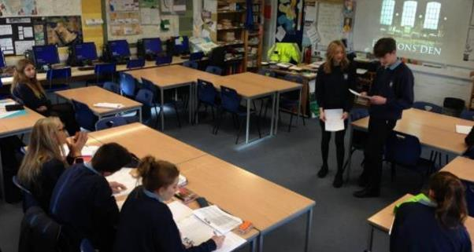
GCSE students presenting their decisions to the ‘Dragons’, a panel of their peers
This approach proved to be popular with students, indicated by very positive feedback in student surveys and debriefs.
Student directed and initiated
This is the first rung where a leap of faith and trust is needed in youngsters. There is an element of risk involved and for most teachers (including myself), a step out of the comfort zone. Some level of adult guidance may still be necessary, especially when it comes to set requirements such as preparation for exams.
GCSE Controlled Assessment data collection trip to North Norfolk Coast (2016)
Giddy on the apparent success of generating student ownership over the controlled assessment, I thought let’s try to push the boat out further. Afterall, yet more reforms were around the corner and I wanted to try something out that could be done whatever approach to fieldwork we had to take. Taking a deep breath, our department gave almost all control of fieldwork over the students, leaving us staff pretty much logistical support only.
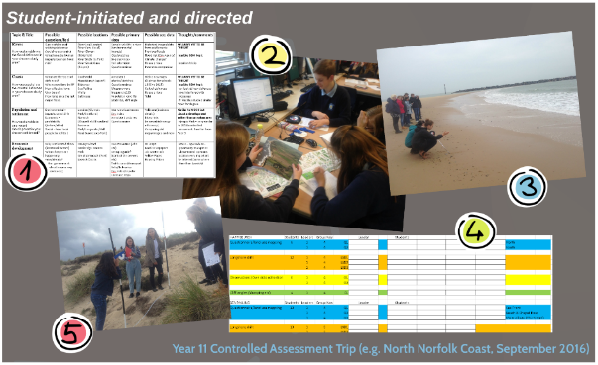
Due to GCSE criteria needing to be met, guidance from staff was needed at first, ensuring that location and topic chosen meets requirements (number 1 on the image above). But after that, it was over to the students. Students chose their own objectives to investigate, while use teachers acted as consultants to help them judge whether or not they would help to answer the overall question, supplied by the exam board. Then, students researched possible primary and secondary data, including setting up their own online questionnaire (2).
The student leaders, who were to lead their peers in groups, wanted to have a pre-visit to test out fieldwork techniques in advance. This was agreed to be done on a Saturday before the full trip (3). This trip was used to refine data collection methods and complete the risk assessment.
The student leaders assigned themselves to lead data collection teams, and the other students signed up to the teams they felt would be most relevant to their chosen objectives (4). On the trip, the leaders led their peers in data collection, ensuring participation and quality (5). Our role as staff was to supervise and advise on ad-hoc basis, but leaders had to initiate.
I have to say, that field trip was both one of the best and worst experiences of my career. The latter being of my own making through anxiety and fear if something went wrong. The controlled assessment fieldwork was worth 25% of their GCSE. Screw that up, and that’s could mean a drop of a grade or two. But I was left delighted by not just the way the student leaders conducted themselves, but also how their peers responded. Only once did I have a very minor complaint from a leader than someone in their group wasn’t pulling their weight, and it only needed a quick chat to sort out – especially when I asked that student would he like to do his data collection with me instead. No brainer!
A tangible outcome giving anecdotal evidence this was worthwhile was one of the leaders got a ‘B’ for his write-up, whereas historically he struggled with investigation work, never surpassing a ‘D’ or equivalent. Needless to say, the pride I felt in the students over the whole process is something I’ll never forget.
Student & faculty partnerships with decision making
The top rung. From the outset, I’ll state that it does not mean a total monopoly by students, put instead is a partnership with staff. On this rung, students aren’t just leaders, they are full decision makers that can inform direction and outcomes. After all, isn’t this type of engagement a model of social sustainability? We should practise what we preach (teach)!
The ‘Geography Leadership Team’ (GLT)
The ‘Geography Leadership Team’ is embedded in official department policy. This is important to avoid ‘tokenism’, as departmental policies usually are vetted and approved by the Senior Leadership Team. Here’s how it worked.
The team to manage and direct the Geography department consisted of a committee of the HOD, the teaching staff, and student leaders. The student posts lasted a year, from Easter in Year 10 to Easter in Year 11, and any student in Year 10 taking GCSE Geography could apply. We treated as voluntary employment, obtained through a non-discriminatory application process. In fact, students who were successful applicants were encouraged to include the post on their CVs as employment, and I as HOD would effectively be their line-manager. We aimed for 10% of the GCSE cohort (e.g. 50 Y10 students in cohort = 5 leaders).
Responsibilities included attendance at all department meetings and events (e.g. Open Evening). Confidential and sensitive items aside, they had full input into the development and evaluation of formal processes and documents, such as the Department Improvement and Development Plan and self-assessments. They were involved in staff appointments, interviews and department reviews. Helped to develop curriculum through research, topic and lesson ideas. When choosing which of the new 9-1 specifications to follow, they had the weight of the choice after a number of meetings to make an informed decision and gather the opinion of their peers. And, of course, they represented the voices of their peers and worked to resolve issues. Quite often, a student may not have felt comfortable raising an issue to an adult, but they did to a student member of the GLT, who then brought it up in a meeting.
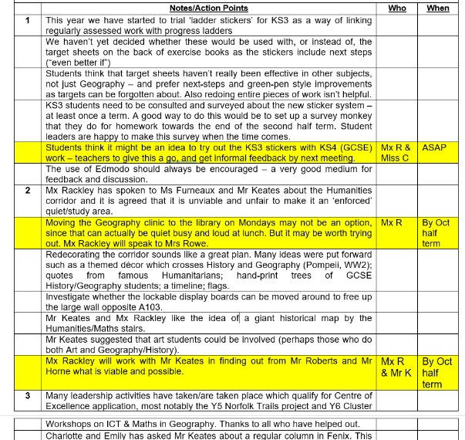
An example of departmental minutes, showing the contributions of the student members of the Geography Leadership Team.
Evidence for outstanding practise
All of the examples I have given above were part of our successful bid to apply to the Geographical Association’s Centre of Excellence Award in 2016.
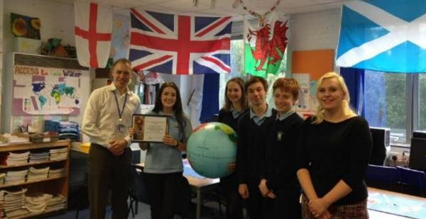
Members of the 2016-17 Geography Leadership Team with the Geographical Association’s ‘Centre of Excellence’ Award.
A quote from ex-student and GLT student member Eleanor Crossland was used in the application. Eleanor said that as a young person who had been involved in almost all the examples “…I would say that being trusted with the responsibility to lead an activity or even a lesson is a massive confidence boost, as well as helping to develop invaluable leadership skills for the future. One of the most important things I value in a teacher is their willingness to treat you like an adult from the age of 11, and by being asked to lead things in the classroom or taking part in decision making certainly makes me feel more like a person as opposed to a grade.” Eleanor has since graduated from St Andrews University in Edinburgh and is about to embark on teacher training. I wonder where she got the taste for that idea from!?
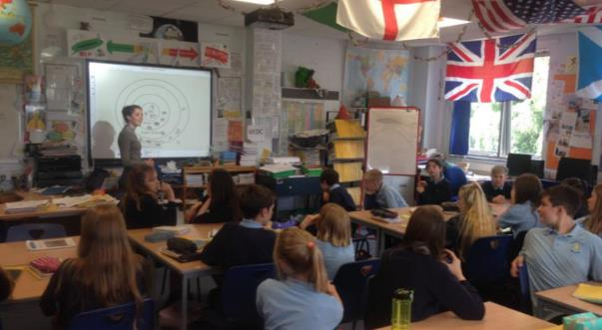
Eleanor Crossland teaching a Year 7 class about urban land-use. Part of a bespoke ‘mini-PGCE week’ arranged for her, before she embarked on an undergraduate course.
Things to ponder
None of the above went without a hitch, of course. But it was all part of the process and fun trying it out. There was great support from SLT, and even if things did go wrong, safeguards were in place that the worst that could happen was a deep learning experience. I left the classroom in 2017, and had these questions left to explore or ponder:
- How much further could the Geography Leadership Team go, in terms of being almost totally student-led? How can trust and autonomy be maintained to avoid ‘tokenism’?
- Which responsibilities can be totally student-owned with almost complete ‘hands-off’ from staff?
- How to manage conflict and disruption to other responsibilities and things young people need to do? They gave up their own time to attend meetings, for example, and there are only so many homeworks-in-lieu you can give before risking interference with their studies.
- Was treating the GLT post akin to a part-time volunteer job realistic and appropriate? Could students be paid? If so, would they need to be bound by a contract?
- Where should the ‘emergency brake’ be where staff step in and ‘take control’? Are more ‘breaks’ needed as you move up the latter?
- Are any of the examples provided above simply not possible in some schools? Or are all of them possible if the right culture is fostered, and support given from management?

You are more than welcome to contact me regarding student partnership, perhaps even arrange an online consultation? Perhaps you are going for the GA SGQM/CofE – this can help! Get in touch via the ‘Contact’ page at https://www.geogramblings.com.
References:
- FEHS Geography Leadership Team, Various student surveys/meeting minutes etc
- Hart R. (1992), Children’s Participation: Tokenism to Citizenship, New York, UNICEF
- Juicy Geography, Montserrat eruption role-play (http://www.juicygeography.co.uk/montserrat.htm)

