Information Sheet: Taiwan
Where is Taiwan?
Taiwan is an island in the Pacific Ocean off the coast of China. The capital city is Taipei.
How big is Taiwan?
Taiwan covers an area of 36,000 square kilometres.
How many people live in Taiwan?
Taiwan has a population of 24 million people
What is the religion in Taiwan?
The main religion is a combination of Confucianism, Taoism and Buddhism.
What language do the Taiwanese speak?
The main language in Taiwan is Mandarin.
What is the history of Taiwan?
In 1927, Civil War (a war with different sides within the same country) broke out in China. There were two sides – the Nationalists and the Communists. Following the Japanese invasion of China 1937, the Civil War was put on hold between 1937 and 1945. After the defeat of Japan in 1945, fighting broke out again with the Communist Party claiming victory in 1949. The Nationalists fled to the island of Taiwan in 1949.
Starting from 1987, Taiwan started to become a democracy with the first elections for a president happening in 1996.
Taiwan’s official name is the Republic of China. It is a relatively wealthy country and it is sometimes known as an “Asian Tiger”. Taiwan has a large military that acts as a defence against China.
What problems has Taiwan faced recently?
The People’s Republic of China (mainland China) does not recognise Taiwan as a country and claims that it belongs to China. The Chinese government has threatened to invade Taiwan and refuses to allow Taiwan to join organisations such as the United Nations and the World Health Organisation.
Taiwan is only recognised as a country by 14 other countries. Many countries do not recognise Taiwan because of pressure from China.
What do the Taiwanese people want?
Many Taiwanese people want their country to be recognised as an independent country. They want Taiwan to fully participate in the United Nations.
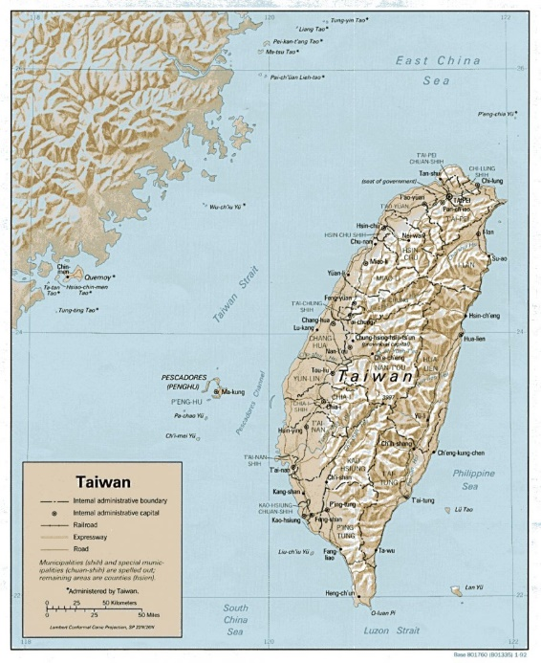
Source: https://unpo.org/members/7908
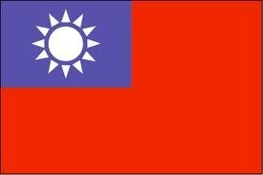
Source: https://unpo.org/members/7908

