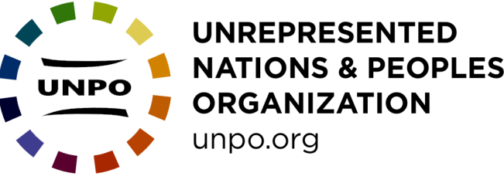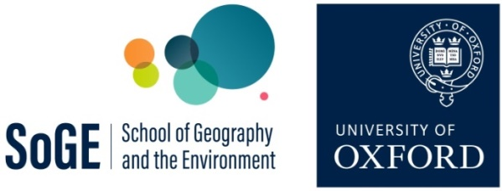

Debating Global Governance: “Model UNPO” role play
Learner Activity Sheet
In this enquiry on global governance you are going to investigate the situation of one community where there are issues around representation, rights and self-determination.
In the final lesson, you will be invited to a meeting of the Unrepresented Nations and Peoples Organization (UNPO). You will take on the role of representing a UNPO member and putting forward their case alongside other nations and peoples.

Preparation for Model UNPO
The UNPO is an umbrella organisation of over 45 unrecognised political communities which are currently denied access to international forums (www.unpo.org). These communities include stateless nations, governments-in-exile, national minorities and indigenous peoples. What they have in common is a desire for self-determination (whether that be independent statehood, autonomy or the protection of cultural, political and human rights), and a commitment to non-violence, democracy and human rights.

‘Model UNPO’ is loosely based on ‘Model United Nations’ simulations, but instead of participants being assigned roles as representatives of nation-states and enacting UN meetings, they are designated roles as representatives of stateless nations, indigenous peoples, and minority communities. Participants research their assigned non-state actor and then simulate a debate of the UNPO’s General Assembly based on pre-established rules of procedure.

Your group will be assigned a UNPO member. You are diplomats of this UNPO Member: during the exercise you will represent the views of this community/ government, and reflect the community’s national interest, not your own personal opinions. It is up to you how you divide up jobs within your group, both in terms of preparation and speaking during the exercise.

Before the Lesson:
- As the representative of ____________ create a brief fact sheet that can serve as a reference resource during the debate and be circulated afterwards as a case study. The fact sheet should include issues faced by that UNPO member as they relate to the topic of the debate. It can also include the following information about the UNPO member:

- Location, territorial size and population size:
  - Where is your polity located?
  - What territory does it claim?
  - What are the important states in the surrounding area?

- Recent history and political environment
  - What has happened recently regarding your polity?
  - Have there been any political development which affect your polity?
  - Have there been any recent conflicts?

- Economic Situation

- What your polity is aspiring for e.g. independent statehood, autonomy within another state, greater cultural and political rights.

- Obstacles to good governance

- Alliances and/or tensions with states and other political actors (e.g. supportive states, host states, occupying states)

Suggested resources for each UNPO member are freely available here: https://linktr.ee/munpo

- Your group should prepare, and rehearse, a two-minute speech to introduce your UNPO member to the group. Your speech should include:
- Your roles and who you represent
- The current situation in your community/homeland
- Your aspirations for self-determination
- A brief statement on your position in relation to the topic of the debate

Useful preparatory reading includes:
Anan, K. (1999) Two Concepts of Sovereignty, The Economist, 16 September 1999 http://www.economist.com/node/324795

Inman H. A. and Sharp, W. G. (1999) ‘Revising the U.N. Trusteeship System - Will It Work?’ American Diplomacy, September 1999:
https://americandiplomacy.web.unc.edu/1999/09/revising-the-u-n-trusteeship-system-will-it-work/

Moore, M., Ed. (1998). National self-determination and secession. Oxford, Oxford University Press.

UN, The United Nations and Decolonization:
https://www.un.org/dppa/decolonization/en

UN, The United Nations and Decolonization Documents
https://www.un.org/dppa/decolonization/en/documents

UN Office of the High Commissioner for Human Rights:
General Comment No.12 , the right to self-determination of peoples (Art. 1), 1984: https://www.uio.no/studier/emner/jus/humanrights/HUMR5508/v12/undervisningsmateriale/General%20Comment%20No12-self-determination.pdf

General Recommendation No. 21 , right to self-determination, 1996: http://hrlibrary.umn.edu/gencomm/genrexxi.htm

UNPO on self-determination: http://www.unpo.org/section/2/2

UNPO Membership http://unpo.org/members.php

- Based on the experience gained learning about your UNPO member, submit three draft clauses for a resolution which your teacher could select for discussion in the lesson. These clauses should relate to the broad theme of the debate but not be too specific to your case (i.e. they should stimulate debate with the other UNPO members). See below for examples of clauses.
Clause 1:

Clause 2:

Clause 3:

Stretch and challenge: Investigate the structure of the UNPO and consider how the organisation works as an alternative form of global governance.

Example resolution

General Resolution adopted by the Model UNPO General Assembly on [TOPIC OF RESOLUTION]:
[DATE AND LOCATION]:

Signatories: [LIST UNPO MEMBERS ATTENDING]

Preamble
The purpose of the preamble is to show that there is a problem that needs to be solved. It should set out the background to the broad theme of the debate but not propose any action.
Operative clauses set out what is to be done about the issue described in the preamble, and by whom (e.g. the UNPO, governments, UN bodies, NGOs). They should be numbered, can include sub-clauses (e.g. 1a, 2a, 3a), should each end with a semi-colon and start with a verb such as ‘accepts’, ‘affirms’, ‘calls upon’, ‘condemns’, ‘deplores’, ‘endorses’, ‘proclaims’, ‘recommends’, ‘reminds’, ‘supports’, ‘urges’. They should be organised in a logical progression, and each clause should be brief and contain a single idea or policy proposal
The Model UNPO General Assembly

Expressing its solidarity with UNPO Members and other communities subjected to any form of oppression, violence, and discrimination,

Reiterating all UNPO members’ commitment to the Organization’s fundamental principles: democracy, non-violence, human rights, self-determination, tolerance, and environmental protection as expressed in the Covenant,

Affirming the importance of ensuring that all nations and peoples have the opportunity to have a say in the decisions that concern their territory, culture, language, heritage, and environment,

The Model UNPO General Assembly:
Operative clauses set out what is to be done about the issue described in the preamble, and by whom (e.g. the UNPO, governments, UN bodies, NGOs). They should be numbered, can include sub-clauses (e.g. 1a, 2a, 3a), should each end with a semi-colon and start with a verb such as ‘accepts’, ‘affirms’, ‘calls upon’, ‘condemns’, ‘deplores’, ‘endorses’, ‘proclaims’, ‘recommends’, ‘reminds’, ‘supports’, ‘urges’. They should be organised in a logical progression, and each clause should be brief and contain a single idea or policy proposal
1. Challenges the UN position on territorial integrity and condemns its inability to authorise interventions in matters which are within the domestic jurisdiction of a member state when there are human rights violations;
2. Recommends the UN’s establishment of a mechanism that will effectively mediate in claims of self-determination which includes unrepresented nations and peoples;
3. Notes the importance of referenda for enacting the right to self-determination and calls upon the UN to assist in the peaceful running of referenda in disputed territories;
4. Calls on the international community to implement mechanisms that protect minority rights including language and cultural rights;
5. Demands all UN members to recognise acts of genocide when they occur, including recent human rights violations of Uyghur people in East Turkestan;
6. Encourages states to…
7. Recommends the UNPO to…

