The geography of Eurovision: ‘united by music’

Good evening, Europe! by Emily Lindley, geography consultant.

The Eurovision Song Contest has been a fixture of European relations and a symbol of peace since its introduction in 1956. Following a tumultuous period of European history in the first half of the 20th century fraught with political strife, world wars, and grand divisions both between and within countries, the contest was devised to ease these tensions and bring a much-needed sense of unity by the power of music.

Although the contest started with humble arrangements – only 7 countries, secret voting, and a winning Swiss entry of ‘Refrain’ from Lys Assia – the message remains very much the same as the 2023 slogan: ‘United by Music’. While plenty of the aspects of the contest show the beauty of unity and hope, it also exposes elements of discord that come from so many different voices from different backgrounds and cultures.
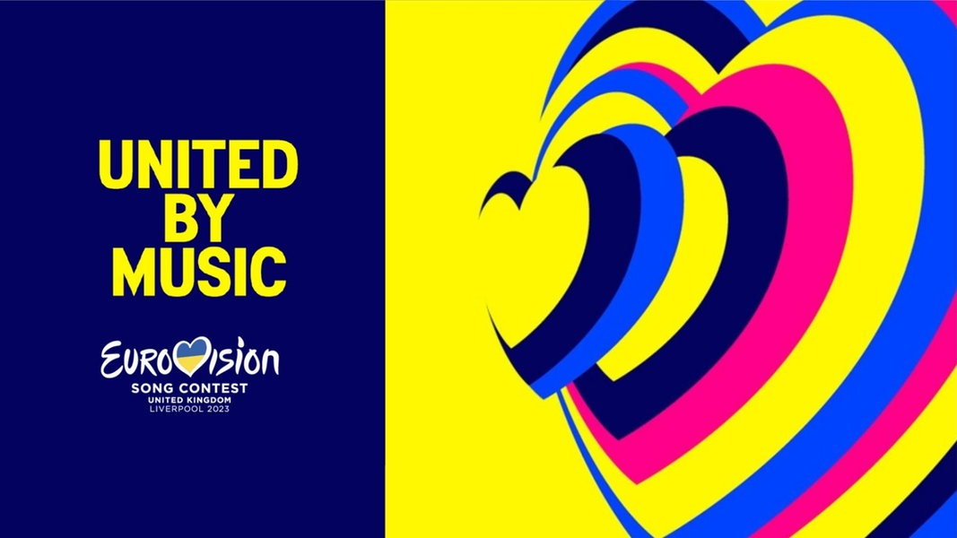
Figure 1 official logo and slogan of 2023 © 2011-2023 Eurovoix

The geographical links of Eurovision go far beyond simply locating European countries and a quiz on flags. Geopolitical relations between the different participants alone are an interesting geographical conundrum. The contest has consistently had to manage them since its conception.

The most obvious example is Russia’s current relationship with Europe. On the 25th of February 2022, the European Broadcasting Union (EBU) announced that the Russian act would not be allowed to participate that year, a decision made by the governing body of the contest, after consulting other EBU countries. The decision reflected the rules and values of the contest. If Russia had competed many worried about the social implications against the entire purpose of the contest.

Since 2014, many countries have made political gestures in their performances in support of Ukraine; Malik Harris of Germany wrote ‘I stand with Ukraine’ on the reverse of his guitar whilst Circus Mircus of Georgia opted for an official music video that displayed the message ‘Video unavailable: This artist condemns russia’s invasion of Ukraine’. As geographers, we understand the geopolitical situation but, in this instance, there is also a subtle political statement by the use of a lower-case ‘r’ for Russia which, in proper nouns of Soviet origin, was a sign of disrespect.

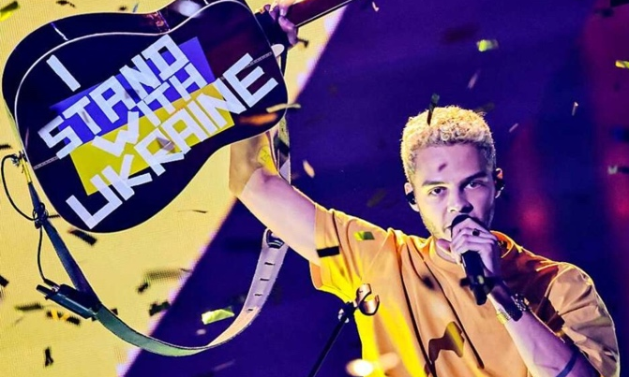
Figure 2 Malik of Germany in 2022 © Hannibal Hanschke, Badische Zeitung

The Eurovision Song Contest has regularly revealed bubbling tension between participating countries over the years. A notable example would be the run up to the 2016 event. In that year Ukraine selected Jamala in their national final with a song called ‘1944’, the lyrics of which detailed the struggles of the ethnic Tatar population in Crimea (Russia invaded and annexed the Crimean Peninsula from Ukraine in March 2014). Pro-Russian officials accused the entry of being blatant ‘political speech’ claiming the song cast shade on Russia’s political actions in Crimea. In response, the EBU tweeted that the song did not break any rules and allowed it to remain. Jamala went on to win the 2016 contest, further stoking antagonism between Russia and the rest of Europe.

Similar political tensions were evident in 2019 in Israel, when the Icelandic act Hatari held up a Palestinian flag as the camera panned over them for their point score. This along with several political statements over Israel’s occupation of Palestine in the run up to the final resulted in a €5,000 fine to Iceland’s broadcasting union.

Entries have also been banned or substantially altered for other geopolitical themes. For example, in 2008, the disqualification of Georgia’s entry ‘We Don’t Wanna Put In’ occurred as Russia protested about the reference to President Putin and the invasion of Georgia. Whilst in 1968 the winning entry for Spain was silenced as the Catalonian singer, Joan Manuel Serrat, refused to sing in Spanish (and was quickly replaced by another performer called Massiel). A clear act of linguistic discrimination and state repression during the Franco regime.

The voting process has taken many forms over the contest’s lifespan. Historically a set of juries from the participating countries made the final decision until, in 1997, televoting was introduced. Now both approaches are used in an ever-evolving system; the famous ‘Douze Points’ being made truly iconic from 1975 onwards. The general pattern of Eurovision’s voting is infamous due to its political nature. Voting blocs are an ever-present entity from year-to-year with, for example, even non-seasoned Eurovision viewers being unsurprised when Greece gives Cyprus its highest points. The voting blocs represent the deeply embedded relations between certain European countries. These neighbourly relationships concern energy transfer, trade agreements, or even shared histories; Northern Europe and the South Balkans show some of the strongest relationships in voting. These patterns in voting can also reflect global events and the resulting reaction from the European community.

In 2003, the UK sent the pop group Jemini to represent the UK and promptly received the country’s first ‘Nil Points’. Regardless of the sub-par live performance and lack of ambition, many speculate that the vote was of a distinct political nature due to the UK’s involvement in the invasion of Iraq that same year. Similarly, in 2019, the UK also placed last with Michael Rice with many Eurovision sceptics blaming the major loss on EU-Brexit negotiations happening at the time.

Despite all this potential for discord, the contest remains a symbol of hope and unity. Eurovision gives people from all over the world an immersion into different national cultures every year. The contest is nearly always hosted in the previous winner’s country, allowing many different cultural identities to come to the international stage, watched by an average of ~180 million people each year. Although the UK currently holds the record for hosting the contest a total of 9 times (including this year), a total of 26 different countries have had the honour of hosting.

Introduced in 1970, visual ‘postcards’ have been used to introduce the participating country and allow for stage set up. These postcards usually feature aspects of the host country’s place identity such as distinctive landscapes, cultural icons, and traditional features of their social background. For example, in 2014, Denmark made postcards featuring public acts of celebration involving their national flag, all showing creative ways to replicate ‘the Dannebrog’. Finland has used ice to invoke a sense of Far North, Germany has utilised traditional desserts and sweets, and caprese ingredients have been used to represent Italy. Another idea has been the creation of the Union Jack out of postal vans and double-decker buses (in 2014), producing an iconic image often associated with England.

Above all, Eurovision has allowed participating countries to show pride in their identity through the songs and performances they put forward each year. When it comes the use of instruments in the contest, one might be tempted to jump straight to Alexander Rybak’s violin entry in 2009 but instruments have had a long, rich history in Eurovision. An orchestra was a staple of the contest until as recently as 1998. Since then, all instrumental music must now be pre-recorded but this has not stopped a range of unique instruments making an appearance, all of which represent the participating countries. In 2010, Eva Rivas performed with a Duduk which is the national instrument of Armenia, and in 2021 Ukraine’s Go_A featured the Sopilka which is a woodwind instrument prominent in Ukrainian folklore (something that was used again in 2022).

Traditional clothing has also served a purpose in representing different countries and exposing others to the variety of cultural practices across Europe. An obvious highlight for any Eurovision fan would be Russia’s 2012 entry Buranovskiye Babushki otherwise known as the ‘Grannies’. This act involved 8 elderly Russian women from Buranovo who performed wearing traditional North Udmurt costumes. Monique Melson is another example, who performed in 1971 wearing stockings and lederhosen indicative of Luxembourg, Whilst in 2022 Kalush Orchestra’s winning performance also involved traditional clothing, as they wore Ukrainian Kaptar and Serdak jackets as well as Vyshyvanka shirts which have since become extremely popular across several European countries.
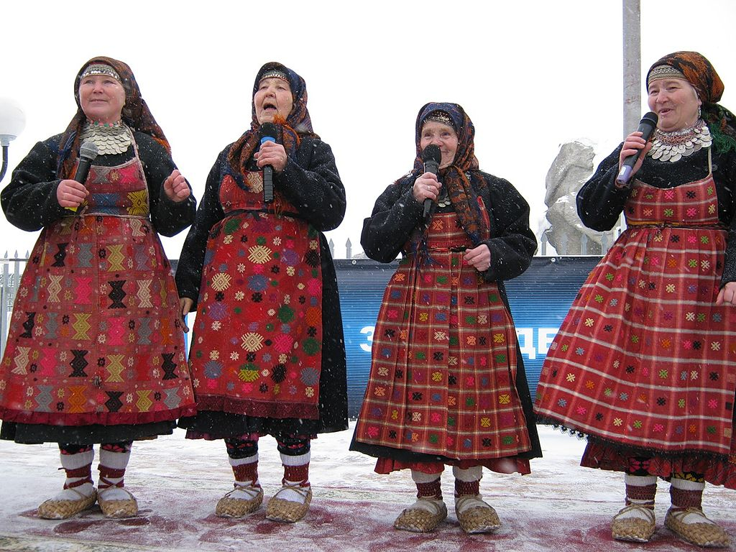
Figure 3 Buranovskiye Babushki traditional costumes in 2012 © Лариса Горбунова, Wikimedia

Since 1956, a key point of all the contests has been the use of a wide variety of languages from across the participating countries. Over the years, new languages have entered the competition and have revealed interesting insight into the histories and evolution of some national identities. In 1996, Breton was used for the first time, a Celtic language used in Brittany since the 1st century. In 1980, Arabic was profiled in Morocco’s only entry ‘Bitaqat Hub’, and in 2020 Israel’s Eden Alene sang part of the song in Amharic to acknowledge the Ethiopian Jewish population within Israel.

Despite the controversies of geopolitics, voting practices, and contested representation, Eurovision remains hugely popular around the world. It is a celebration of the enormous variety of cultures across Europe (and beyond). In 2022 alone, ~161 million people tuned in to watch the grand finale. In 2003, the popularity of the contest led to the creation of ‘Junior Eurovision’ an international song competition for children. Importantly, this new spinoff has highlighted the presence of climate change anxiety within Generation Z, with songs each year being sung about the climate crisis and the harm we are causing to the natural world, a theme that is often ignored in the adult contest.

With the messages of peace for Ukraine rolling in as we approach the 2023 competition final, can the contest live up to its original purpose for Europeans – as well as this year’s theme – to be ‘United by Music’?

