Demographics in Venice: Demographics and population factsheet
Graphs, diagrams, and the sources follow the tabulated information
QUESTION THAT THE PARAGRAPH ANSWERS | KEY POINTS | PARAGRAPH  Main focus 1951 to today, compiled by Frederica Ursotti and Angelica Girardi, with research by Alice Sanguin, Bianca Illing, Arthur Chatto
How has the population of the municipality of Venice been changing?  How much has the resident population in the historic city of Venice declined in the last 60 years? | >municipality of Venice  >demographic decline  >moving from Venice to the mainland | Venice grew slowly from 130,000 in 1861 to almost 175,000 people in 1951 (when the entire municipality of Venice, lagoon and mainland was 316,000) but since then the city has almost collapsed, with a migration from the city on the water to the cities on land, Mestre and Marghera. The total population of the municipality reached its peak in 1968 at 367,832, although the population of the historic city of Venice was declining by then. In 1961 Venice had lost 20% of the population just a decade before, and another 20% ten years later. In 1981 the population was just over half of the 1951 level, and now the population is just under 60,000 (the figure of 60,000 was regarded as the next significant benchmark in the demographic decline), about 1/3 of the 1951 population.  Industrialization at Marghera on the edge of the lagoon was flourishing. Most Venetians have moved to the mainland nearby, the towns of Mestre and Marghera, where you can live a “normal” life, with a house, a car, shopping malls and all the other modern amenities you don’t have easy access to in the lagoon. The population of Mestre and Marghera has grown even faster than the decline in Venice, but with a recent drop. Population in the lagoon (on the islands and the estuary areas) also continued growing until the late 1960s, although it has been stable since then.  Resident age distribution in the historic city and lagoon islands is becoming increasingly old. About 35% of people are 60+.  Taken alone, the municipality's official figures would appear to confirm the widely held belief that Venice is shrinking. It has shrunk by a further 9% since the beginning of the century or a net average loss of about 1,500 people annually since the year 2000.  But the real population of Venice includes many others who "inhabit" the city, albeit less officially - the numerous tourists and day-trippers who collectively make heavy demands on the city's infrastructure.
What is the decrease in population due to? | >decrease in population  >low birth rate  >high death rate  >emigrants and immigrants | Compiled by Francesco Bellati, Francesca Drago, Alice Sanguin  The decrease in population is not an exclusive characteristic of Venice; indeed it involves the whole of Italy and particularly the urban areas of the northern and central regions. Yet in the long run it is the migration gap more than the natural decrease which influences the decline of population in Venice, causing remarkable changes in the structure of age groups and in family composition.  The macro trends which stand out from the evolution in Venice’s demographic structure relate to:  the low birth rate;  the high death rate, which in the last twenty years has become more than double of the birth rate;  the steady predominance of emigrants over immigrants;  More recently, together with a high death rate per 1000 inhabitants (due to the high percentage of elderly people) there is also a slow but progressive minimization of the negative gap between those born and those dying. Another observation is a decline in the migration gap, attributable to an absolute and relative growth of people who come to live in the city.  Differently from what happened in the recent past, nowadays the demographic crisis is more due to the natural gap (natural decrease).
Historic population change: what was the Venice Republic very successful in that enabled its population to grow?  What impact have plagues had on the population of Venice? | >success in trade and shipping  >plague deaths impacted each individual city in Italy  >the plague killed 80,000 in 1680  >Plague decimated the population of Venice / easier for Napoleon to overthrow it | Compiled by Francesco Bellati, Francesca Drago, Alice Sanguin  Because of its success in trade and shipping, the Republic of Venice had grown into a city of substantial wealth and prosperity by 1630. Venice enjoyed the advantage of being a port city and had built its economy on maritime trade routes. The Venetians had outdistanced Genoa, their fiercest competitor to become the most important mercantile power in the Adriatic. The Venetian Republic had bested its competitors because the government led efforts to increase the wealth of the Republic including signing treaties for peace in the region, balanced against building up the military fleet to protect is mercantile interests.  Wealth and prosperity did not stop bubonic plague. The anatomy of the plague itself was an important factor as well as the fact that medieval physicians possessed a limited understanding of plague and could do nothing to cure it. Between 1350 and 1700, over 100 epidemics of plague swept over the world, especially over Asia, Europe, and Russia. Historians estimate that about 75 million people died, one third of them in Europe. The plague came in three varieties, bubonic, pneumonic, and septicaemia. The most visible symptom of bubonic plague is painful. Bubonic plague can progress into two other forms called pneumonic and septicemic. Modern scientists have discovered that bacterium Yersinia pestis causes bubonic plague.  Severely reducing the populations of the Medieval world, the plague is believed to have originated in China, although recent studies contend that its origins were in Egypt. Rats and fleas hitchhiking on ships spread the bubonic plague westward to Europe along the Venetian and Genovese trade routes.  Venice had experienced 22 outbreaks of plague between 1361 and 1528. The plague of 1576-1577 killed 50,000 in Venice, almost a third of the population. The 1680 version of the plague was just as deadly. In just seventeen months, 80,000 people in Venice died of the plague. On November 9, 1680 alone, 595 people died.  Plague decimated the population of the Republic of Venice in 1680. This led to weakening of the Republic thereby setting the stage for its eventual subjugation by Napoleon in 1797.  In the 17th century, Italy’s political structure differed from that of other European states. Italy was composed of separate city states and each city state managed the ravages of the plague individually. These individual city states often cooperated and worked together, but the plague deaths impacted each individual city state more heavily than it did centrally organized countries like France.
What kind of decline has Venice experienced beginning from the 17th century?  What did it retain in the years to come? | >17th-18th centuries → decline of Republic  >Its maritime activities fell prey to foreign competition  >Venice remained a powerful symbol of freedom and prosperity | The 17th and 18th centuries in Venice saw the gradual decline of the Republic. Venice lost its status of a Mediterranean power as well as its prominent position in international trade and politics. Its maritime activities and once prosperous industries stagnated or fell prey to foreign competition, especially to the Dutch and the English, who gradually surpassed Venice in shipbuilding, in navigation, and in the spice trade.  Nevertheless, Venice retained most of its cultural and social vigour throughout the period, and, in the eyes of the foreign visitors who flocked into the city in ever growing numbers, it remained a powerful symbol of freedom and prosperity as well as the cultural centre of Europe.

Sources:
http://www.myvenice.org/Demographic-trends-of-Venice.html
http://www.venipedia.org/wiki/index.php?title=Demographics
http://www.tuttitalia.it/veneto/40-venezia/statistiche/censimenti-popolazione/
http://www.ibtimes.com/venice-tourism-debate-2015-residents-fear-visitors-are-destroying-their-city-demand-2063682
http://windowstoworldhistory.weebly.com/the-plundering-plague-and-the-downfall-of-the-republic-of-venice.html
http://venus.unive.it/macellosangiobbe/popolazioneve.htm
http://nuovavenezia.gelocal.it/venezia/cronaca/2015/02/23/news/da-175-000-a-56-000-abitanti-cosi-si-svuota-venezia-1.10921951?refresh_ce
Graphics
- Census recordings of the resident population of the municipality Venice for decades spanning 1871 to 2011
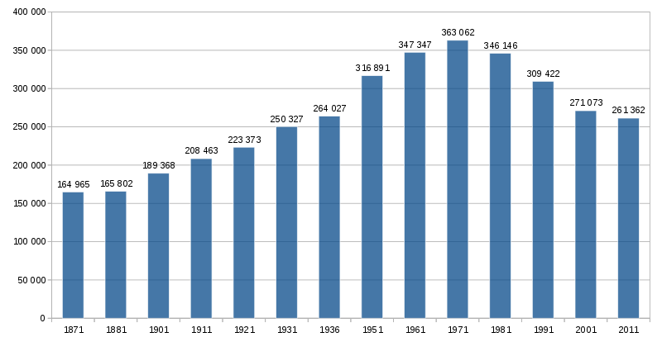
Population of Venice in 19th-21st Centuries © Wikimedia Commons

- Resident population trend in the historical centre of Venice spanning 1540 to 2015:

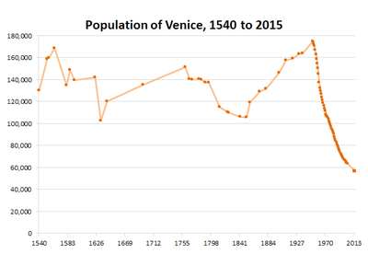
Population of Venice 1540 50 2015 © Venipedia

- Resident population of the historical centre, the lagoon and islands (Estuario) and the mainland (Terraferma) from 1921:
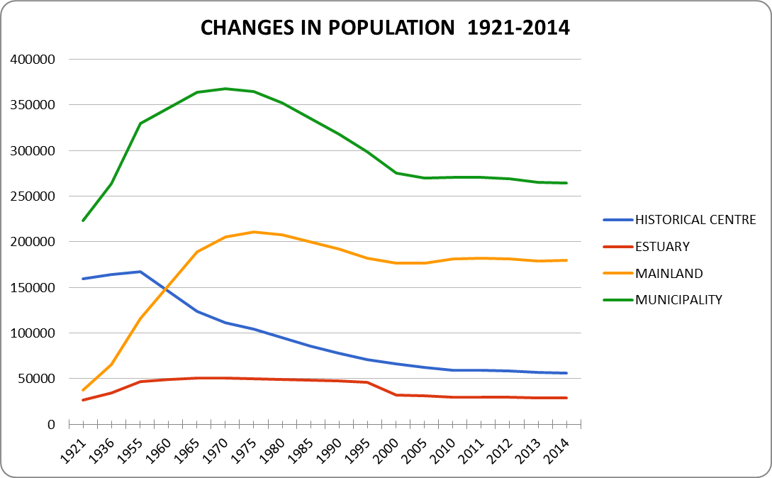

- Resident population of the historical centre, the lagoon and islands (Estuario) and the mainland (Terraferma) from 1880:
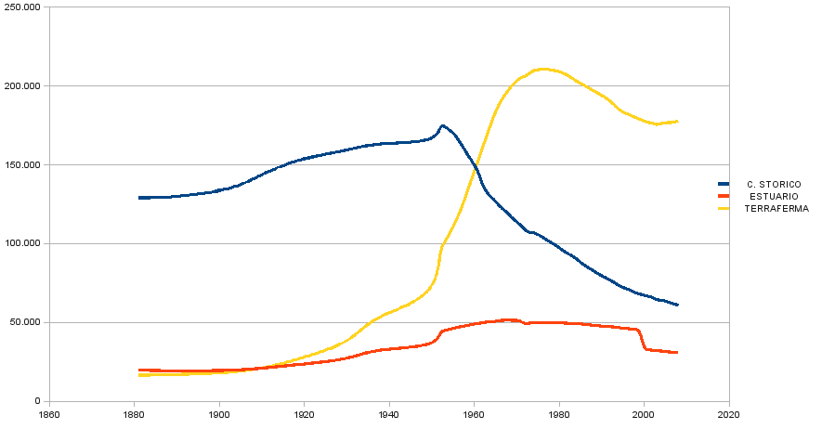
http://rene.seindal.dk/2009/03/12/theme-park-venice/

- Data on household size comparing the historic city with the other lagoon islands and with the whole municipality (from the Venice Report 2009):

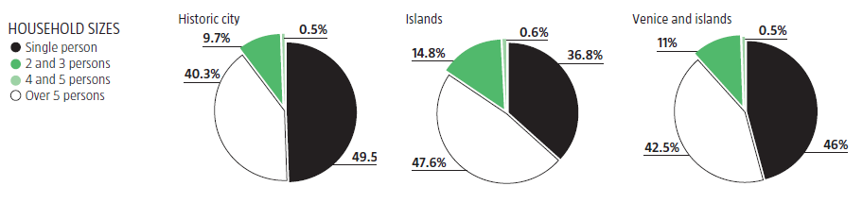
Household sizes in Venice © Venipedia

- Data on average daytime population compared with total number. For example, note that in the chart below it is estimated that on average about 54,000 tourists each day were in the historic city and surrounding islands in 2008, compared with a total of about 20 million tourists visiting in that year (from the Venice Report 2009):

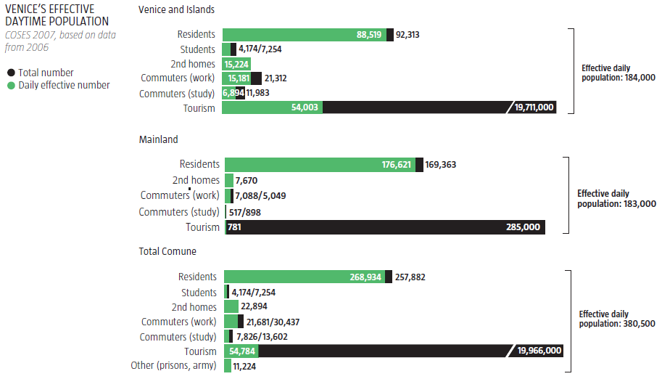
Venice’s effective daytime population © Venipedia

