Tourism Factsheet
Graphs and diagrams and sources to follow tabulated information

Demographics in Venice

QUESTION THAT THE PARAGRAPH ANSWERS | KEY POINTS | PARAGRAPH  Compiled by Bianca Illing, Marta D’Este, also research by Pascal Tchen, Max Vaughan, Eva Mariotto, Catalina Josanu, Francesco Bellati, and Francesca Drago, Tom Austen, Laith Belkacem
What impact has tourism had on the types of shops found in Venice?  What impact on housing? | >tourism  >economic resource  >practical problems  >residential shops  >open-air museum | As everyone knows, tourism is the main economic source for Venice and it is fundamental to the local job market. (About 30% of private sector employment is in hotels and restaurants.) At the same time this constant flow of people is putting a lot of strain on the city. First of all residents are forced to move to the mainland, such as Mestre or Marghera; the loss of the typical shops is taking place as well, caused by the increasing number of tourists, much higher than the local people. These shops, even supermarkets, are now replaced by souvenir shops or other tourist attractions.  In some areas, the tourist:resident ratio can be 600:1. Essential services are lost as commercial activities increasingly cater for tourists.  The city is turning into a huge living museum with all the changes involved in this process.  “Many people think that Venice will turn into ‘’Disneyland’’: a theme park only for tourists without any population in it, so visitors will be able to visit the city during the “opening hours” and leave at “closing time.”  Since 2000 annual increase in residential house prices in the historic city has been 11.21%, driven by international buyers. Many buildings are bought to be converted into hotels and souvenir shops. Locals find it increasingly difficult to afford to live in the city.
What impact has the tourism had on public transportation? | >unsustainable tourism  >rapid increase  >public transportation issues | The number of tourists visiting the city of Venice has been rapidly increasing, verging on unsustainable, especially during the summer months. The amount of tourists that come on average every day to visit Venice is now higher than 60,000 - more than the entire resident population of the city.  The public transportation network consequently has many issues. It has been estimated that cruise ship passengers increased public boat use by a factor from 2 to 4 at most. These data may prove essential to further understanding how tourism, as well as the extensive public boat system, might be modified to ensure the continuing health and prosperity of Venice.
What impact have cruise ships had on the city? | >Impact of cruise ships on the city  > UN’s intervention in the situation | Venice is a wonderful city, but at the same time it is really fragile; for that reason cruise ships are damaging the living heritage of Venice. Groups like UNESCO explain that the ships cause waves that erode the foundations of buildings, contribute to pollution and have an impact on the cityscape as they dwarf the city’s monuments.  The situation has been analysed by the UN and it has been decided that Venice will be placed on UNESCO’s list of endangered heritage sites if Italy fails to ban giant cruise ships from the city’s lagoon by 2017, the United Nations has warned.  Development was also causing irreversible changes to the delicate ecosystem, it complained, stressing a lack of architectural and town planning coherence.  There has been a 439 percent increase in cruise dockings in the past 15 years, according to statistics from the Venice Passenger Terminal. This port is now the most popular cruise destination in Europe. Indeed a fact-finding mission to Venice by UNESCO officials in October 2015 found that the capacity of the city, the number of its inhabitants and the number of tourists is out of proportion and causing significant damage.
Are cruise ships important from an economic point of view? | >cruise ships as an economic resource  >Venetians employed by cruise ship related jobs  >Debate between environmentalists and business people  > A possible solution | Giant cruise ships which disgorge thousands of tourists in Venice every day are of course putting the city at a very high risk, but there is another point of view to be considered.  According to the Cruise Venice Committee, cruise-ship passengers spend around $194 million annually in the city. More than 650 ships make their way in and out of the city’s passenger port each year, and each ship brings an additional $324,000 to those who man the port and supply the ships with provisions.  Each ship provides additional income from docking fees and purchasing supplies such as food and water from local contractors. The cruise sector also employs an estimated 3,000 Venetians  "It's a paradox, because tourists are very important for the economy of Venice”  The debate between environmentalists and business people has been going on for very long and solutions have been researched.  An alternative solution being considered by the ministry of the environment is to build a fully reversible structure at the Lido entrance to the lagoon and bring the cruise ship passengers into the Venice port on special boats designed to produce almost no wake and no polluting emissions.
What’s the overall impact of tourism in Venice? And how do residents feel about it? | >twenty million tourists in 2008  >ill-mannered tourists  >Venice = Veniceland (amusement park, Disneyland)  >every given day residents are outnumbered by tourists  >bad behaviour – sleeping on bridges, swimming in canals, tagging churches with graffiti | Compiled by Francesco Bellati, Francesca Drago, Alice Sanguin  Venice is one of the world’s most visited cities due to its legacy of beautiful and historically important art.  In 2007, it was estimated that on average over 50,000 visitors came to Venice each day (about 20 million over the year), and this trend has increased as the years have passed.  This large amount of tourism traffic has caused many issues in Venice.  An influx in recent years of ill-mannered tourists, who locals say treat their hometown like an amusement park, has led some to give it a new name: “Veniceland”.  Venice welcomes millions of tourists every year, and on any given day in the summer its residents are outnumbered by visitors. With few industrial opportunities existing in the island city, tourism has long been one of its main sources of income. Most of the revenue is earned through hotels, museums, restaurants and tours.  However, as tourists increasingly exhibit bad behaviour - sleeping on bridges, swimming in canals and tagging churches with graffiti - some Venetians fear the visitors who keep their city alive could also be those who are slowly destroying its culture and history.  Venice’s tourism problem has existed for many years, and it has never been properly addressed by city officials or governmental entities, according to locals. Most Venetians welcome tourists, but they want to see authorities set out strict guidelines to manage their numbers. “It’s an outdoor museum,” said Celeste Bueno, manager of the ArtViva tours group that encourages tourists to appreciate Venice through private walking tours that delve into the city beyond the guidebooks. “Pretty much everything you see around has some cultural, historical, artistic value. This has become like a Disneyland.”

SOURCES
http://www.venipedia.org/wiki/index.php?title=Demographics
http://rene.seindal.dk/2009/03/12/theme-park-venice/
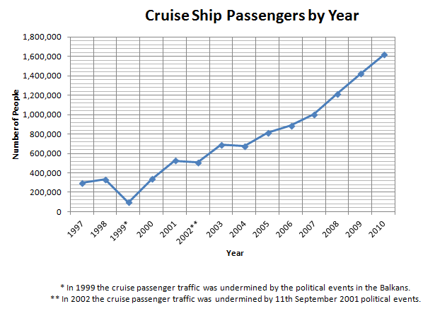
Cruise ship passengers by Year © Wikimedia Commons
More graphics on the next page

FURTHER GRAPHICS
Researched by Eva Mariotto and Catalina Josanu

- Estimated annual number of visitors to the historic city and islands:

- Estimated average daily number of visitors to the historic city and islands:

