Migrants on the Margins
- Halgans’s Story - Resource linked to the video
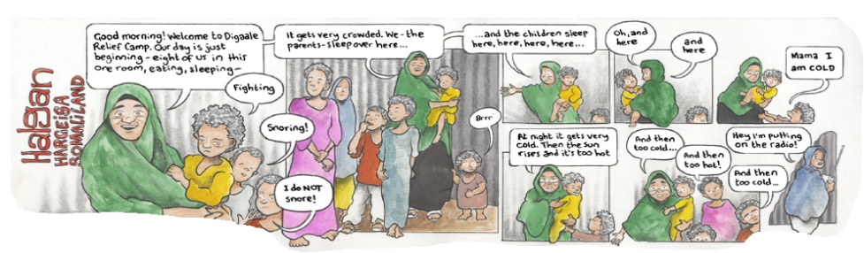

Introduction:
Before watching the video answer the following questions:

- Where is Somaliland? _________________________________________________

- Do you know anything about Somaliland already? _________________________________

During the video

- What job does Halgan do? _______________________________________

- After the drought, how did Halgan’s life change? ____________________________

- Halgan’s animals used to be her priority and now her children are. Why is this?

_________________________________________________________________________

- How has climate change impacted Halgan’s life?

_________________________________________________________________________

- What does Halgan mean? ____________________________

Discussion after the video

Climate change is increasingly causing people around the world to migrate or become displaced from their original home. Whose responsibility is it to ensure that the people who are forced to move from their houses are offered new places to live?

