The Russian Arctic: the Arctic biome activity sheet 1

This is a worksheet for Key Stage 3 geography. It is designed to complement a wider scheme of work either on climate change or on Russia specifically.

Curriculum relevance
Understanding global biomes is important because:

- Students should be able to use world maps to show the location of global biomes
- Russia is the world’s largest country by landmass; it has five distinct biomes
- It is a key skill to be able to compare climate graphs for different biomes

World Biomes
Where is the Arctic tundra? There are (confusingly) three definitions for the boundary to the Arctic: the Arctic tree line, the area where the average temperatures of the warmest month are less than 10°C or simply where the Arctic Circle is.

- Colour code the different biomes below to identify the 6 main biomes of planet Earth. Why not use a highlighter to emphasis number 1 — the Arctic tundra?

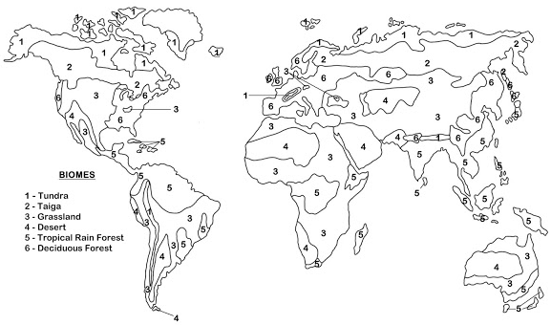
Figure 1 © Debbie Crockett www.classroomtimesavers.com/2013/08/biomes.html by Worksheet Place

The world’s major biomes are ribbons of land or ocean which wrap around the Earth. They are characterised by the same or similar flora and fauna (plants and animals), which are influenced in the first instance by soil, temperature and the amount of light and water in the biome.

A biome is different to an ecosystem because it is larger and is a specific geographical area (and is not about the interaction between living and non-living organisms). Go to BBC Bitesize www.bbc.co.uk/bitesize/guides/zh2p34j/revision/1 to really get to grips with this topic.

- Go to Arizona State University Ask a Biologist webpage, scroll down to Biomes of the World (there are a few more than you have shaded for question 1) and write out a sentence to describe each of the 9 world biomes: tropical rainforest, temperate forest, desert, tundra, taiga, grasslands, savannah, freshwater and marine.

Biomes change and move as they are influenced by climate change. For example, the Sahara Desert was once a lush landscape described as a ‘green oasis’ with abundant water and flowing rivers. Now north Africa has dried up and is dominated by high pressure and aridity. This transition was caused by a shift in circulation of the Hadley cell, changing the tropical atmosphere and allowing the tropical rain belts to move northwards over time. Such a huge change in the movement of tropical air is related to what happens elsewhere in the world and stems from a change in the Earth’s orbit around 6,000 years ago. The effect has been a change in vegetation and an evolution of the mammals found in north Africa from giraffes and African long-horned buffalo (Pelorovis) to hyenas and scimitar-horned oryx. You can find out about why his change might have occurred by reading this Smithsonian article on prehistoric pastoralists.

The Arctic
Do you know where the Arctic is located?

- Highlight the following words in two separate colours: latitude and longitude. Now use those same colours to highlight the lines of latitude and lines of longitude onto the globe diagram on page 3.

- Add 0° onto the correct line of latitude. Then add 23.5°N, 23.5°S and 66°N

- Now add the following labels: the Arctic Circle, the Equator, the Tropic of Capricorn, the Tropic of Cancer and the Prime Meridian.

- Go back to the BBC Bitesize www.bbc.co.uk/bitesize/guides/zh2p34j/revision/1 revision webpage. Annotate the diagram with a description of the landscapes that are found:

  - In the Arctic Circle
  - Around the Equator
  - Along the Tropic of Capricorn and the Tropic of Cancer
  - Down the Prime Meridian

- Moscow is the capital of Russia; it is found at 55.7°N and 37.6°E. Can you plot the coordinates for the city onto the diagram?

- Murmansk is a major Russian port within the Arctic Circle, it is the largest city above the Arctic Circle and has one of the largest fish-processing plants in all of Europe. Murmansk is located at 68.9°N and 33.0°E. Can you plot the coordinates for this strategic city onto the diagram?
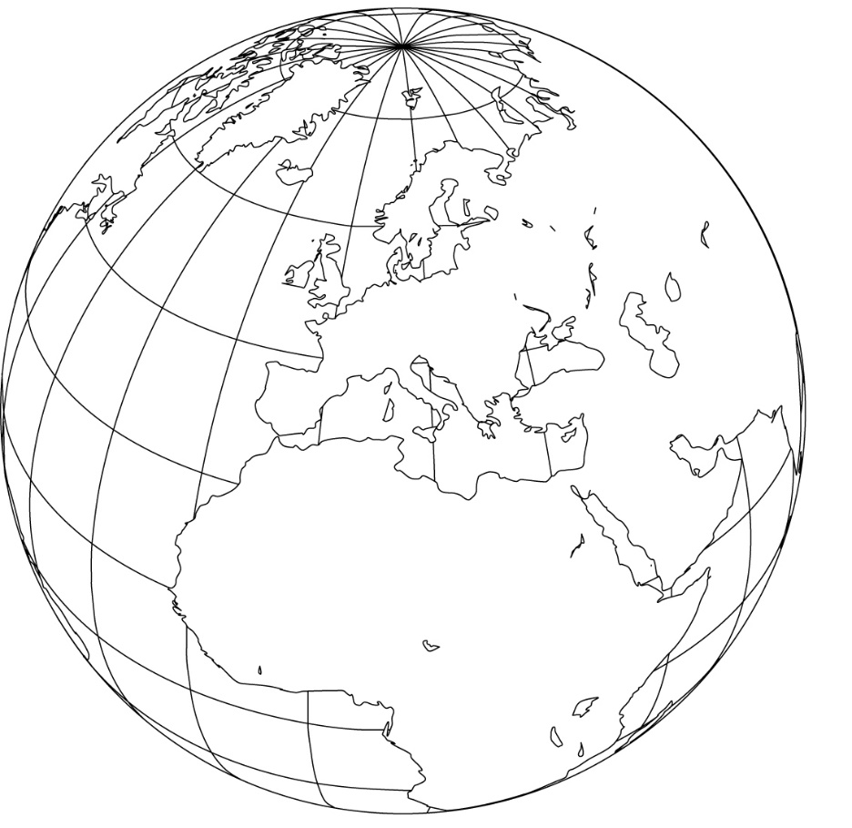

Figure 2 © Bruce Jones design www.freeusandworldmaps.com/html/World_Globes/GlobePrintable.html

Tundra or Taiga?
Watch this video from BBC Bitesize on the different biomes www.bbc.co.uk/bitesize/topics/z849q6f/articles/zvsp92p and read this article from the National Geographic www.nationalgeographic.org/encyclopedia/taiga/. You should now understand the definitions for Arctic tundra and subarctic taiga:

The tundra is the coldest of all the biomes. There is very little rain or snow and the temperatures are freezing. Winters are long and summers are short. Part of the soil is frozen all year round, although the top part defrosts in summer and plants such as mosses can grow.

The taiga is a forest of the cold, subarctic region. The subarctic is an area of the Northern Hemisphere that lies just south of the Arctic Circle. The taiga lies between the tundra to the north and temperate forests to the south.

- Using all the knowledge you have amassed on the different biomes — identify which photographs (Figures 3 to 6) show tundra and which ones show taiga in Russia.
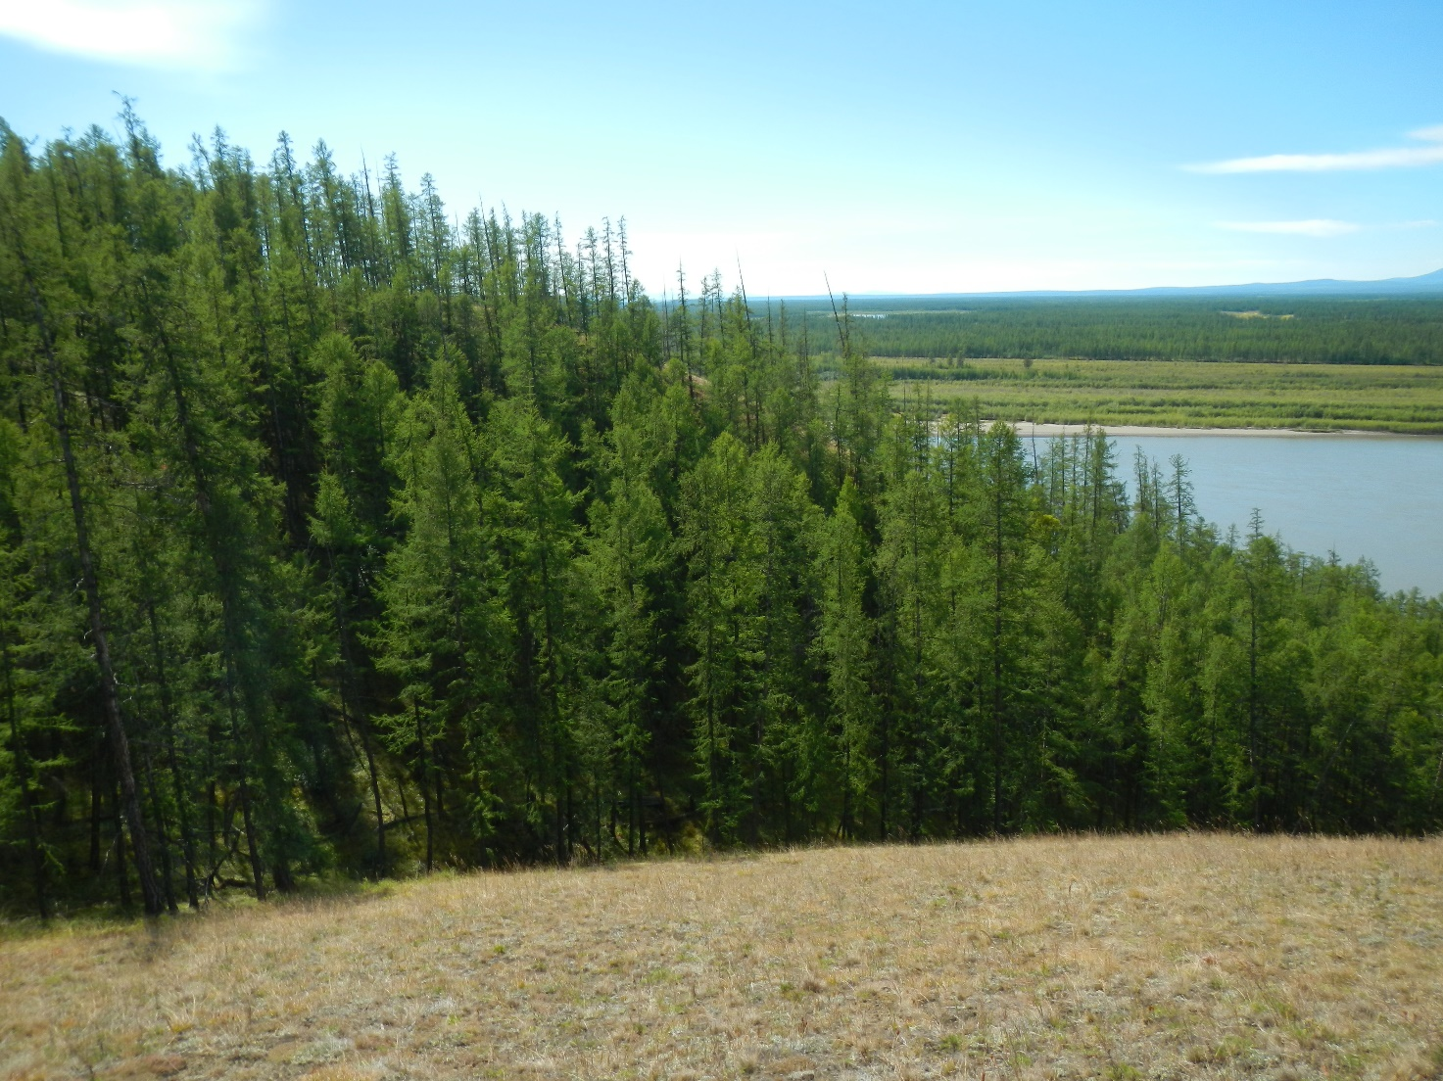
Figure 3 © Thomas Opel
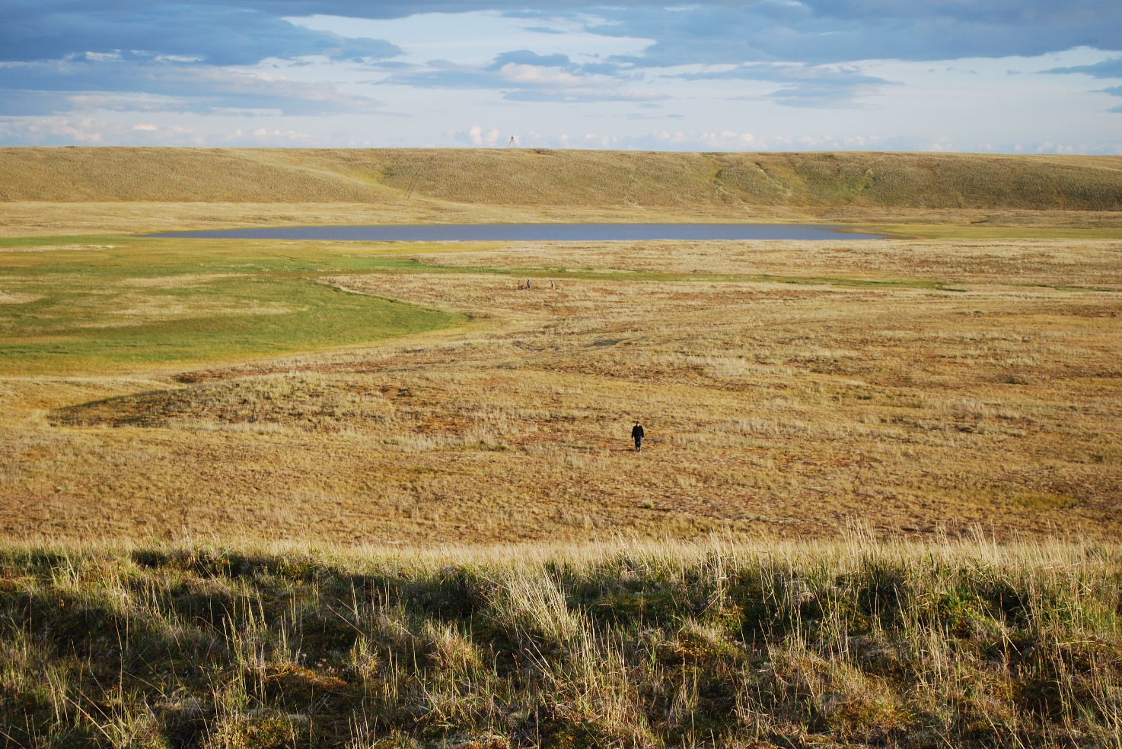
Figure 4 © Thomas Opel
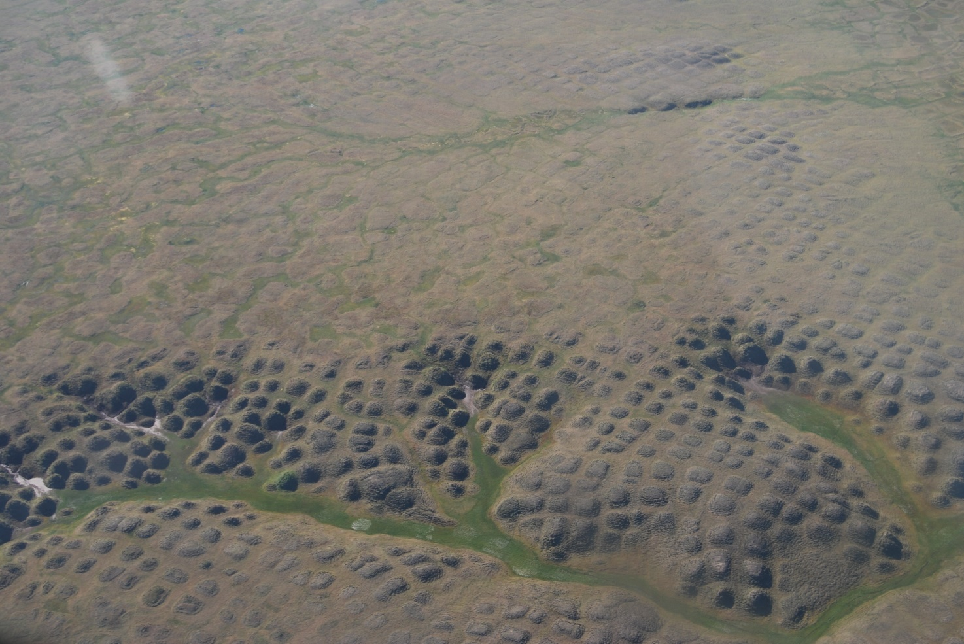
Figure 5 © Thomas Opel
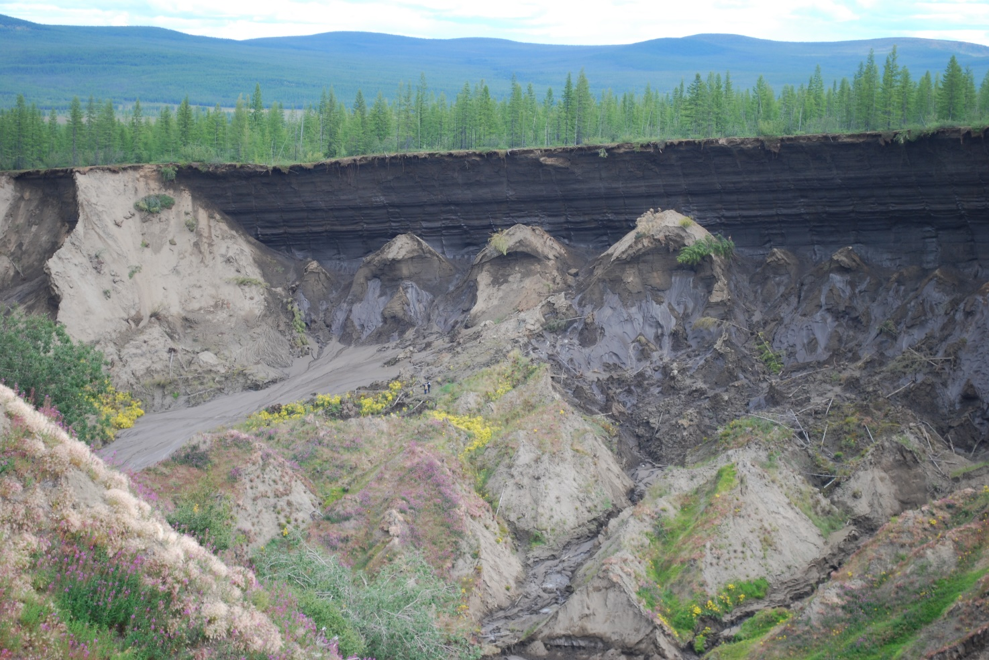
Figure 6 © Thomas Opel
Further information
- National Geographic The Five Major Types of Biomes

- Arizona State University Biomes of the World

- Look at the NASA climate graphs for different global biomes: print off two different biomes i.e., rainforest Campa Pita, Belize and compare it with the tundra biome tundra Yakutsk, Russia?

- Try a free biome word search from the WWF

- BBC Bitesize Biomes

- National Geographic The Tundra Biome

Thank you to Dr Caroline Coch, Polar specialist at WWF-UK, for helping with the production of this resource

