Migrants on the Margins
- Why do people move? Resource linked to the video

Introduction:
Before watching the video ask the following questions: What is your perception of a migrant? When you think about migration, do you view it as a positive or a negative? What are main reasons people living in low-income, middle-income and high-income countries migrate? Do these reasons differ? Why do you think they differ?
Write the answers/key words on the board and then revisit the questions after having watched the video.

During the video
As you watch the video write down the words that stand out for you and then produce a word cloud, similar to the one below.
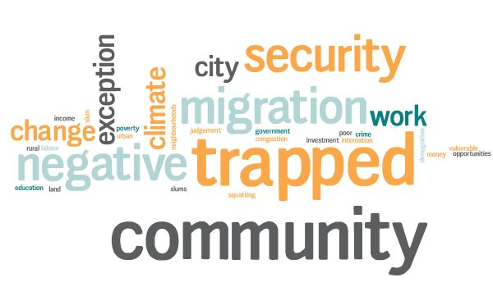

Activity to follow the video
Reflect on the answers that you gave before watching the video. Would you give the same answers now? How have your perceptions of migrants changed?

