Country  Lesson one: UK Population fact sheet POPULATION | Population in millions | % of UK population
Scotland | 5.3 | 8.3
Wales | 3.1 | 4.8
Northern Ireland | 1.8 | 2.9
England | 53.9 | 84.0
United Kingdom | 64.1 | 100.0

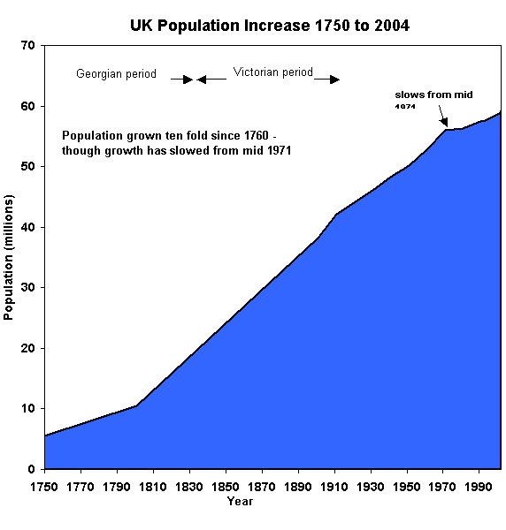
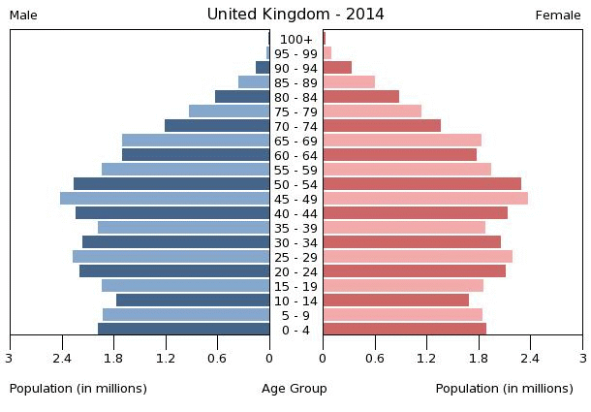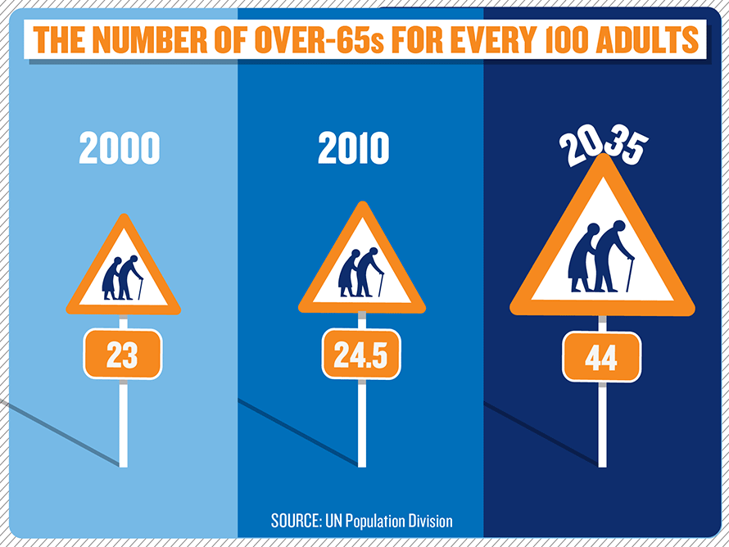
The UK's overall population is set to reach 73m people by 2037 with the number of people aged 80 and over set to double to 6.1m.
The average age of someone in the UK will rise from 39.7 years (2012) to 40.6 years in mid-2022 and 42.8 years by mid-2037.
The figures also show a 31% growth in the number of people of state pension age putting it up to 16.1m in 2037.
Why might an ageing population be a problem for the UK in the future?

