Migrants on the Margins
- Let’s investigate, Halgan’s story (Hargeisa)

The Migrants on the Margins research explores four cities: Colombo, Dhaka, Hargeisa and Harare. We explore the lives of four people living in these cities through comics. This quiz will help you to find out more about why each participant has moved and how they find life on the urban margins.
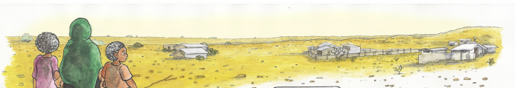

- What age did Halgan help her Dad with their herd of goat, cows and camels? ___________
- How old was Halgan when she met her husband? _________________
- How many goats did Halgan have in 2011? _________________
- To stay in the camp in Hargeisa, how much rent did Halgan pay each month? ___________
- How many families live in the camp? _________________

- If you could ask Halgan one question about her life and experience what would it be?
__________________________________________________________________________________________________________________________________________________________
_____________________________________________________________________________

