**London Landmarks**

[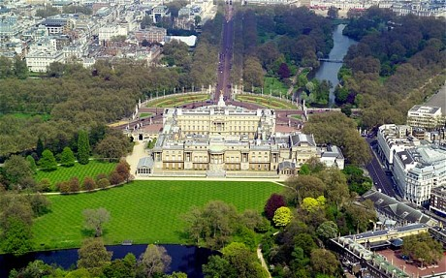](http://www.google.co.uk/url?sa=i&rct=j&q=&esrc=s&frm=1&source=images&cd=&cad=rja&uact=8&ved=0CAcQjRxqFQoTCNWLlc6WjccCFcltFAodWs0F0A&url=http://www.telegraph.co.uk/news/uknews/theroyalfamily/8306921/Green-gardener-needed-for-Buckingham-Palace.html&ei=w4G_VZWeDsnbUdqal4AN&bvm=bv.99261572,d.cWw&psig=AFQjCNEIrwdy5Ow91xtCHmfOE0gp8KwPZA&ust=1438700324049006)[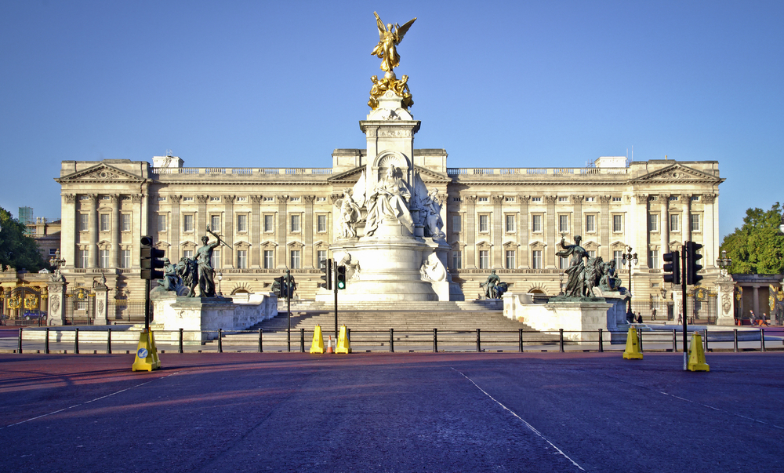](http://www.google.co.uk/url?sa=i&rct=j&q=&esrc=s&frm=1&source=images&cd=&cad=rja&uact=8&ved=0CAcQjRxqFQoTCPjL76-WjccCFUm7FAodnFYDIw&url=http://www.recruitmentagencynow.com/one-million-on-zero-hours-contracts-finds-cipd/buckingham-palace/&ei=g4G_Vbj-Ksn2UpytjZgC&bvm=bv.99261572,d.cWw&psig=AFQjCNGCUK9SBpOTxPJeIj76aWsFgEeXFw&ust=1438700283779592)

**Buckingham Palace**

**London Landmarks**

[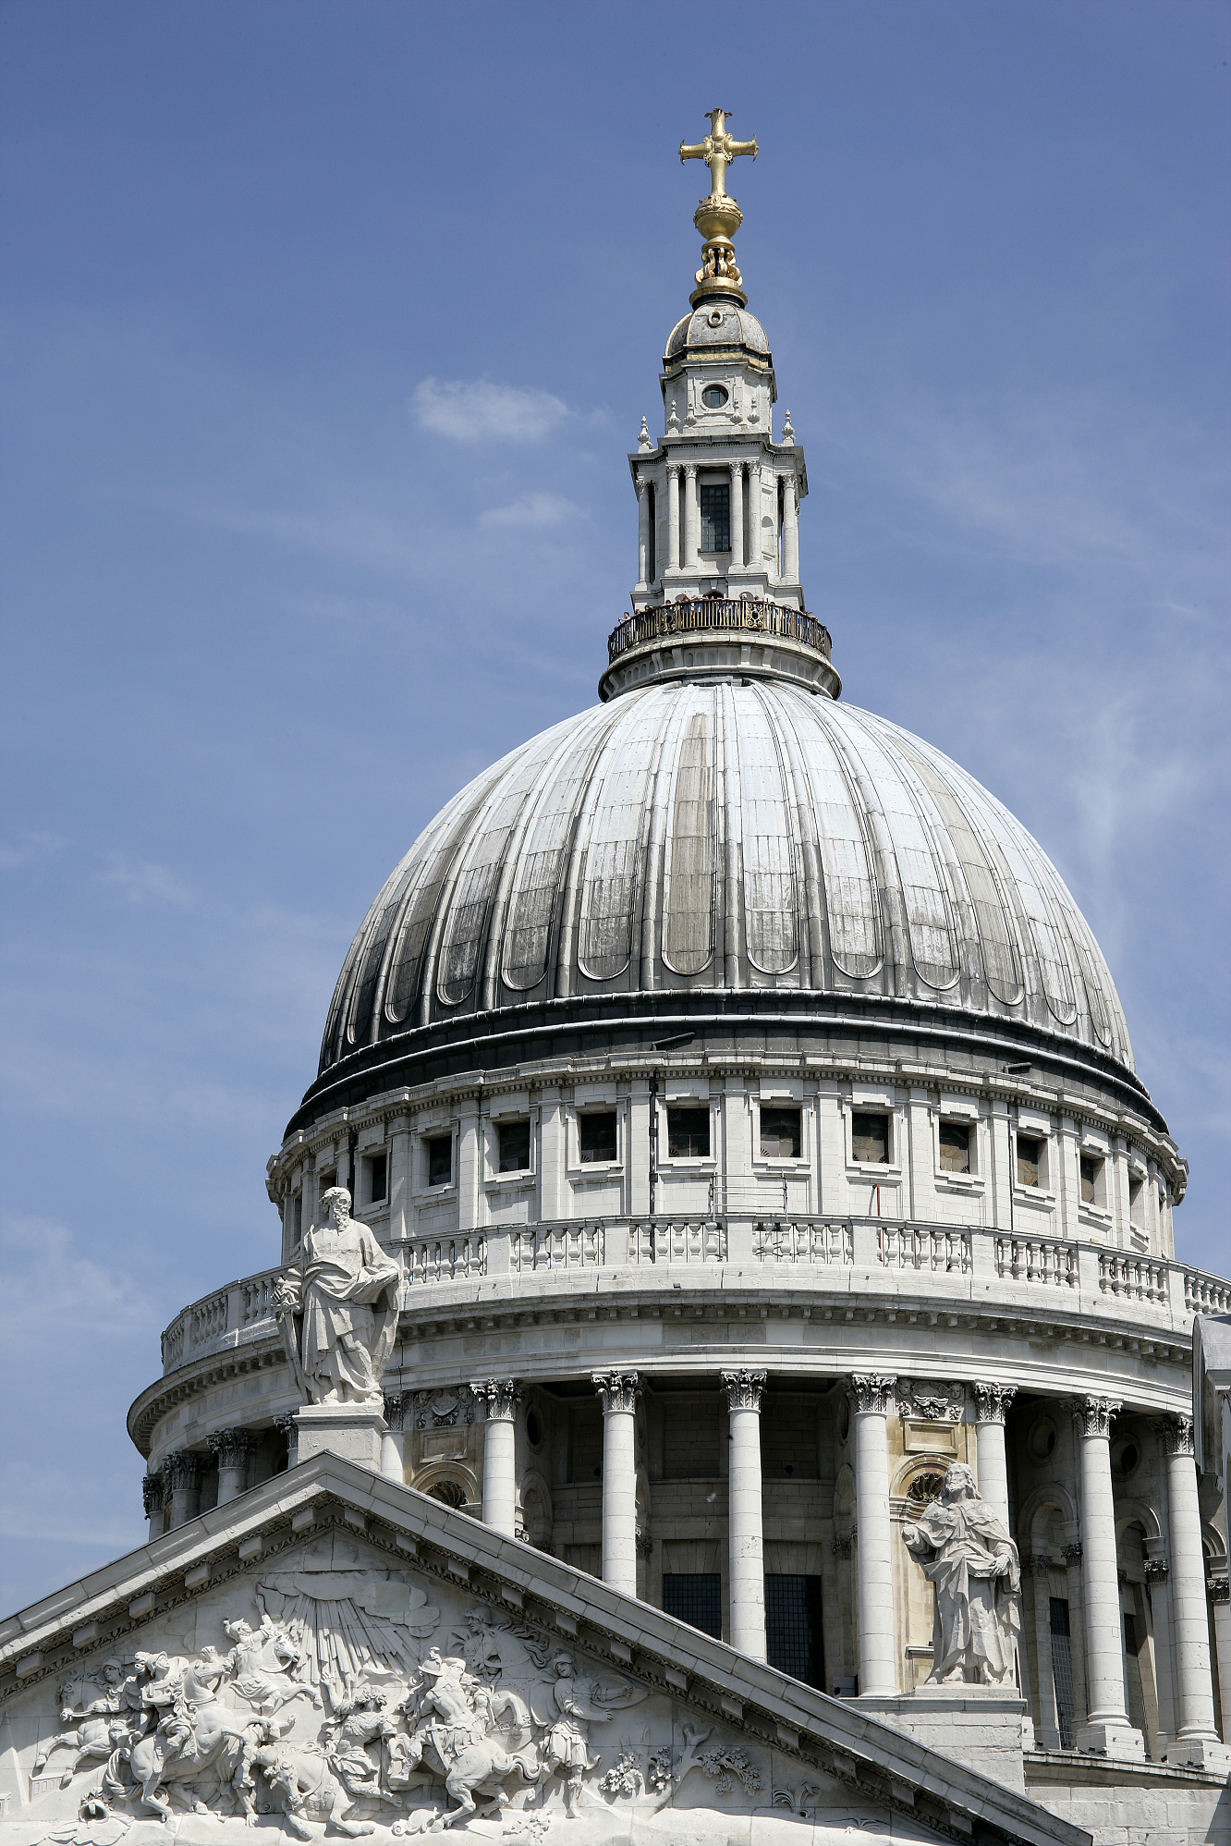](https://www.google.co.uk/url?sa=i&rct=j&q=&esrc=s&frm=1&source=images&cd=&cad=rja&uact=8&ved=0CAcQjRxqFQoTCKWw0-aVjccCFUI5FAod5XIEjQ&url=https://www.stpauls.co.uk/visits/visits/sightseeing-times-prices&ei=6oC_VaWTCcLyUOXlkegI&bvm=bv.99261572,d.cWw&psig=AFQjCNFS_VZTikDfZ-11Tr7rPK4_vXVsnQ&ust=1438700129784797)

**St Paul’s Cathedral**

**London Landmarks**

[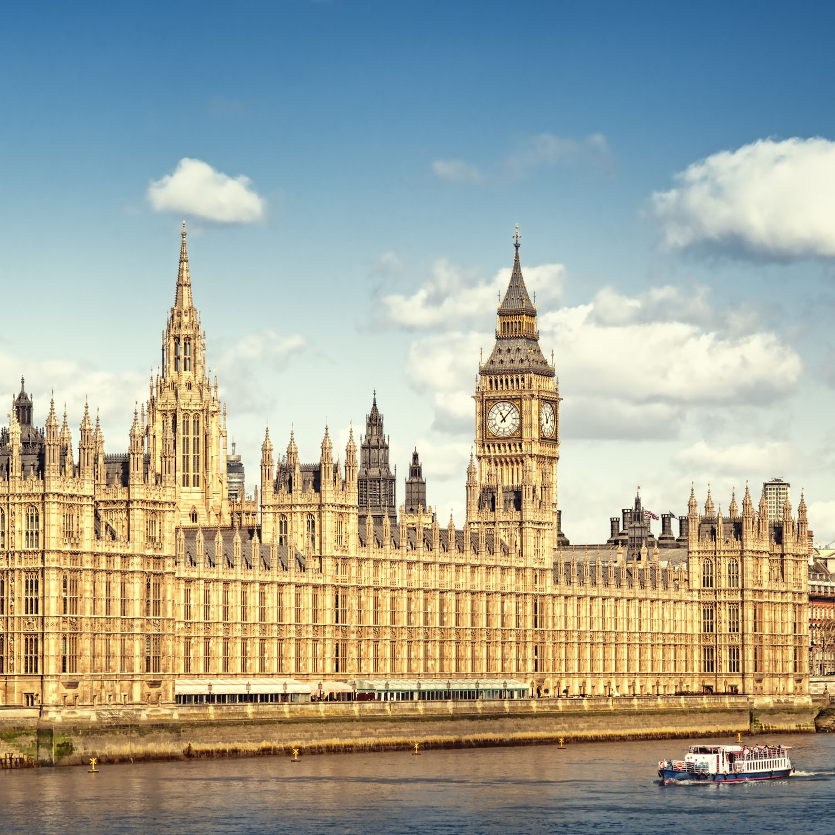](http://www.google.co.uk/url?sa=i&rct=j&q=&esrc=s&frm=1&source=images&cd=&cad=rja&uact=8&ved=0CAcQjRxqFQoTCKmKhfKUjccCFcFdFAodPTwGrA&url=http://www.theinquirer.net/inquirer/news/2419617/parliament-is-populated-with-online-porn-peeping-peers-and-personnel&ei=9X-_Vem7JMG7Ub34mOAK&bvm=bv.99261572,d.cWw&psig=AFQjCNGUqiuOLOY_iM8KBXWUD8wOgir3ww&ust=1438699857615086)

**Houses of Parliament**

**London Landmarks**

[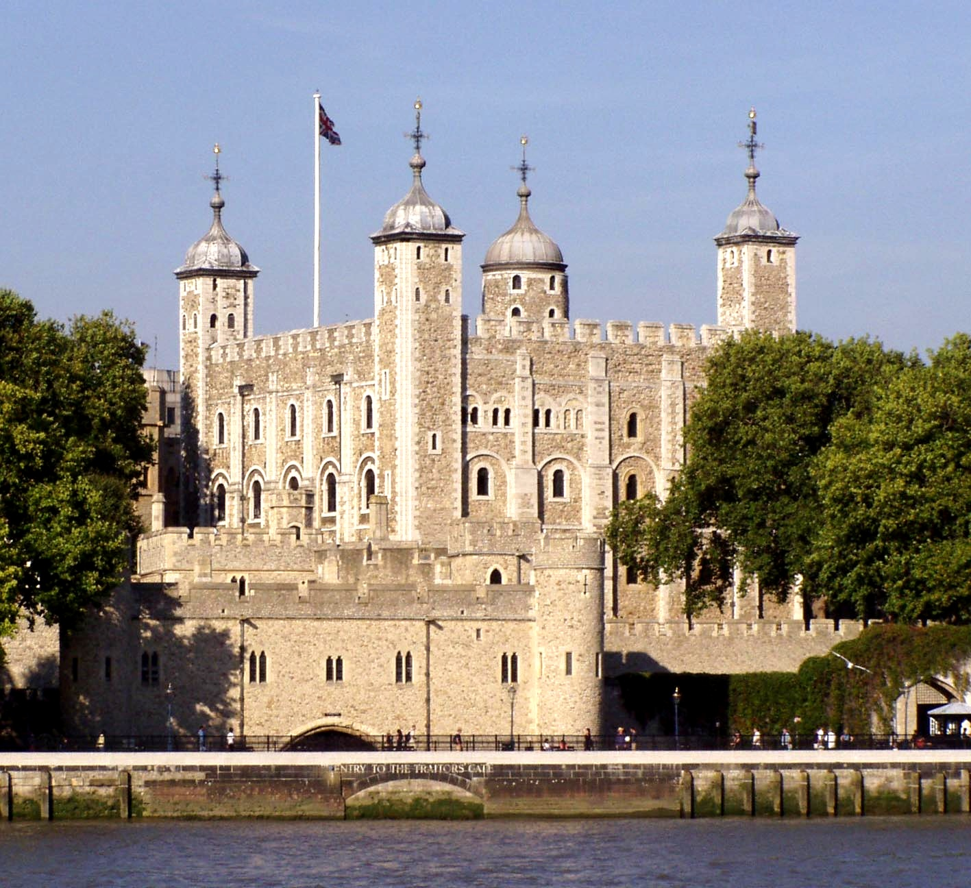](http://www.google.co.uk/url?sa=i&rct=j&q=&esrc=s&frm=1&source=images&cd=&cad=rja&uact=8&ved=0CAcQjRxqFQoTCPTPv7OUjccCFcpVFAod6ZYAWw&url=http://openbuildings.com/buildings/tower-of-london-profile-6426&ei=cn-_VfTOGsqrUemtgtgF&bvm=bv.99261572,d.eXY&psig=AFQjCNE3TbdfBM7reJNH5UqiNe5vSgYRQA&ust=1438699759618990)

**Tower of London**