**Lesson four: Sheffield Industry resource pack**

A castle is built at Sheffield and a town grows up around it

Sheffield has a population of over 135,000

1801

Sheffield has a population of 2,207

Sheffield has a population of more than 31,000

1120

The first cutlers appear in Sheffield

The population of Sheffield is about 5000

1756-8

1843

A company of Cutlers is founded

Sheffield is given its own assay office

1624

The roads from Sheffield to Derby and Leeds are turnpiked

Sheffield is the main town outside London where cutlery is made

1851

1773

1690

1617

1600

1300

Sheffield is given a charter

[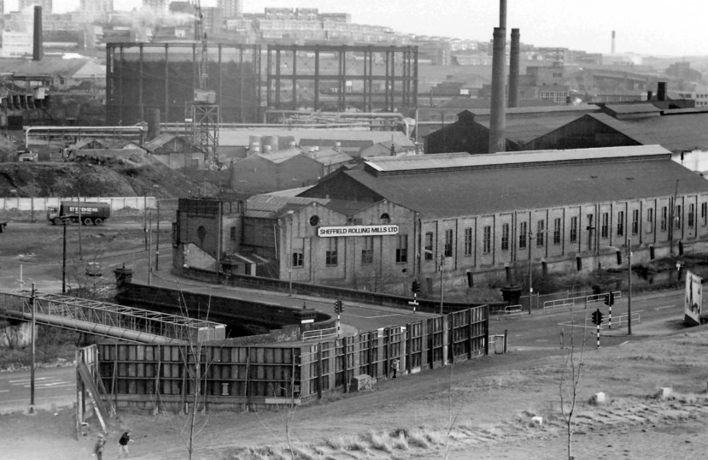](http://www.google.co.uk/url?sa=i&rct=j&q=&esrc=s&frm=1&source=images&cd=&cad=rja&uact=8&ved=0CAcQjRxqFQoTCOLzu7exmccCFWGP2wod3yMNRA&url=http://www.sheffieldhistory.co.uk/forums/index.php?/topic/12082-sheffield-forge-and-rolling-mills/&ei=gOjFVeKzD-Ge7gbfx7SgBA&bvm=bv.99804247,d.dmo&psig=AFQjCNGKQxCJTv85rKO_zW9ie_mfPnMlfA&ust=1439119868799336)[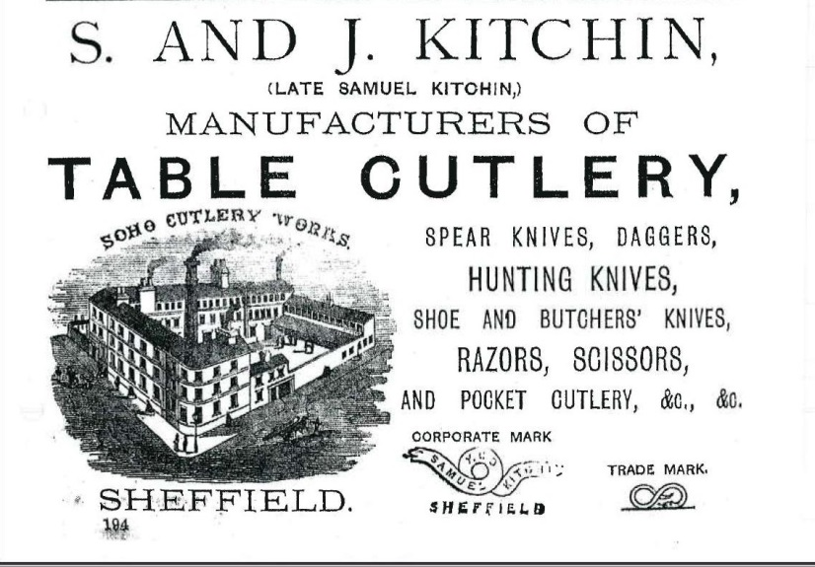](http://www.google.co.uk/url?sa=i&rct=j&q=&esrc=s&frm=1&source=images&cd=&cad=rja&uact=8&ved=0CAcQjRxqFQoTCJ69jdKwmccCFVJn2wode-0NjQ&url=http://www.sheffieldhistory.co.uk/forums/index.php?/topic/7059-1871-trade-directory-images/&ei=q-fFVd67KdLO7Qb72rfoCA&bvm=bv.99804247,d.dmo&psig=AFQjCNFI1aARDpi6ymRDFFC_NxWTVfeRsw&ust=1439119641717811)[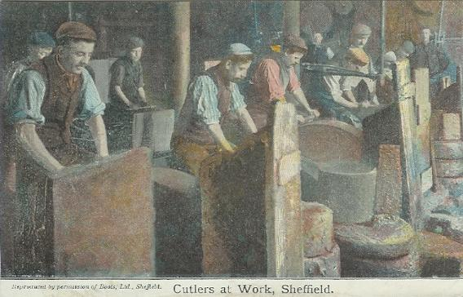](http://www.google.co.uk/url?sa=i&rct=j&q=&esrc=s&frm=1&source=images&cd=&cad=rja&uact=8&ved=0CAcQjRxqFQoTCK76v72vmccCFU8Y2wodPAgKaw&url=http://www.sheffieldindexers.com/MasterCutlersMayorsIndex.html&ei=dObFVa7wAc-w7Aa8kKjYBg&bvm=bv.99804247,d.dmo&psig=AFQjCNFiI4p77XbN2np8UPWvF-T0XFDi5A&ust=1439119337096041)[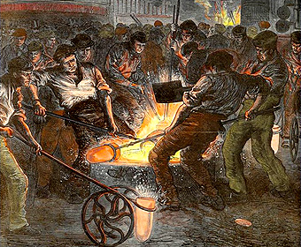](http://www.google.co.uk/url?sa=i&rct=j&q=&esrc=s&frm=1&source=images&cd=&cad=rja&uact=8&ved=0CAcQjRxqFQoTCMTq2e2tmccCFYaz2wodehMEJQ&url=http://www.crtools.co.uk/tool-cutters-sheffield.html&ei=wOTFVcSKD4bn7gb6ppCoAg&bvm=bv.99804247,d.dmo&psig=AFQjCNEZbWQQqWydEujc3G7A9pEa32ngwA&ust=1439118760394386)[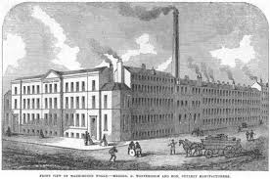](http://www.google.co.uk/url?sa=i&rct=j&q=&esrc=s&frm=1&source=images&cd=&cad=rja&uact=8&ved=0CAcQjRxqFQoTCO2js5GwmccCFYuh2woddmsOJQ&url=http://www.uk-legal-knives.com/pocket-knife-history-33-w.asp&ei=I-fFVa2GPIvD7gb21rmoAg&bvm=bv.99804247,d.dmo&psig=AFQjCNFbzHJfJFrGO0kGJ_5UqpQ7L9GEbw&ust=1439119505514411)[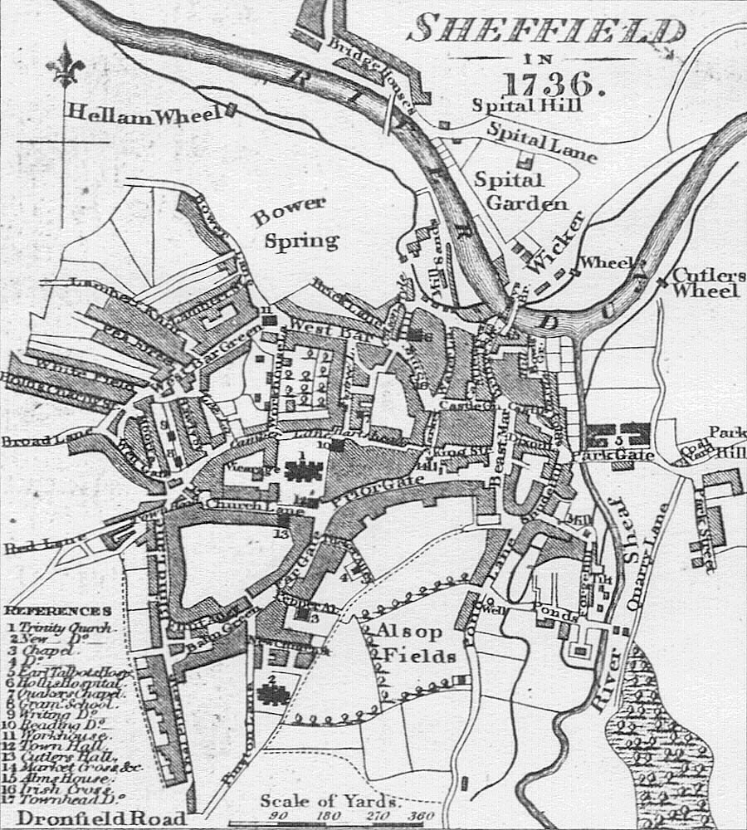](https://www.google.co.uk/url?sa=i&rct=j&q=&esrc=s&frm=1&source=images&cd=&cad=rja&uact=8&ved=0CAcQjRxqFQoTCJaI_KWtmccCFYuW2wodifoI1g&url=https://en.wikipedia.org/wiki/History_of_Sheffield&ei=KeTFVdbPMYut7gaJ9aOwDQ&bvm=bv.99804247,d.dmo&psig=AFQjCNEZbWQQqWydEujc3G7A9pEa32ngwA&ust=1439118760394386)