KS2 lesson Colouring London – My local area
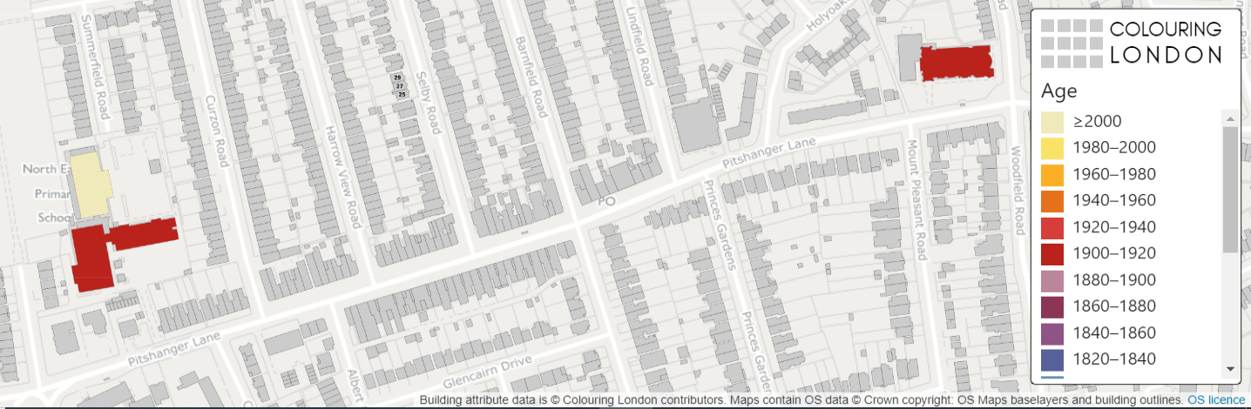

Colouring London aims to collect information on every building in London, to help make the city more sustainable. It provides information about your local area https://colouringlondon.org/

The Colouring London team would like to colour in every building in London and they need your help.
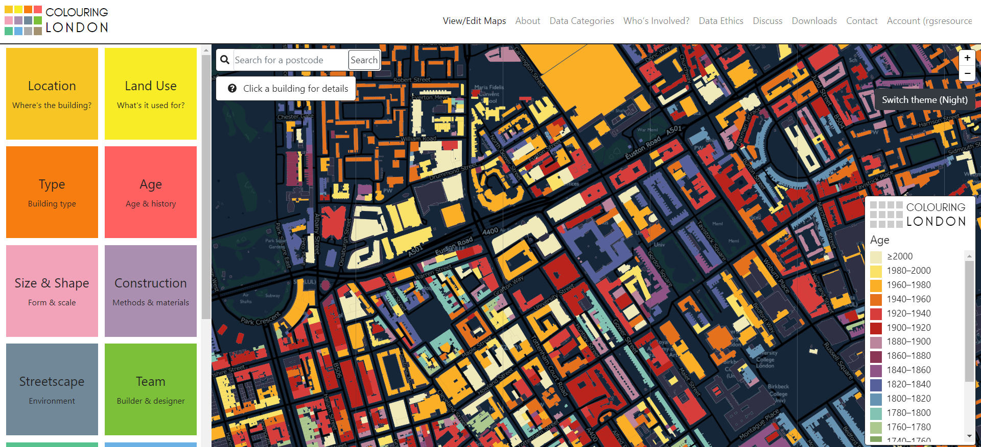

What is GIS?

GIS stands for Geographical Information Systems

It allows us to collect, store, process and display different categories of information linked to places on maps.

GIS can be used to identify patterns and can tell us about what a place is like.

In fact, you have probably used GIS without realising it, such as searching where you live in Google Maps.

You can find out more by visiting https://www.ordnancesurvey.co.uk/mapzone/gis-zone

What information should I collect?

Thinking hats task
Divide into groups of 6 to discuss the following two questions:
- What does sustainability mean?
- What information could you collect about a building that might tell us about how sustainable it is?

Discuss

Write your class ideas into the bubble below.

Review

What information should you collect?

Colouring London would like to collect:
- Location
- Land use
- Type
- Age
- Size & Shape
- Construction
- Streetscape
- Team

Detailed information about how to collect information is available on https://www.pages.colouring.london/buildingcategories

You are the experts in your local area and your aim is to gather information on:
- The age of the buildings
- The type of the buildings
- The height of the buildings

How could you collect this information?

- Primary data
  - Carry out some local fieldwork
  - Colour in your own map
  - Return to school and your teacher can add the data to the Colouring London website
- Secondary data
  - Use Google Earth, Maps and Streetview
  - Use websites such as Historic England or Survey of London

What do I know about my local area?

Think of some geographical questions such as:
- Are the buildings in my local area all the same age?
- How many different types of building material have been used in my local area?
- Which buildings in my local area are sustainable?
- Are all the buildings the same height?
- Are all the buildings residential?

Planning fieldwork

Your route to successful fieldwork
- Write 1-3 key questions
- Choose 1-2 streets near school to survey
- Print out a map of your streets (Digimap for schools or ArcGIS)
- Design a colour coding system to record on your printed map
- Discuss the potential risks of carrying out fieldwork

This is following the Route to Enquiry method – further information can be found on https://www.rgs.org/schools/teaching-resources/the-case-for-qualitative-fieldwork/

Example study - Ealing, London

Key questions:
- Do the buildings get older as you get further away from school?
- Does the type of building change as you get further away from school?
- Do buildings get taller (have more storeys) as you get further away from school?

Maps of study area

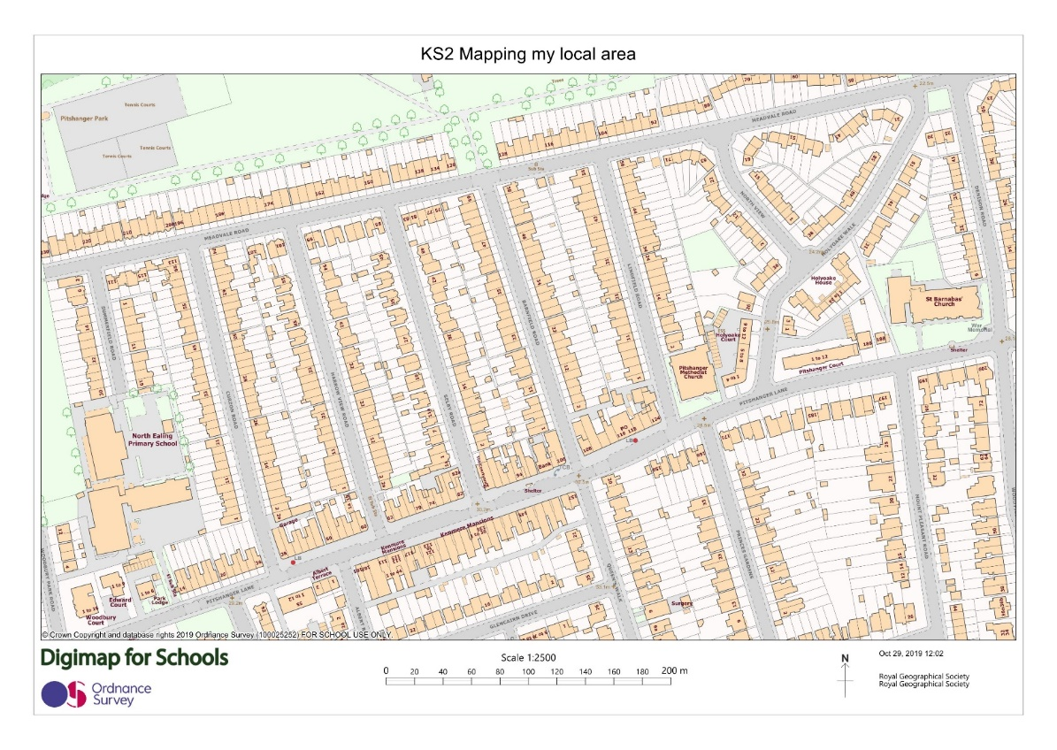

School

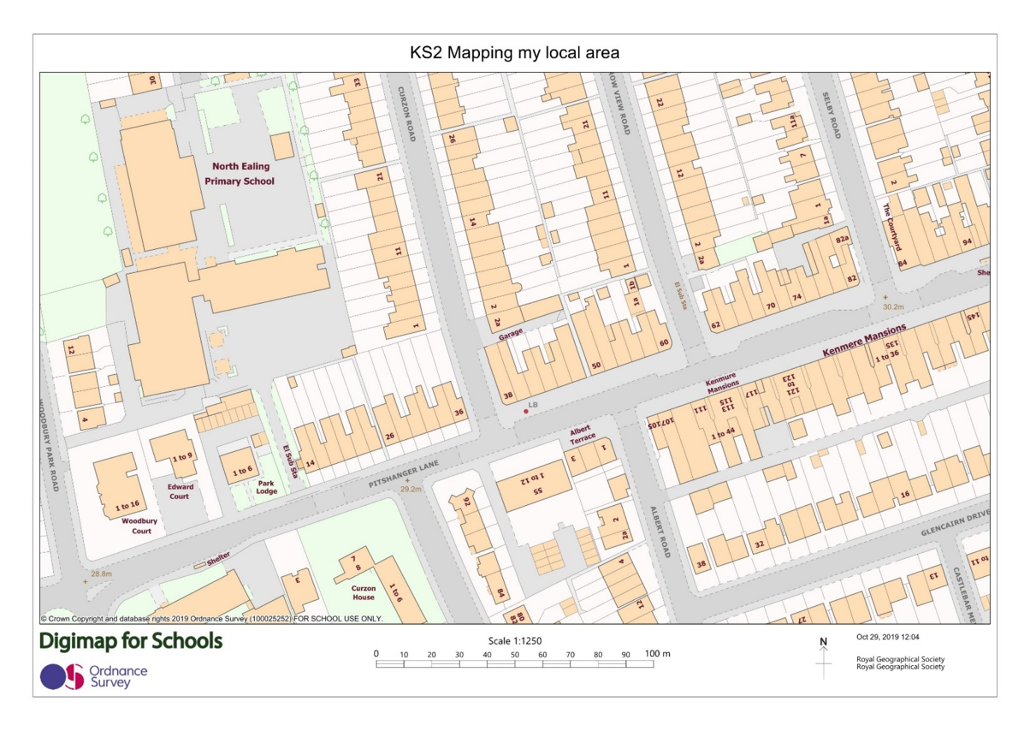

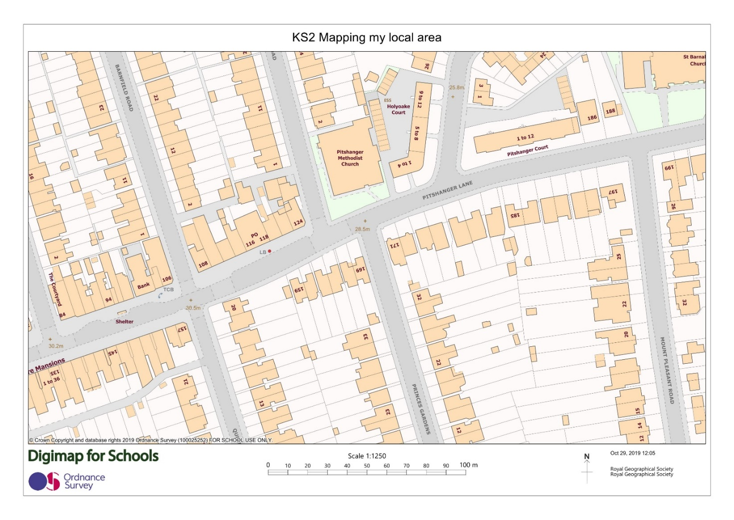

Risk assessment

Before you collect any data, think about your safety and the risks.
Your school will have a clear policy on carrying out a risk assessment before embarking on any fieldwork.
Please refer to this and for further information please visit the RGS-IBG Fieldwork safety and planning pages.

Designing a key

Example of field map coloured in

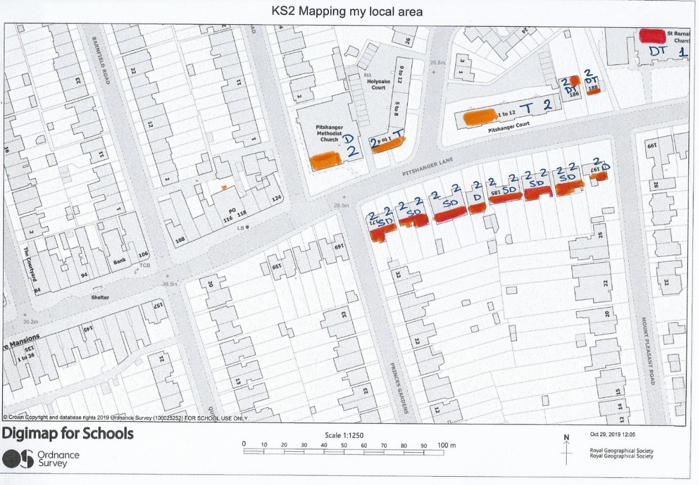

How to identify the age of the building

Using the Colouring London Building Typology handout, before you leave the classroom, agree which features of the building you will use to date it.

For example:
Construction material – brick or concrete?
Windows – single or double glazed? Wooden or PVC frames?

Photos of example building typologies

Entering data into Colouring London

Note: The teacher should enter the data. Please see KS2 and KS3 Colouring London guidance notes for teachers for further information

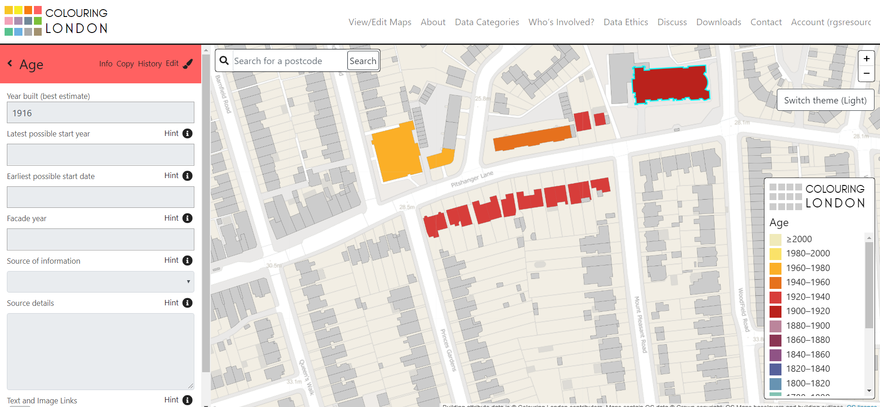

Answering your questions

- Do the buildings get older as you get further away from school?
  - The buildings are similar in age (1920-1940) on the north side of the road
  - Buildings on the south side of the road are younger (some 1980s and 1990s)

- Does the type of building change as you get further away from school?
  - The main building type on the north side of the road was Terraced (Mid-Terraced and End-Terraced).
  - The buildings on the south side were more varied with Detached, Semi-Detached and Terraced being observed.
- Do buildings get taller (have more storeys) as you get further away from school?
  - There is no change in building height, most are 2 storeys, with the exception of a row on the south side which is 3 storeys.

Conclusions

Using the key enquiry questions suggested above, draw a conclusion about the age and characteristics of your local area.

e.g. There is little variation in the age or height of the buildings in my local area.

What does this tell us about how sustainable our local area is?

e.g. Age, type and height of buildings can tell us about the lifespan of the building. Knowing this helps local government to decide whether to demolish and replace buildings in cities

