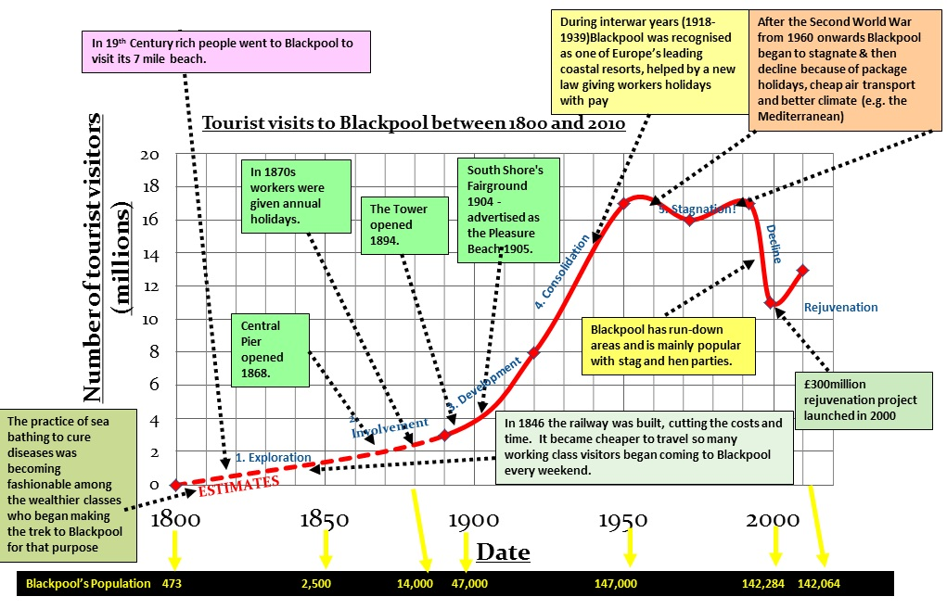

Source: David Pyle

**Lesson five: Blackpool resource pack**

**GROWTH** **(Mid 19th C – 1960)**

Influences:

* Railway links to Manchester and other Lancashire textile towns
* Introduction of paid annual leave in 1938
* Natural advantages e.g. long, sandy beach.
* Tourist attractions: piers, hotels, Blackpool Tower
* **SOLUTIONS**
* Smarten up run-down areas
* Demolish old buildings and landscape car parks
* Clean up beaches and improve beach facilities (in 2006, three of Blackpool's beaches were given blue flags for clean sea-water)
* Reduce sand extraction further up the coast which will reduce the   
  rate of erosion of the beaches
* £10 million modernisation of 'Blackpool Illuminations' to extend the visitor season into the autumn
* Introduce other off-season events, such as conferences and festivals
* New attractions at the pleasure beach theme park and Nickelodeon land

**DECLINE (1960 – 2000)**

1990 – 99: visitor numbers dropped from 17 to 11 millions. 1000 hotels & 300 holiday premises closed; hotel occupancy fell by 25%

Main reason:

* Competition from cheap package, sun & sea holidays in Mediterranean countries

**PROBLEMS**

* Families frightened off by reputation for drinking culture: stag nights/hen parties
* Beach erosion in winter storms
* Beach and sea pollution
* Overcrowding and traffic jams
* Unreliable summer weather

Source: Coach holiday

Source: Wikipedia Commons

Data source: David Pyle

Blackpool has **poor life expectancy**, with males the poorest in England at 73.6 years compared to 78.5 years. Life expectancy for females is similarly poor, at 79.4 years, compared to 82.5 years for England -the 3rd poorest after Manchester and Liverpool. The biggest contributors for both men and women are diseases related to poor diet, smoking and alcohol misuse.

The **population** of Blackpool is estimated at 142,080, with a larger proportion of residents aged 60+ (26%) compared to national age structure (22%). Residents are mostly of White ethnicity, with Black and Minority Ethnic groups estimated to make up just 3% of the population (approximately 4000 people), compared with the estimated proportion for England of 15%.

In terms of **workforce**, Blackpool has a low employment rate at 68.1% compared to a national rate of 70.3%. **Poverty** is a significant factor in Blackpool. In 2010, 30% of children in Blackpool were estimated to be in poverty, compared to 20.6% of all children in England. The majority of children in poverty live in lone parent families.

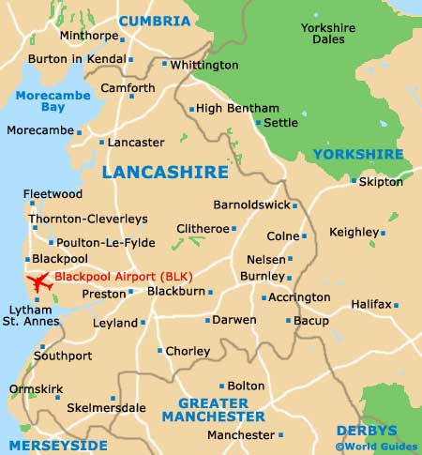

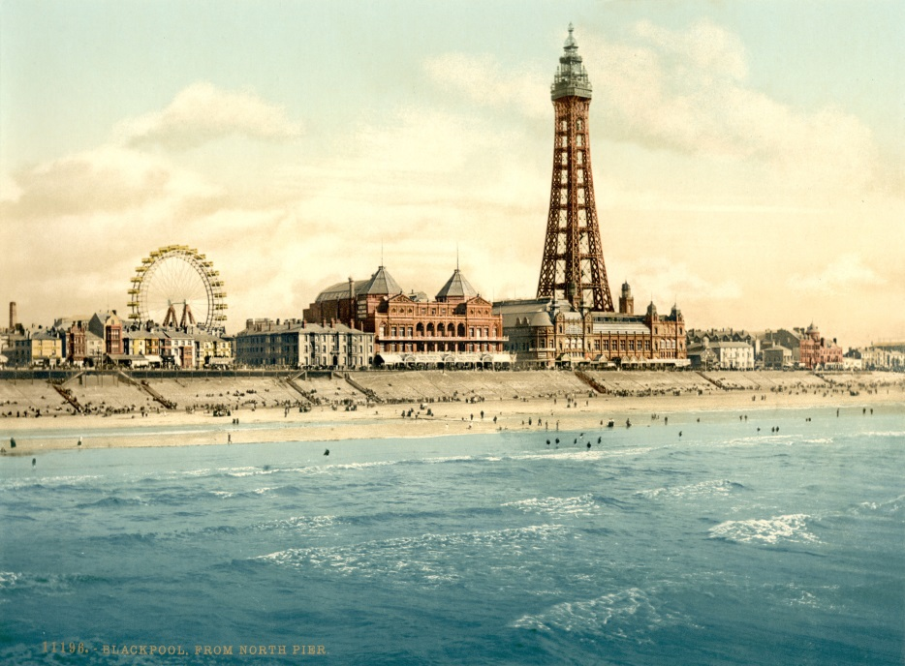

[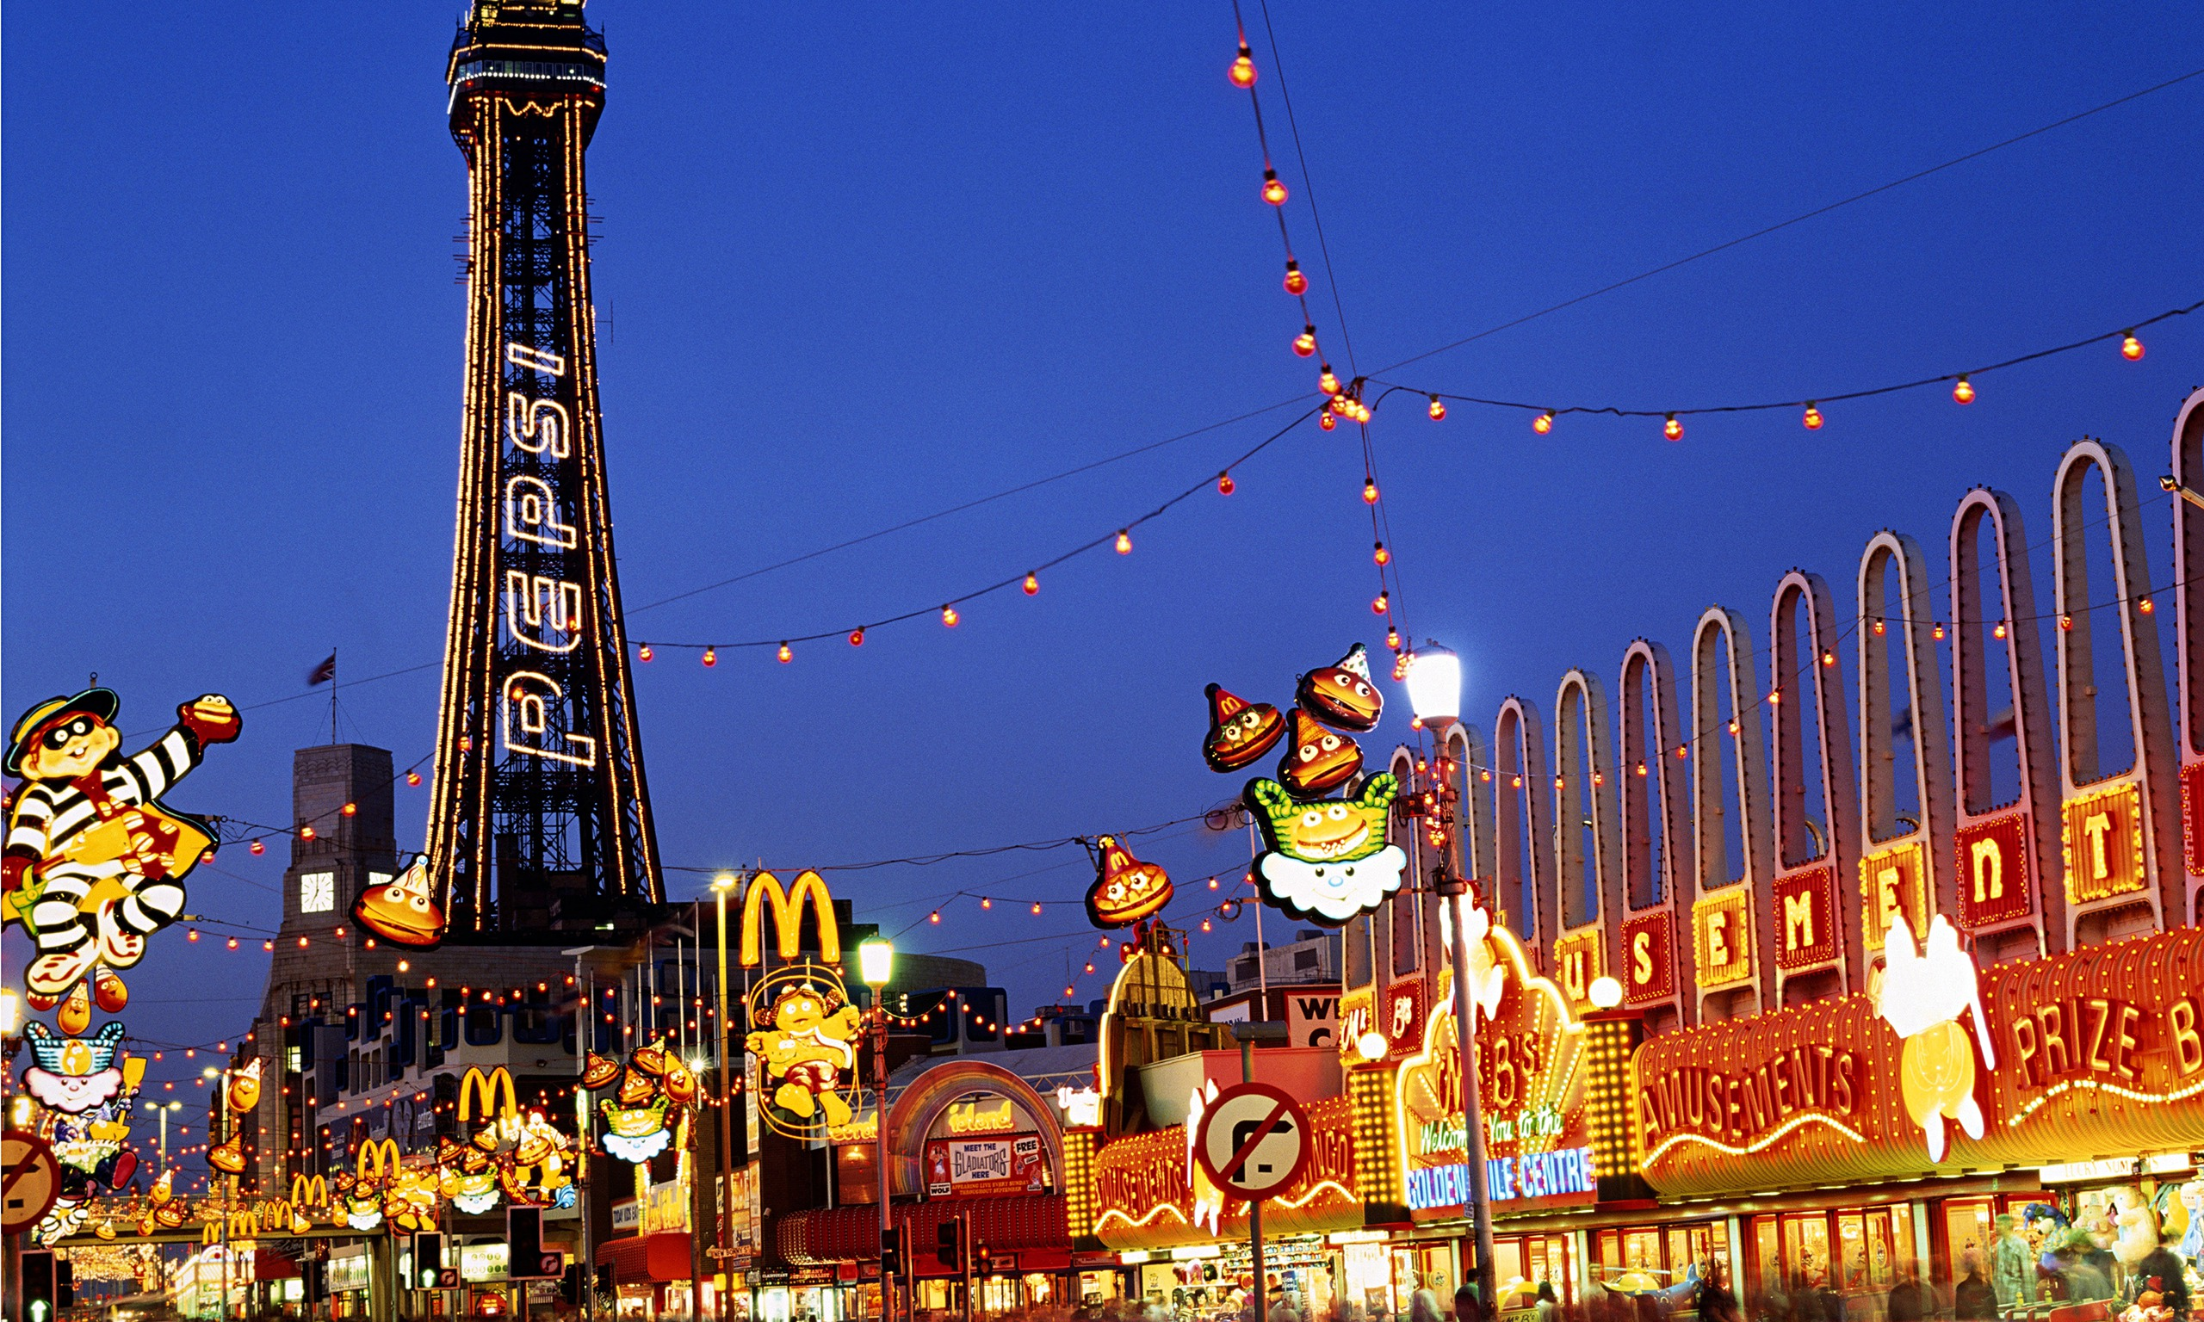](http://www.google.co.uk/url?sa=i&rct=j&q=&esrc=s&frm=1&source=images&cd=&cad=rja&uact=8&ved=0CAcQjRxqFQoTCOKL37jrm8cCFW5r2wodsP8HGQ&url=http://coachholiday.com/daily_offer/blackpool-bar-break/&ei=wzHHVaKeKO7W7Qaw_5_IAQ&bvm=bv.99804247,d.ZGU&psig=AFQjCNEoXp_eE3s89khk6qm1_h42Cgm25g&ust=1439204127129184) 