**CORNISH PASTY**

**Lesson three: Counties and products information poster (example)**

[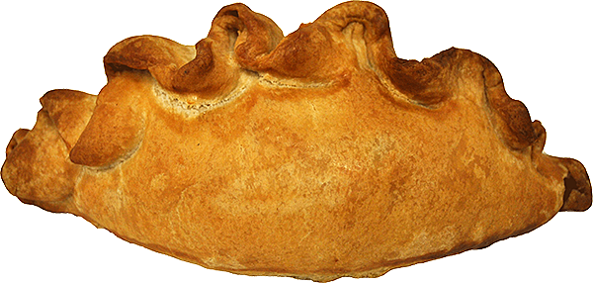](http://www.google.co.uk/url?sa=i&rct=j&q=&esrc=s&frm=1&source=images&cd=&cad=rja&uact=8&ved=0CAcQjRxqFQoTCIOgj92dmccCFUEq2wodzBEB0w&url=http://www.theenglishporkpiecompany.com/products/cornish-pasty&ei=1tPFVYPdHsHU7AbMo4SYDQ&bvm=bv.99804247,d.ZGU&psig=AFQjCNEkWQYCLjNthwsg42mNPd31OS3s2g&ust=1439114574899056)

[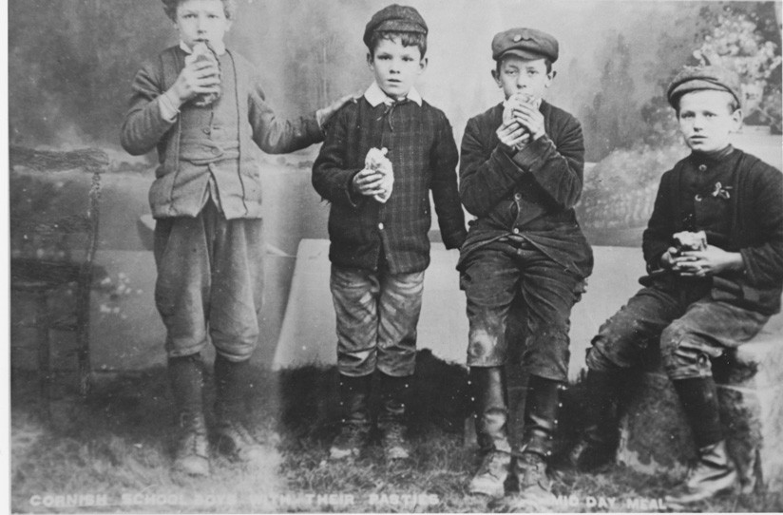](http://www.google.co.uk/url?sa=i&rct=j&q=&esrc=s&frm=1&source=images&cd=&cad=rja&uact=8&ved=0CAcQjRxqFQoTCJiGvtWgmccCFQad2wodpMEJEw&url=http://www.cre8tivecupcake.com/history-of-the-pasty&ei=69bFVdjkMIa67gakg6eYAQ&bvm=bv.99804247,d.eXY&psig=AFQjCNHiACniaP20FknDcYcsOyKw5-SSGw&ust=1439115353175091)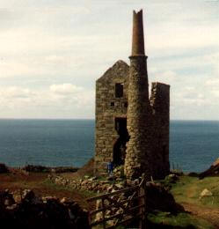

As with a lot of British cultural symbols, there are **superstitions and beliefs** surrounding the humble pasty that have been passed on through the ages and accepted as ritual. Firstly, it was said that the Devil would never cross the River Tamar into Cornwall for fear of becoming a filling of a Cornish pasty after hearing of the Cornish women’s inclination to turn anything into a tasty filling!

A genuine **Cornish pasty** has a distinctive 'D' shape and is crimped on one side. The texture of the filling for the **pasty** is chunky, made up of uncooked minced or roughly cut chunks of beef (not less than 12.5%), swede, potato and onion and a light peppery seasoning.

Some mines had stoves in the mine shafts to cook the raw pasties. This is how the well-known British rhyme “Oggie, Oggie, Oggie” came about. “Oggie” stems from “Hoggan”, Cornish for pasty and it was shouted down the mine shaft by the bal-maidens who were cooking the pasties, when they were ready for eating. In reply, the miners would shout “Oi, Oi, Oi!”

* **Dates back to the reign of Henry 111 in 13th C.**
* **By 18th C, staple diet of children & men working in the mines**