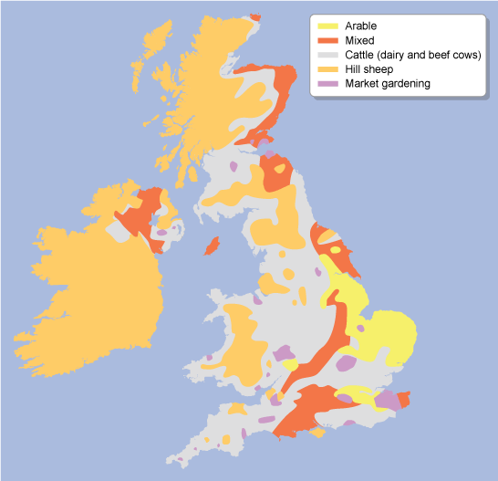

**Distribution of farming**

Physical factors will determine which **type** of farming takes place in a particular **area**. **Climate**, **relief** and **soils** are the dominant factors in determining which crops will grow and which animals are suited to the landscape.

Human factors, such as proximity to markets, are important with some types of farming, such as market gardening.

**Lesson three: Farming Types in the UK Factsheet**

**Arable farming**

Arable farming is common in the south east where the summers are warm and the land is low, flat and fertile. The south east also has good transport links and farms are close to markets in towns and cities such as London.

**Market gardening**

Human factors such as finance and proximity to markets are important to market gardening. It is common in East Anglia where fruit, vegetables and flowers are grown.

**Hill sheep farming**

Hill sheep farming takes place in the north and west of Britain in highland areas such as Snowdonia and the Lake District. There are cool summers and high rainfall. The climate and steep land make these areas unsuitable for growing crops.

**Dairy farming**

Dairy farming is common in the south west and the west of England where the climate is warm and wet. There are also good transport links and good access routes to markets in these areas. The land may be flat or hilly, but not too steep.

**Mixed farming**

Mixed farming is found in areas where the climate and relief suit both crops and animals. It needs to be warm, but not too wet, and the soils need to be fertile and flat. Mixed farms need good transport links and accessibility to markets.

**FARMING TYPES: UK**