[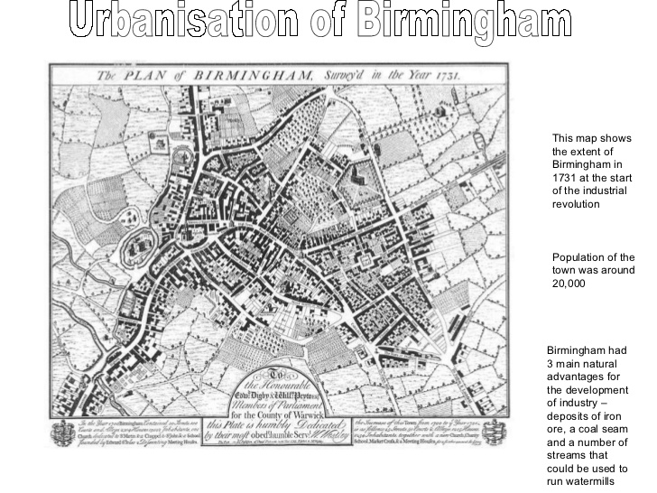](http://www.google.co.uk/url?sa=i&rct=j&q=&esrc=s&frm=1&source=images&cd=&cad=rja&uact=8&ved=0CAcQjRxqFQoTCIPH0-zimccCFWeB2wodnHUAVQ&url=http://www.slideshare.net/PLANETGE0GRAPHY/urban-change-in-birmingham-8065129&ei=URzGVcPaB-eC7gac64GoBQ&bvm=bv.99804247,d.ZGU&psig=AFQjCNH-3S-71F5sZtKEdOuOz0m_XOaaxA&ust=1439133117462758)[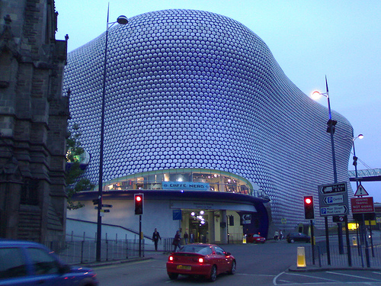](http://www.google.co.uk/url?sa=i&rct=j&q=&esrc=s&frm=1&source=images&cd=&cad=rja&uact=8&ved=0CAcQjRxqFQoTCNar7o3nmccCFRAq2wodq7QJFg&url=http://blog.michaelgray.org.uk/?cat%3D21&ei=yCDGVdanH5DU7Aar6aawAQ&bvm=bv.99804247,d.ZGU&psig=AFQjCNHISQ_eyUk1wlyONXZ8MxU_brl-3A&ust=1439134245306656)[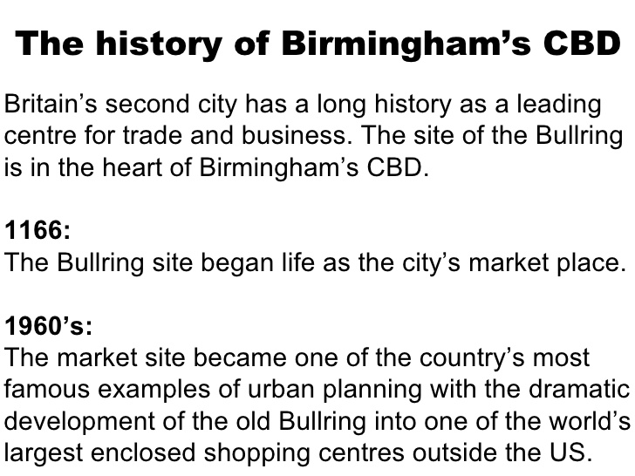](http://www.google.co.uk/url?sa=i&rct=j&q=&esrc=s&frm=1&source=images&cd=&cad=rja&uact=8&ved=0CAcQjRxqFQoTCIDSltnkmccCFeoW2wodKc0EdQ&url=http://www.slideshare.net/missm/birmingham-cbd-pres&ei=QR7GVcCtCeqt7AapmpOoBw&bvm=bv.99804247,d.ZGU&psig=AFQjCNGHlvobqCxqq8e-U6Ehh8pp4DDaAA&ust=1439133603753652)[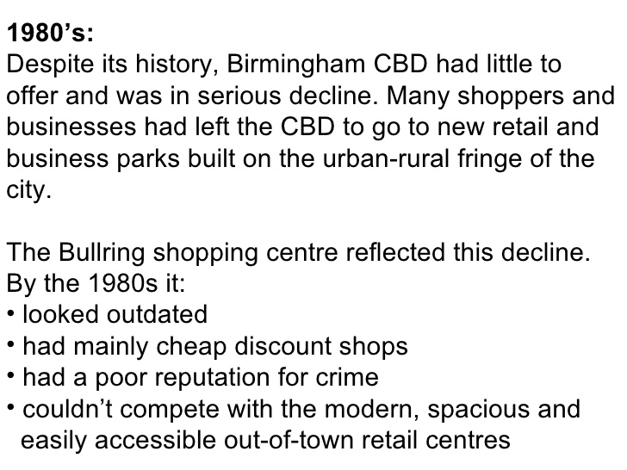](http://www.google.co.uk/url?sa=i&rct=j&q=&esrc=s&frm=1&source=images&cd=&cad=rja&uact=8&ved=0CAcQjRxqFQoTCIP3yaDlmccCFeSu2wodYmkAhw&url=http://www.slideshare.net/missm/birmingham-cbd-pres&ei=1h7GVYO0NuTd7gbi0oG4CA&bvm=bv.99804247,d.ZGU&psig=AFQjCNEs8Bus56Bd84A1OD6awTuDetyv8w&ust=1439133758921417)[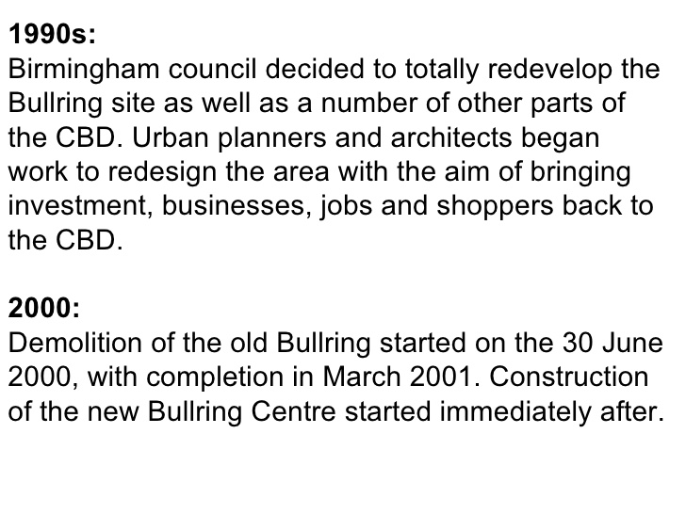](http://www.google.co.uk/url?sa=i&rct=j&q=&esrc=s&frm=1&source=images&cd=&cad=rja&uact=8&ved=0CAcQjRxqFQoTCO2s9OjlmccCFQs52wodWRgIJw&url=http://www.slideshare.net/missm/birmingham-cbd-pres&ei=bh_GVe29I4vy7AbZsKC4Ag&bvm=bv.99804247,d.ZGU&psig=AFQjCNH8TFJf-liTIsJM_vzvxsbaI_5kCg&ust=1439133925505155)

**Lesson five: Birmingham resource pack**

**BIRMINGHAM: RESOURCE PACK**

canal
River
railway
Industrial
sites
Victorian
terraced housing
 [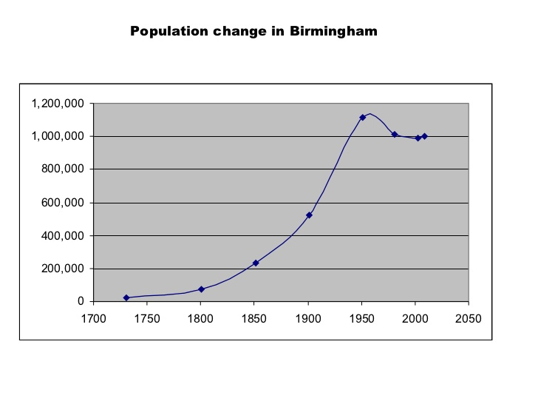](http://www.google.co.uk/url?sa=i&rct=j&q=&esrc=s&frm=1&source=images&cd=&cad=rja&uact=8&ved=0CAcQjRxqFQoTCPa-q5DjmccCFS5r2wodxaEAeQ&url=http://www.slideshare.net/PLANETGE0GRAPHY/urban-change-in-birmingham-8065129&ei=mxzGVbaFO67W7QbFw4LIBw&bvm=bv.99804247,d.ZGU&psig=AFQjCNH-3S-71F5sZtKEdOuOz0m_XOaaxA&ust=1439133117462758)

**LAND USE IN CENTRAL BIRMINGHAM**

[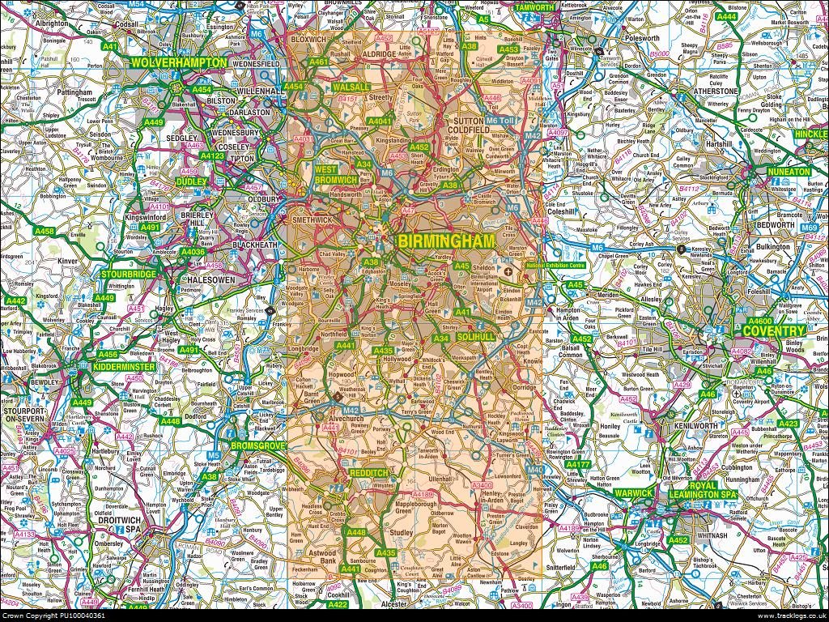](http://www.google.co.uk/url?sa=i&rct=j&q=&esrc=s&frm=1&source=images&cd=&cad=rja&uact=8&ved=0CAcQjRxqFQoTCLGF0bLxm8cCFehq2wodxcIOrw&url=http://www.tracklogs.co.uk/online-shop/ordnance-survey/25k-explorer-standard-sheets/ecf720.html&ei=ATjHVfGAHOjV7QbFhbv4Cg&bvm=bv.99804247,d.ZGU&psig=AFQjCNF13wKniM0n-eJ6mNx53TsT6Gqq8A&ust=1439205759811093)[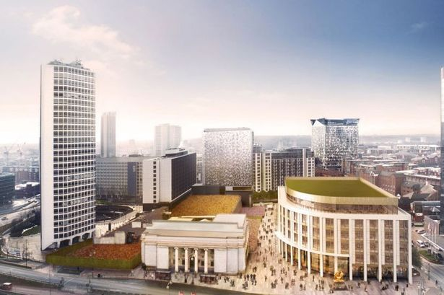](http://www.google.co.uk/url?sa=i&rct=j&q=&esrc=s&frm=1&source=images&cd=&cad=rja&uact=8&ved=0CAcQjRxqFQoTCNGf3KnrmccCFSOz2wod8l4Hkg&url=http://www.birminghampost.co.uk/business/commercial-property/birmingham-post-skyline-2014-arena-6400065&ei=NCXGVdG1KaPm7gbyvZ2QCQ&bvm=bv.99804247,d.ZGU&psig=AFQjCNFLF2Ads1A-yqW6kdSIjBEKwF_qSg&ust=1439135410833704)[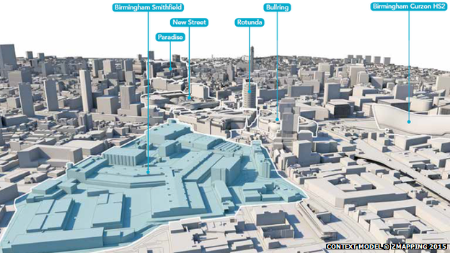](http://www.google.co.uk/url?sa=i&rct=j&q=&esrc=s&frm=1&source=images&cd=&cad=rja&uact=8&ved=0CAcQjRxqFQoTCJTs6f7qmccCFauh2wod3iACMw&url=http://www.bbc.co.uk/news/uk-england-birmingham-31821366&ei=2iTGVZSXLKvD7gbewYiYAw&bvm=bv.99804247,d.ZGU&psig=AFQjCNH3VLyldzPQKWMg-UgjoU_TkTIQxA&ust=1439135296502570)

**BIRMINGHAM BIG CITY PLAN**

* **Expansion of core area of the city by 25%**
* **£2.1 billion to the economy each year**
* **50,000 new jobs**
* **1.5 million square metre of new floorspace**
* **£600 million on redevelopment of New Street station**
* **Development of new offices in Snow Hill district**
* **Construction of a new library**
* **Increased pedestrian access**
* **Restoration of the canal system**
* **More public space for leisure and retail**
* **Greater areas of green space**