Everyday Drone Stories
KS5.3 Getting familiar with drones

Specification
AQA 3.2.1.2 Global systems. Unequal flows of people, money, ideas and technology within global systems can sometimes act to promote stability, growth and development but can also cause inequalities, conflicts and injustices for people and places.

Edexcel Topic 7: Superpowers. TNCs are dominant economic forces in the global economy and economic and cultural globalisation in terms of technology (patents) and trade patterns.

OCR Topic 2.1 – Changing Spaces; Making Places. How shifting flows of people, resources, money and investment and ideas have helped shape the demographic, socio-economic and cultural profile of places over time.

WJEC Changing Places. External forces and factors influencing economic restructuring including changing technology and lifestyles, government strategy and globalisation.

What are drones?
Drones, like the example pictured below, are small aircraft without a pilot on board. Drones can also be called Unmanned Aerial Vehicles (UAVs) or Remotely Piloted Aircraft Systems (RPAS).

Drones can be operated by a pilot on the ground or can be pre-programmed to independently follow a set flight path or route. Drones are a growing feature of UK skies. Drones have lots of different users and uses. Drones can be flown:

- As a hobby or for fun (perhaps a family member or friend has a drone).

- By researchers to capture images of places and environments from the air.

- By civil actors such as emergency services (police, fire, search and rescue) to help locate missing people or identify the spread of fires.

- By commercial actors such as businesses to inspect buildings from the air or to deliver items.
Drones come in different shapes and sizes. Some drones have cameras and sensors attached to them so they can take photographs, capture videos and collect different types of data from the air. Other drones are used to carry, transport and deliver things – like medicine or small parcels.

While drones allow us to do a lot of things and offer a range of benefits (e.g., increasing safety and reducing costs), they also introduce different risks and challenges into our airspace.

These include issues such as: safety (what if a drone crashes or collides with someone or something), security (how might drones be misused to cause disruption or harm to people or places), privacy (what can drones see, what data do they capture and record), and noise (how might the noise from drones disturb people or animals).

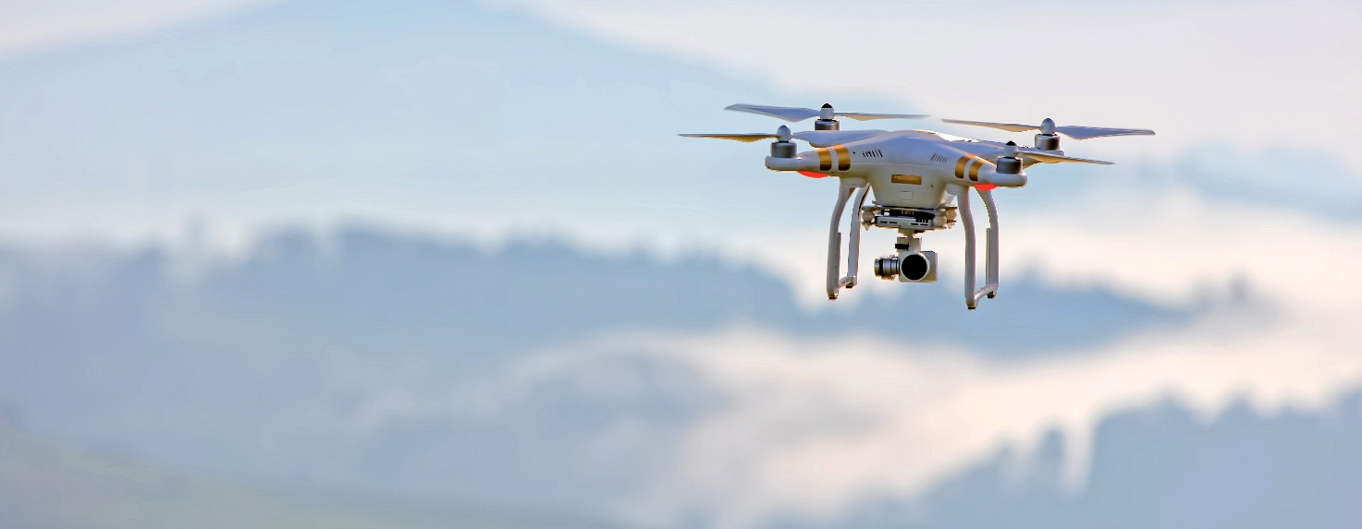
Figure 1 A drone in flight © Ricardo Gomez Angel

Activity
In this worksheet we’re going to learn more about what drones can do and reflect on some of the potential positives and negatives of using, living with and sharing our skies with drones.

We’ve selected two current drone applications – police drones and drones to support wildlife conservation – as examples.

We’re going to think about who and what these applications involve and impact, and their benefits and risks.

Example 1: Police drones
Drones are being used by at least 40 of the UK’s 48 police forces (UK Drone Watch, 2020). They are used to support a range of policing activities, including search and rescue, gathering evidence, pursuit of suspects, and to search and monitor crime scenes.

To learn more about how and why UK police use drones, read these two short articles:

- College of Policing (2023) Drones – five things you need to know https://www.college.police.uk/article/drones-five-things-you-need-know

- Bowden D (2017) Full-time flying squad: Police launch first 24-hour drone unit. Sky News https://news.sky.com/story/full-time-flying-squad-police-launch-first-24-hour-drone-unit-10947852

- As you read these articles, address the following questions:

- How are police drones being used and who might these operations impact?
- What might the potential benefits and opportunities be for this drone application?
- What might the potential challenges and risks be for this drone application?
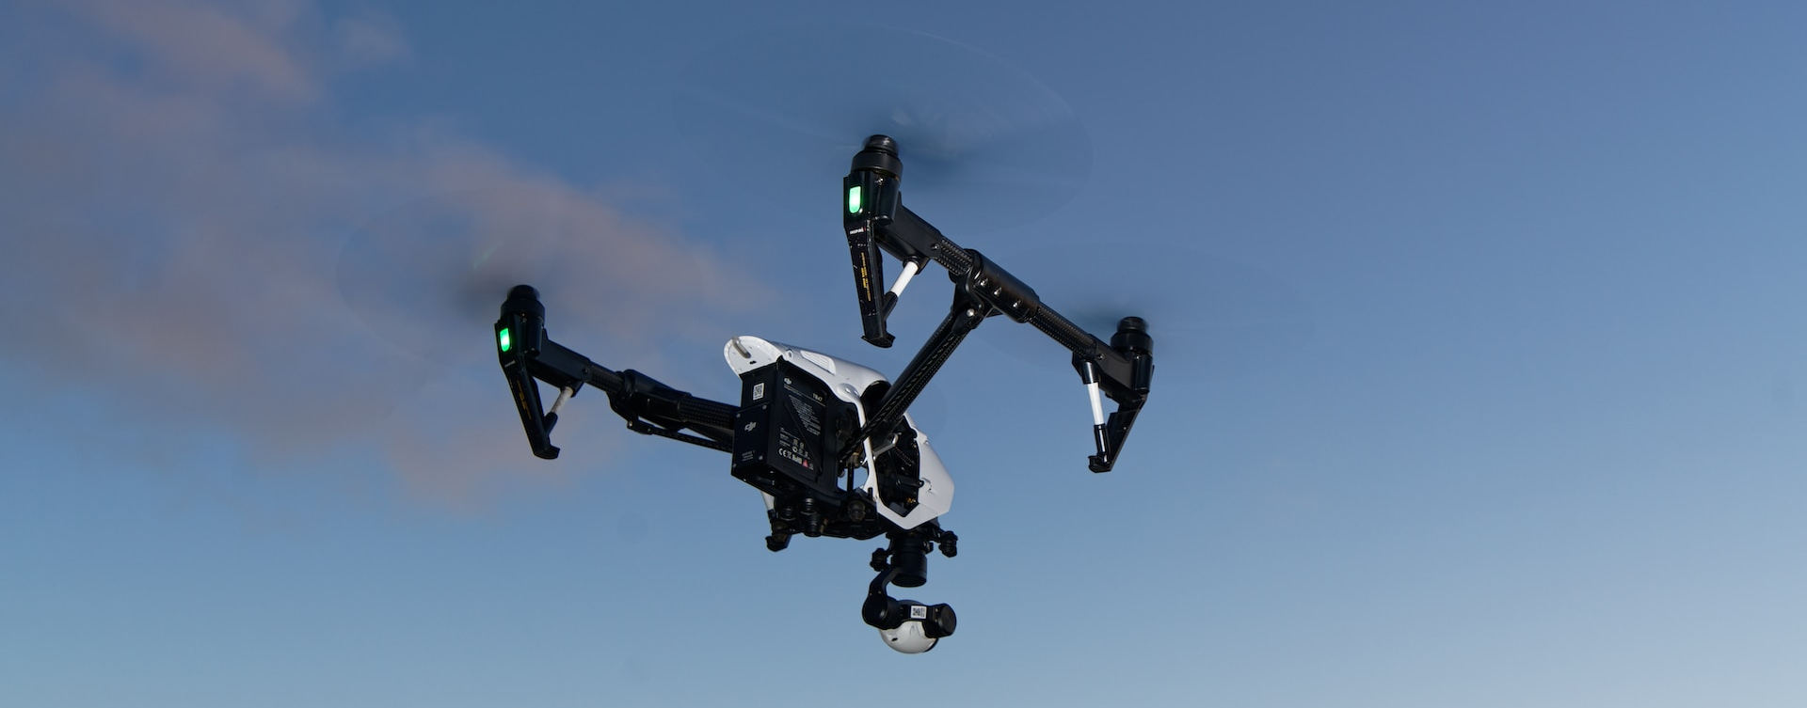
Figure 2 A drone in flight. © Colin Watts

Example 2: Drones to support wildlife conservation
Drones are increasingly being used in global conservation efforts. As tools praised for their comparative accessibility, affordability and data-capturing capabilities, drones are being deployed by diverse users in a range of applications. From wildlife monitoring and vegetation mapping, to the detection of poachers and the (counter-)mapping of territories and land, drones have emerged as a key part of the toolkit for many conservation practitioners and researchers.

To learn more about how and why drones are used in conservation efforts around the world, read these two short articles:

- Young RJ (2014) Conservation drones – here comes the animals’ air force. The Conversation https://theconversation.com/conservation-drones-here-comes-the-animals-air-force-35220

- Mulero Pazmany M (2018) Viral bear video shows how drones threaten wildlife – and what to do about it. The Conversation https://theconversation.com/viral-bear-video-shows-how-drones-threaten-wildlife-and-what-to-do-about-it-106903

- As you read these articles, address the following questions:

- How are conservation drones being used and who might these operations impact?
- What might the potential benefits and opportunities be for conservation drones?
- What might the potential challenges and risks be for conservation drones?

Answers
- Police drone use: How are police drones being used and who might these operations impact? The articles highlight a range of potential applications, including search and rescue, response to major road accidents, hazmat response, suspect pursuit, gathering evidence, searching a crime scene, and public order response. The articles identify different actors who might be involved and impacted, including the police and local people/ communities. What might the potential benefits and opportunities be for this drone application? The articles identify a range of potential benefits associated with police drone use, including reduced costs (when compared with other forms of police air support such as helicopters), speed of response, flexibility and portability, the ability to gather different kinds of information (e.g. photos, videos, infra-red or sensor data more widely) and to operate in difficult conditions (e.g. low light, darkness). What might the potential challenges and risks be for this drone application? The articles raise different issues, such as safety (risk of collision with other aircraft including drones, property or people) and privacy concerns (e.g., what can drones see and data can they capture).

- Conservation drone use: Who or what might these drone operations involve and impact? The articles involve a range of actors, including researchers and conservation organisations, and different wildlife (i.e., humans and non-humans). They demonstrate that while drones can be used in conservation efforts designed to monitor and protect different wildlife, they can also be disruptive to the wildlife they target and wildlife more widely that are in the vicinity. What might the potential benefits and opportunities be for this drone application? The articles highlight that drones can be very useful conservation tools that allow the capturing of important visual data on animals, their habitats, behaviours and movements. What might the potential challenges and risks be for this drone application? While drones are often used to collect data that informs effective conservation efforts, their use can also disturb wildlife, including both animal species being monitored and non-target species. Drones can prompt a range of anti-predatory responses in wildlife (including curiosity, vigilance, alert, alarm, fleeing responses and aggressive behaviour), as well as non-visible responses (such as an increased heart rate). While varying by animal characteristics (such as species), operators can consider and adapt drone attributes and flight timings and patterns to minimise potential disruption and exhibit care to non-humans with whom we share the (air)space.

Further reading
- Schippers B (2020) Coronavirus: drones used to enforce lockdown pose a real threat to our civil liberties. The Conversation https://theconversation.com/coronavirus-drones-used-to-enforce-lockdown-pose-a-real-threat-to-our-civil-liberties-138058

- TED talk: SnotBot: A drone that studies whales https://www.ted.com/talks/ocean_alliance_snotbot_a_drone_that_studies_whales

- Aublin JA (2023) Drones gather new and useful data for marine research, but they can disturb whales and dolphins. The Conversation https://theconversation.com/drones-gather-new-and-useful-data-for-marine-research-but-they-can-disturb-whales-and-dolphins-198985

- Responsible drone use in biodiversity conservation: Guidelines for environmental and conservation organisations who use drones. CIFOR ICRAF https://www.cifor-icraf.org/knowledge/publication/8851/

- Jackman A, Millner N (2023) From data to disturbance: Fostering responsible and considerate conservation drone use. Geography Directions https://blog.geographydirections.com/2023/06/29/from-data-to-disturbance-fostering-responsible-and-considerate-conservation-drone-use/

