Migrants on the Margins
- Arunachalam’s Story - Resource linked to the video

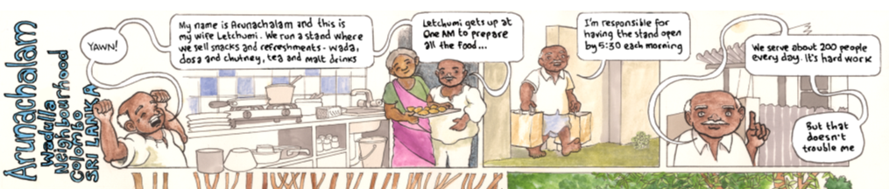

Introduction:
Before watching the video ask yourself the following questions:

- Where is Colombo? ________________________________________________________

- Do you know of any reasons why someone may want to move from a rural to an urban area? ____________________________________________________________________

- What type of migration do you think Arunachalam’s story will be about? ______________

- Do you think he chose to move? Will it be voluntary or forced? ______________________

- Do you think that the story will have a positive or negative message? __________________________________________________________________________

After the video
- Was the reason for Arunachalam’s migration the reason you came up before watching the video? ____________________________________________________________________

- Did it surprise you that the story had a very positive message? _______________________

- How would you classify this type of migration? Is it economic or social? ________________

- Do you think other migrants would tell a similar story? _____________________________

Extension
Imagine that you are interviewing Arunachalam’s children in the future. Draw a comic strip similar to the one above to tell their story. Where are they living? Did they go to school? What type of job do they have?

