Net zero interactive: The BEIS My2050 carbon calculator

Resource
BEIS is the government department for Business, Energy, and Industrial Strategy. In 2020 BEIS launched the My2050 carbon calculator which you can access through our My2050 webpage. My2050 is an interactive webtool designed to encourage students ‘to create a clear pathway to a low carbon UK by 2050’. User must find their way to reduce UK greenhouse gas emissions to Net Zero by 2050 using 15 levers and a CO₂e meter.

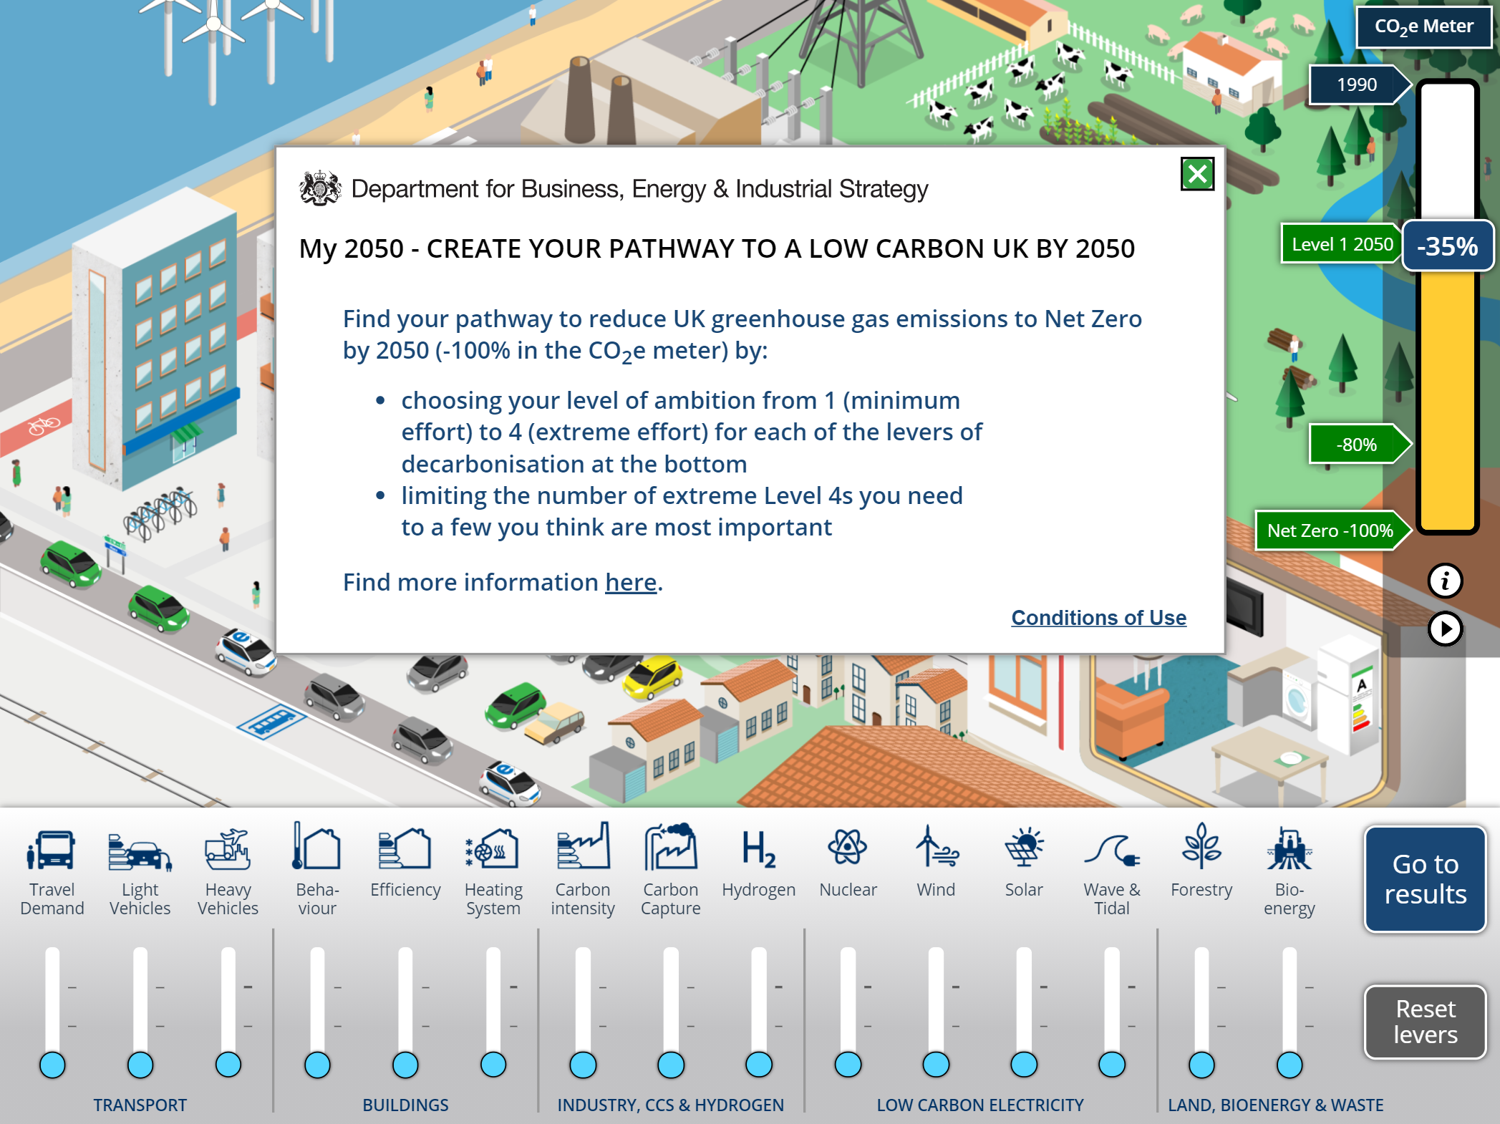

Activity
Return to our My2050 webpage, download the My2050 Teacher pack and, using the My2050 carbon calculator, complete the 7 lessons.

Suggested further work
What is the background to the ambition of achieving net zero by 2050? https://www.gov.uk/government/news/uk-becomes-first-major-economy-to-pass-net-zero-emissions-law

If you are an A level geography student you may wish to also access and explore the more detailed MacKay carbon calculator, again from BEIS. You will find both the calculator and more teaching resources on The MacKay carbon calculator webpage.

How will the election of US President Joe Biden alter the accomplishment of net zero by 2050? https://www.theguardian.com/environment/2021/jan/21/biden-raises-hopes-of-addressing-climate-crisis-as-cop26-nears

How does US President Joe Biden describe the challenge of the climate crisis? https://www.bbc.co.uk/news/world-us-canada-55829189

Is £12 billion enough to get the UK on track for net zero carbon emissions? https://www.theguardian.com/environment/2020/nov/18/is-12bn-enough-to-get-uk-on-track-for-net-zero-carbon-emissions

In partnership with the Royal Meteorological Society, the Royal Geographical Society (with IBG) publish climate change-related papers in the journal WIREs. Members, Fellows, Postgraduate Fellow and Young Geographers all have access WIREs Climate Change - WIREs (wiley.com)

