Net zero interactive: The BEIS MacKay carbon calculator

Resource
BEIS is the government department for Business, Energy, and Industrial Strategy. In 2020 BEIS launched the MacKay carbon calculator which you can access through our MacKay webpage. This is an A level resource. The MacKay carbon calculator is a webtool with 30 graphs, maps and flow diagrams which are linked to levers on the left of your screen. These levers are categorised under 6 lever groups: Transport, Buildings, Industry, CO₂ Removal & Gases, Electricity Supply, Land use & biofuels.

Without instantly jumping all levers up to level 4 (which is considered by experts to be the limit of what is plausible), can you use the carbon calculator to hit net zero by 2050?

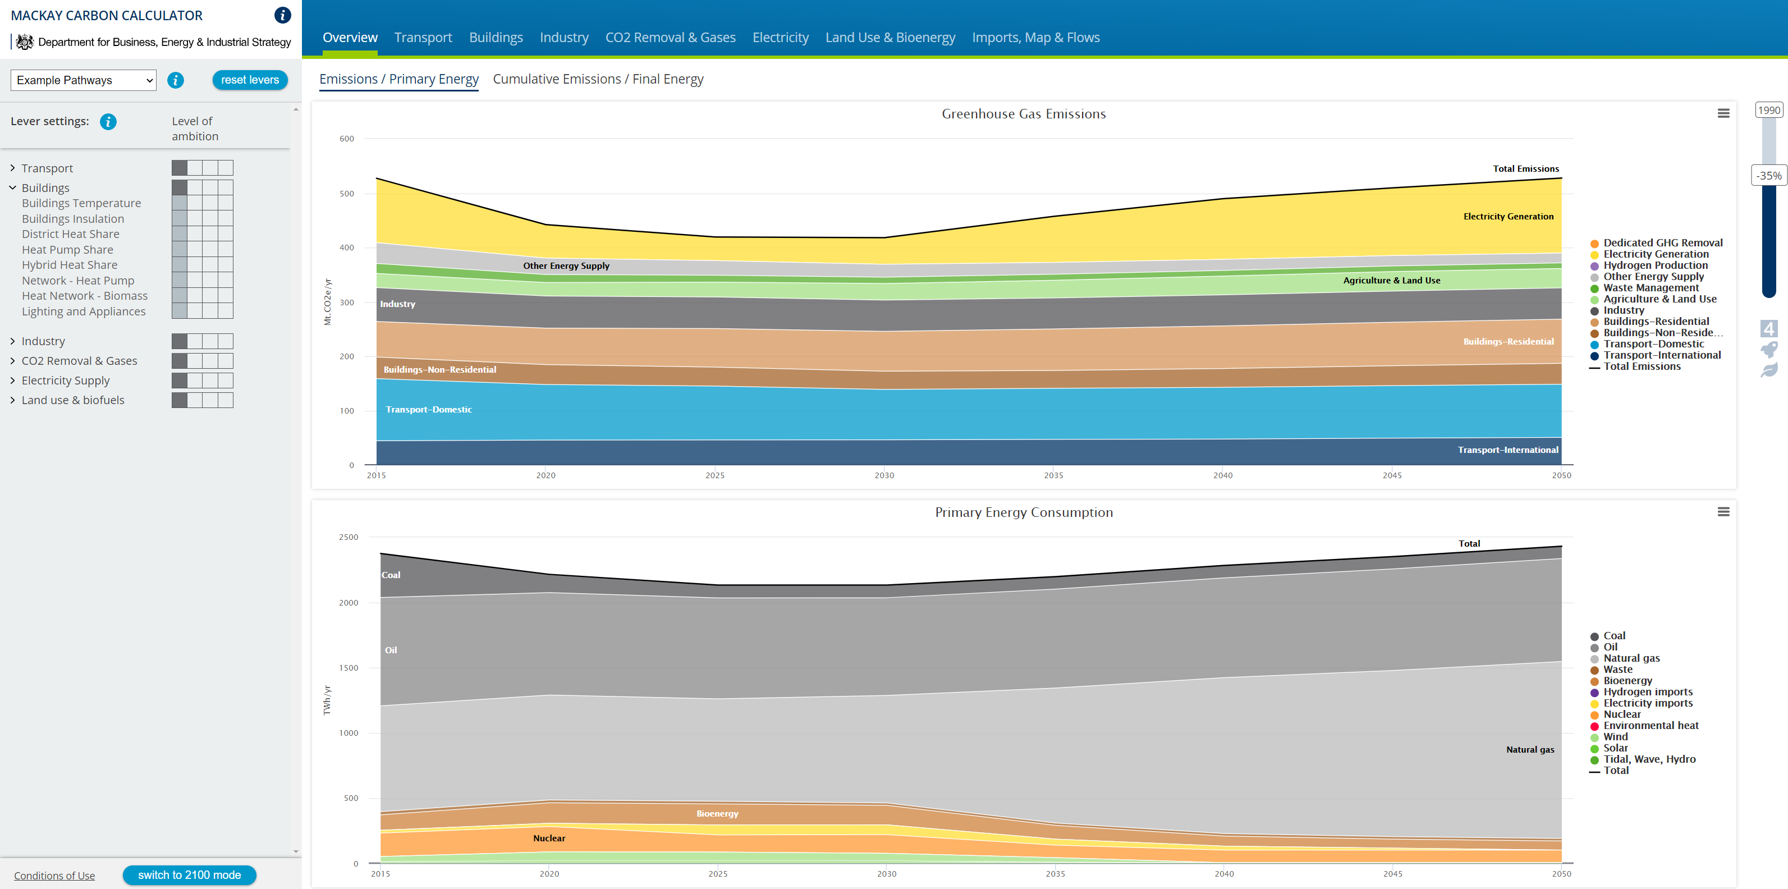

Activity
Return to our MacKay webpage, download the MacKay carbon calculator worksheet and complete the 4 in-depth lessons.

Suggested further work
What is net zero? Grantham Research Institute on Climate Change and the Environment https://www.lse.ac.uk/GranthamInstitute/news/what-is-net-zero/

What is the background to the ambition of achieving net zero by 2050? https://www.gov.uk/government/news/uk-becomes-first-major-economy-to-pass-net-zero-emissions-law

In depth Q&A: the UK becomes the first major economy to set net-zero climate goal https://www.carbonbrief.org/in-depth-qa-the-uk-becomes-first-major-economy-to-set-net-zero-climate-goal

If you are a GCSE geography student you may wish to also access and explore the more visual My2050 carbon calculator, again from BEIS. You will find both the calculator and more teaching resources on My2050 webpage.

How will the election of US President Joe Biden alter the accomplishment of net zero by 2050? https://www.theguardian.com/environment/2021/jan/21/biden-raises-hopes-of-addressing-climate-crisis-as-cop26-nears

How does US President Joe Biden describe the challenge of the climate crisis? https://www.bbc.co.uk/news/world-us-canada-55829189

UNEP: net zero pledges provide an ‘opening’ to close growing emissions ‘gap’ https://www.carbonbrief.org/unep-net-zero-pledges-provide-an-opening-to-close-growing-emissions-gap

Is £12 billion enough to get the UK on track for net zero carbon emissions? https://www.theguardian.com/environment/2020/nov/18/is-12bn-enough-to-get-uk-on-track-for-net-zero-carbon-emissions

What changes are needed? The CCC explains https://www.theccc.org.uk/uk-action-on-climate-change/reaching-net-zero-in-the-uk/

Big investors push UK to go further on green finance https://www.ft.com/content/cff58c77-ed90-49ff-bd1f-94b69d00d054

UK fintech offers world’s ‘first’ net zero pension fund https://www.ft.com/content/e780606c-d46b-4e57-abcb-06add462e293

In partnership with the Royal Meteorological Society, the Royal Geographical Society (with IBG) publish climate change-related papers in the journal WIREs. Members, Fellows, Postgraduate Fellow and Young Geographers all have access WIREs Climate Change - WIREs (wiley.com)

