Lesson ideas for geography teachers to share: population pyramids

Answers

- Early expanding Expanding Stationary Contracting
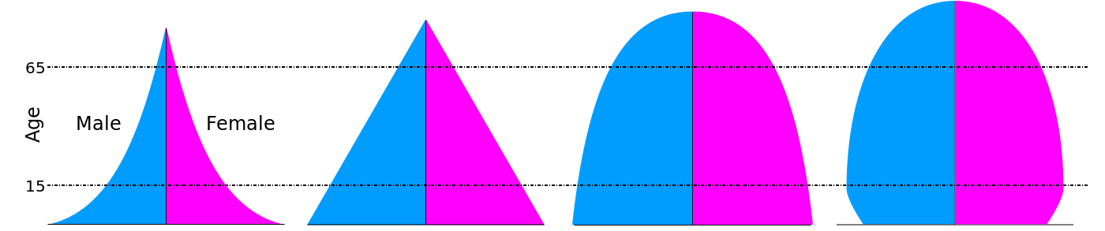

- Birth rate Life expectancy Death rate
The number of deaths, per 1000 of the population, per year

The number of births, per 1000 of the population, per year
The average number of years a person is expected to live

The dependency ratio Old age Economically active
36 million people in the UK are of a ‘working age’ (aged between 16 to 64)
A default retirement age no longer exists but generally speaking this age group is 65+
Those who are in non-economically active age groups (the young and old) versus those who are economically active

- The UK has a remarkably balanced population although, overall, the dominant age group is middle aged. The UK does have a dependent population – it is largely the elderly as birth rates are declining.

- The challenge of this type of demographic is that ultimately a declining population means there will be a smaller workforce in the future as the working population shrinks in proportion to the dependent population. New industries will need to be created to care for the elderly, who will become an increasingly dominant – and reliant age group.

- There are multiple opportunities in science and technology for innovative new businesses for the elderly. Robotics in healthcare, pharmaceutical drug research, biomedical science and nanotechnology are but a few ideas believed to be future growth areas in the UK economy.

