Lesson ideas for geography teachers to share: population pyramids

Go to
https://www.ons.gov.uk/peoplepopulationandcommunity/populationandmigration/populationestimates/articles/ukpopulationpyramidinteractive/2020-01-08

Activity
Start by browsing through the data. If you click the ‘Play’ button the interactive will play the population pyramids as if they are all streamed together, jumping in 10 year intervals from 1998 to 2038.

- Population pyramids are classified into 4 shapes: early expanding, stationary, expanding and contracting. Can you match these titles to the shapes below?

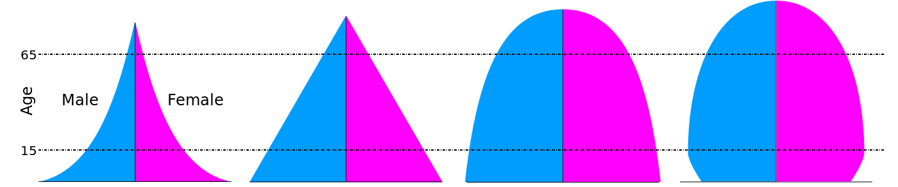

- In each population pyramid there are a number of key terms. Can you match the key terms to their meanings below?

Death rate, birth rate, the economically active, old age, the dependency ratio, and life expectancy (research concave and convex to extend the activity)

The average number of years a person is expected to live
The number of deaths, per 1000 of the population, per year

The number of births, per 1000 of the population, per year

A ‘default retirement age’ no longer exists but generally speaking this age group is 65+
36 million people in the UK are of a ‘working age’ (aged between 16 to 64)
Those who are in non-economically active age groups (the young and old) versus those who are economically active

- Return to the ONS population pyramid. How would you describe the 2018 UK population now? Overall, is it young, middle aged or old? Does the UK have a ‘dependent’ population?

- What do you think are the challenges with this type of demographic?

- Are there any opportunities for the UK with this type of demographic?

